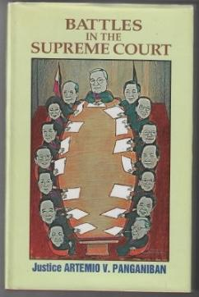

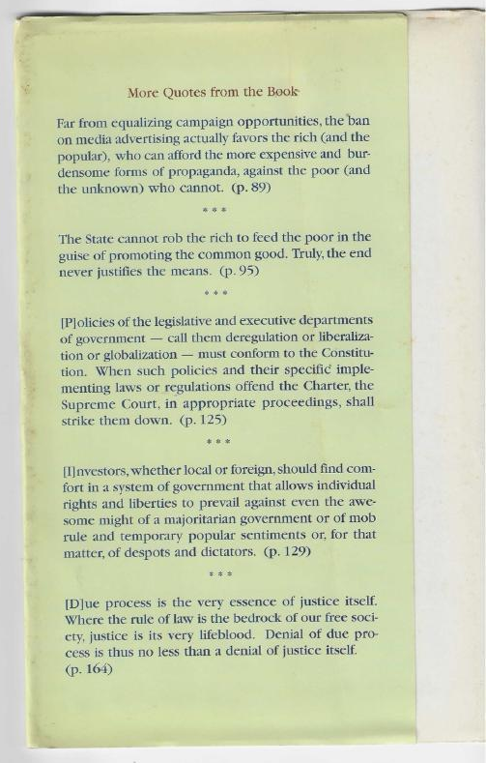

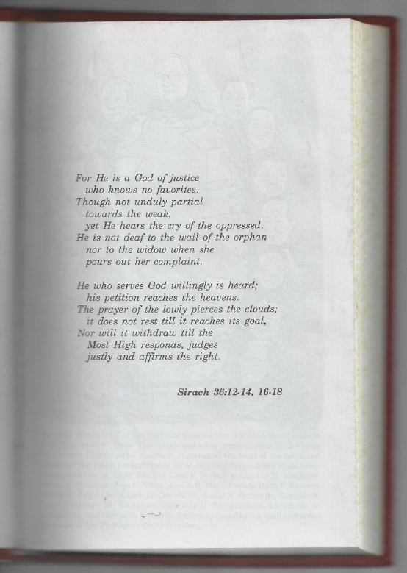

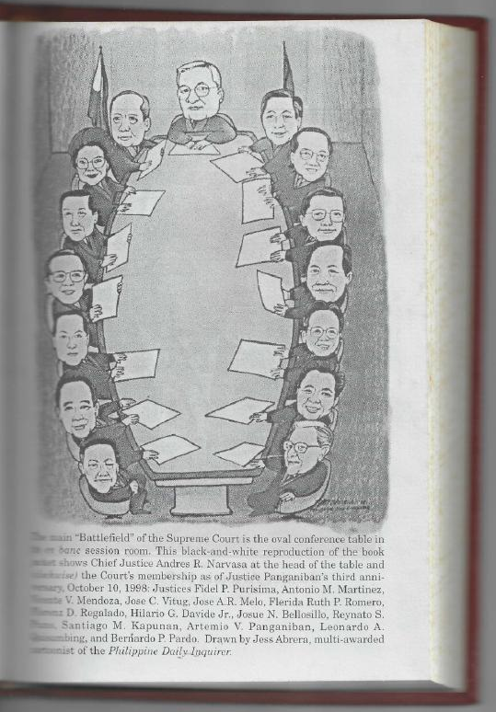

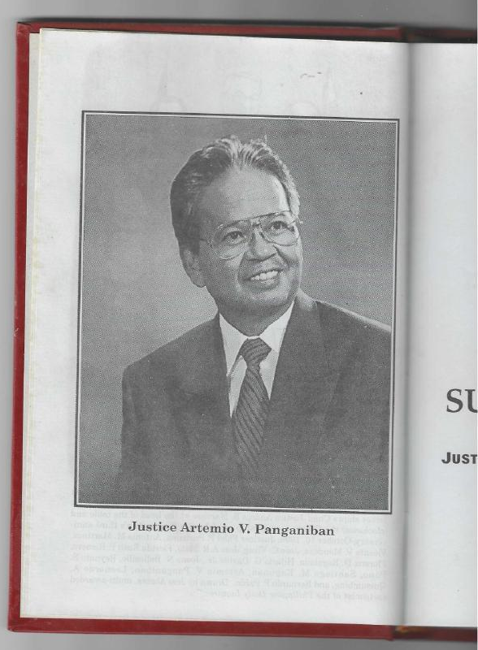
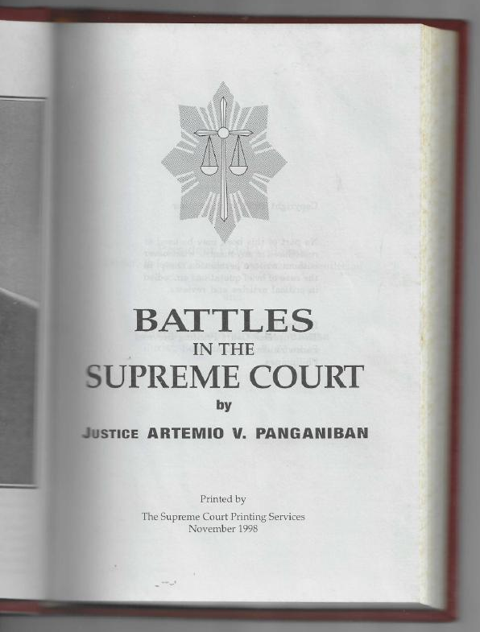

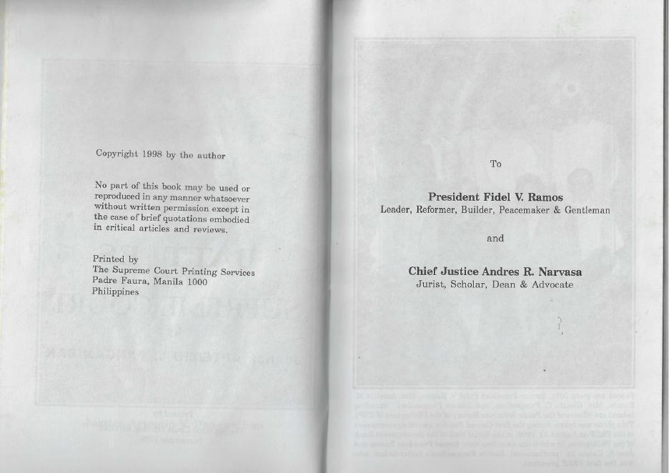

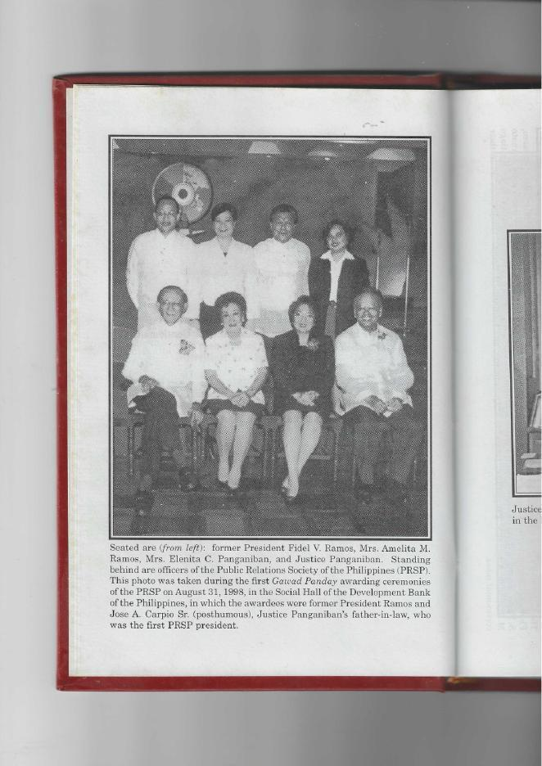
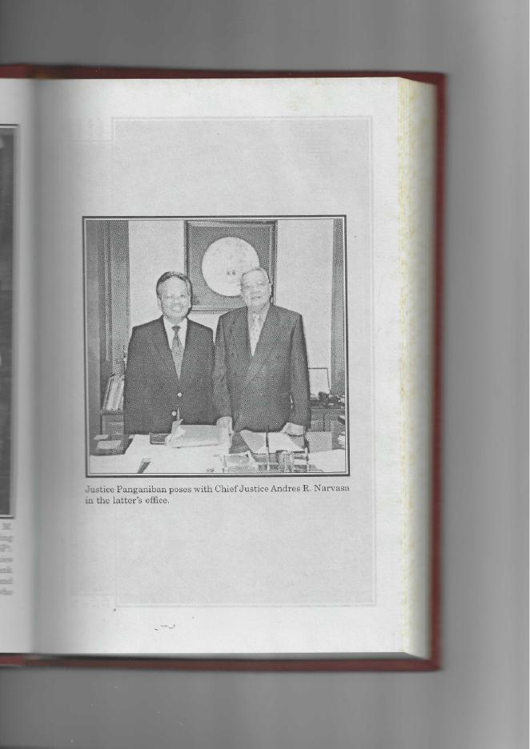
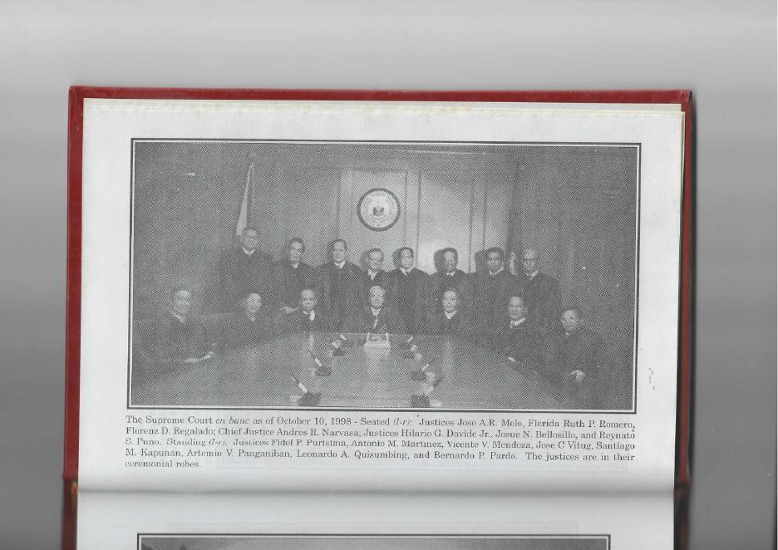
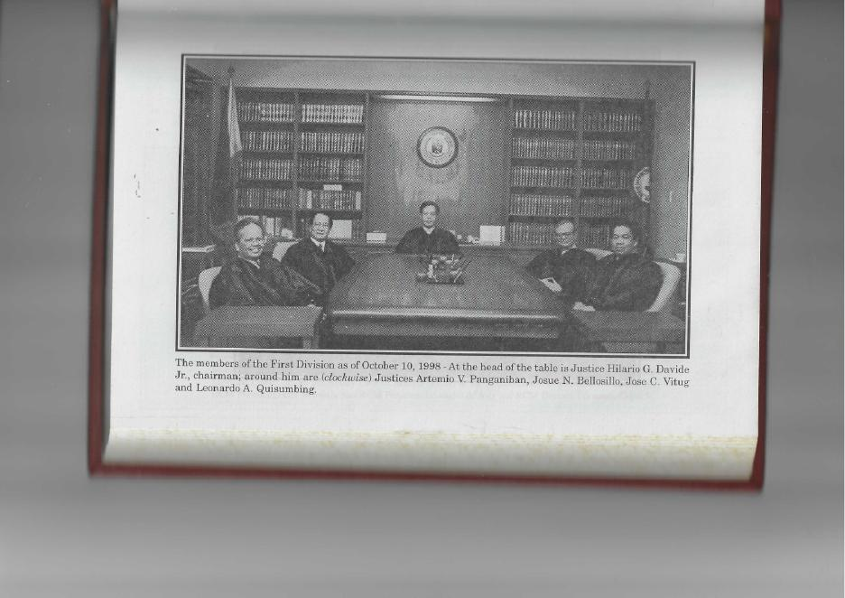
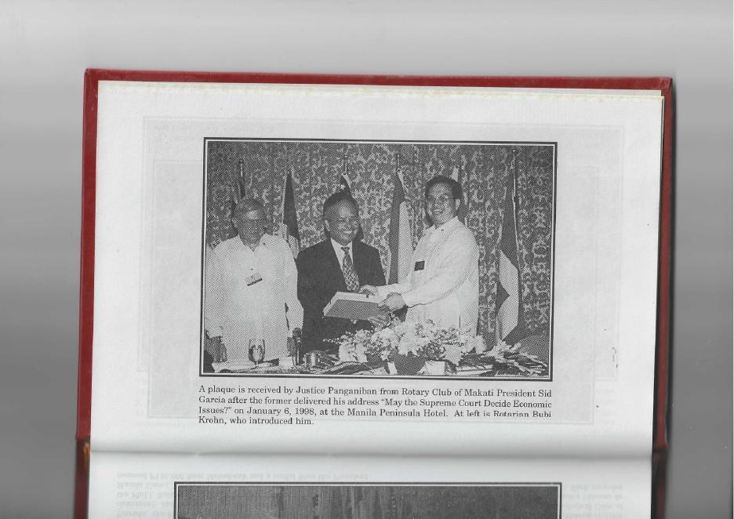
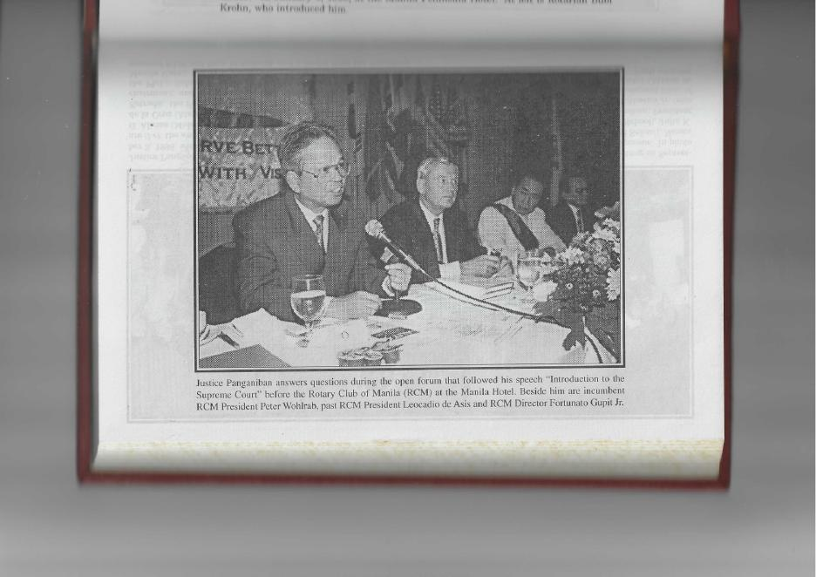
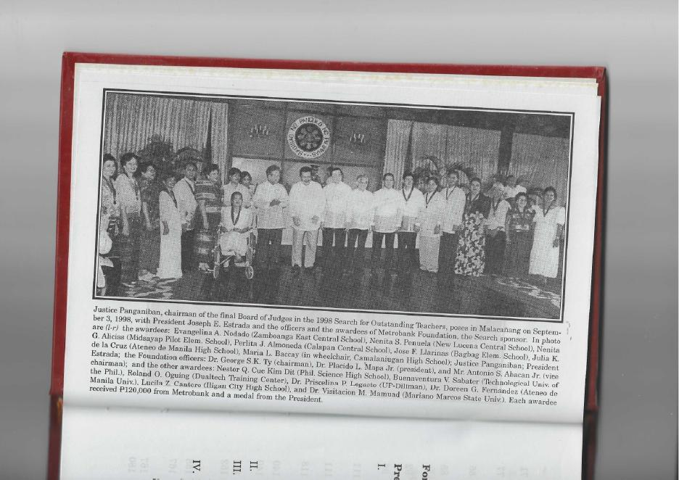

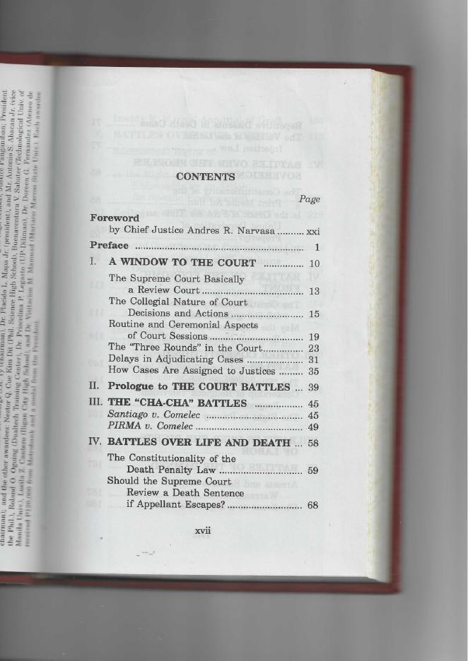
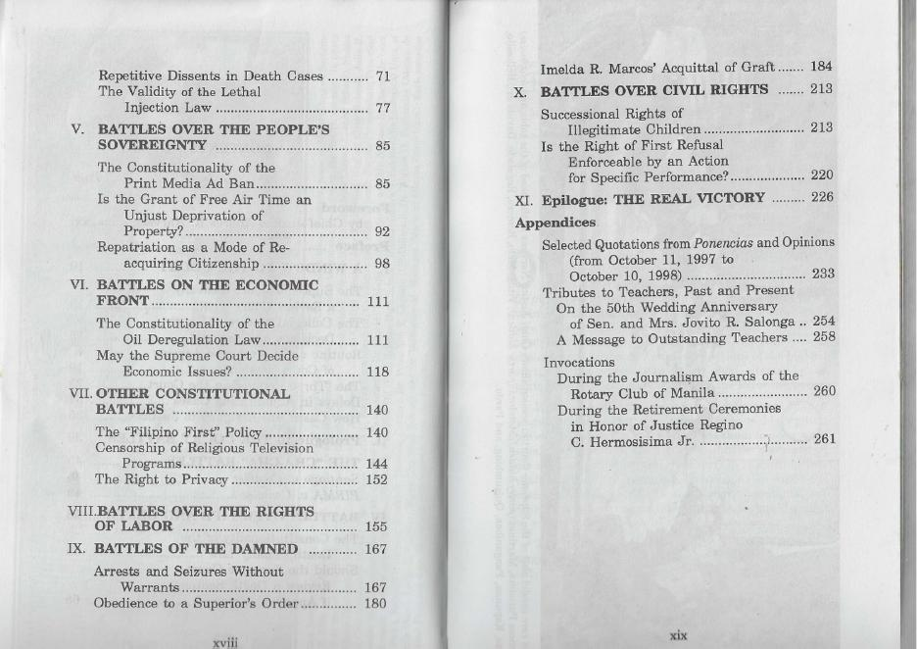

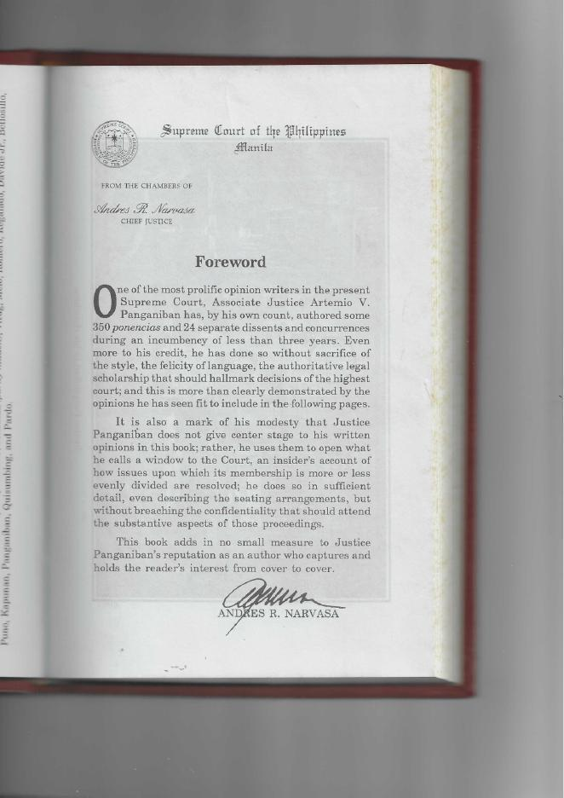

Supreme Court of the Philippines Manila

FROM THE CHAMBERS OF
Andres R. Narvasa
Chief Justice

Foreword

one of the most prolific opinion writers in the present Supreme Court, Associate Justice Artemio V. Panganiban has, by his own count, authored some 350 ponencias and 24 separate dissents and concurrences during an incumbency of less than three years. Even more to his credit, he has done so without sacrifice of the style, the felicity of language, the authoritative legal scholarship that should hallmark decisions of the highest court; and this is more than clearly demonstrated by the opinions he has seen fit to include in the following pages.

It is also a mark of his modesty that Justice Panganiban does not give center stage to his written opinions in this book; rather, he uses them to open what he calls a window to the Court, an insider's account of how issues upon which its membership is more or less evenly divided are resolved; he does so in sufficient detail, even describing the seating arrangements, but without breaching the confidentiality that should attend the substantive aspects of those proceedings.

This book adds in no small measure to Justice Panganiban’s reputation as an author who captures and holds the reader’s interest from cover to cover.

ANDRES R. NARVASA

Preface

The year 1998 marks a transition in our political history. On June 30, 1998, Fidel Valdez Ramos finished his term as chief executive of the country, and Joseph Ejercito Estrada succeeded him. Congress, too, elected new leaders, namely, Marcelo B. Fernan (a former Chief Justice) as Senate President and Manuel V . Villar Jr. as Speaker of the House of Representatives. Later in the year, the judiciary, too, will experience a change of headship when Andres R. Narvasa reaches the compulsory retirement age of 70 on November 30, 1998. By express constitutional mandate, the President will have to appoint his successor within ninety days from November 30, 1998, from a list of nominees to be submitted by the Judicial and Bar Council.

On October 10, 1998, I too will mark a milestone - my third year as a member of the highest court of the land.¹ To commemorate the occasion, I decided to write this little book to report on my work as a jurist, with emphasis on the "battles" in the Supreme Court, in which I had actively participated during the first three years of my incumbency. And because
_______________

¹And because although my appointment is dated October 5, 1995, I actually took my oath and assumed office on October 10, 1995.

a new Chief Justice will be appointed soonI th, ought that it would be timely to write on my impressions of the present Court. It is my hope that this book would provide a window to the internal workings of the Narvasa Court from my own observations and experiences. In this sense, I dedicate to Chief Justice Narva this little memento of my recollections of the little-known processes and battles during his last —my first - three years in the high tribunal.

Perhaps unknown to him, Chief Justice Narvasa had provided me with an early inspiration to study law. In the early 1950s, my family rented a small apartment in the corner of J. Barlin and Cataluña Streets in Sampaloc, Manila, just a block away from the Narvasa home. As I hawked newspapers on the streets of Sampaloc, I would watch this tall, crew-cut-sporting, lanky law scholar and athlete (a varsity basketball star) pass by, and I would wonder how he could combine and excel in both and the brawns departments. And when the bar exam results showed him at the top (he was No. 2), I thought I would heed my own father's advice to take up law, instead of chemical engineering which I had cherished earlier. How true indeed that the excellent work and example of a person can inspire and ignite ambition in others whom he may not even know at the time. That was why, many years later, I was very glad that my daughter Celine became a very close friend of his daughter Rina, a friendship I had no opportunity to enjoy with him — until I joined the Court.

With this background, I started my work as a magistrate with a rather reverential regard for the Chief. Although I sat during most of the last three years at the foot of the table in our session room, he would however always reach out to me with a furtive glance to find out whether I wanted to speak. And speak I would, with his nod and at times express prod, "Let us now listen to Art."

In Justice and Faith which came out in December 1997, I included an article I had written to commemorate my second anniversary in the Court on October 10 of the same year. In that article, I outlined the main features of my decision-writing style. By way of update, let me report that as of my third year, I have written over 350 ponencias and 24 Separate (including Dissenting and Concurring) Opinions.² These ponencias and Opinions have been bound into 18 volumes consisting of about 500 pages each.³ So, too, I am pleased to say that I have maintained my 100 percent attendance in all regular Court sessions. I realize that I must have disappointed many of my friends and relatives by my refusal to receive them in my chambers or to speak with them even by phone, particularly about judicial matters pending before the Court. I hope, however, that one day they will understand and appreciate the reasons for this judicial isolation.⁴
_______________

² Compared with 230 ponencias and 11 Separate Opinions as of October 10, 1997, i.e. for my first two years. (See Panganiban, Justice and Faith, 1997 ed., p. 4.) I have thus kept pace with my yearly output of decisions and opinions.
³ Compared with 11 volumes as of October 10, 1997. (Ibid.)
⁴ I tried to explain this little understood norm in a speech I delivered before the Rotary Club of Manila in this wise:

“The Supreme Court is the last bulwark of democracy. When rights are violated and the people have no more recourse

By way of further update, may I say that since last year, I have revised a few items in my decision writing style, which are set forth in the footnote below.⁵
_______________

in the political departments of government, they look up to the Supreme Court for a final redress of their grievances. It is thus indispensable to the very survival of democracy that the Supreme Court should merit the trust and confidence of our people.
"For this reason, being in the judiciary, particularly the Supreme Court, calls for behavior different from that in the two other branches of government. When a newly elected legislator or a newly appointed cabinet member speaks before his constituents and friends, he would normally ask them to visit him or call him so he could be of service to them. In the judiciary, however, particularly in the Supreme Court, the situation is different. Because litigations are decided on the basis of the evidence and the arguments presented by the parties, magistrates are barred from discussing cases pending before them, except during official proceedings and in the presence of all parties or their lawyers.
"So, in all my speeches, I usually ask my audience to please refrain from visiting me or calling me up for the purpose of discussing with me any matter pending before the Court. I assure them that I carefully read and pass upon every pleading brought before me. And thus, it is not necessary for them to do so. If for any reason, like close friendship or kinship, I feel I cannot be completely objective in passing upon a litigation, then I excuse or inhibit myself from the case. I must be completely fair and just to everyone. Thus, the bottom line is that, to my bosom friends and close relatives, I am, in this regard, useless. That is the irony of my position."
⁵ These updates are:
1. In footnotes, I indicate the exact date when the case was deemed submitted for resolution, to show compliance with the constitutional requirement that cases must be decided by the Supreme Court within two years from the date the parties filed their last pleadings or complied with any

I thank the members of the Court, present ⁶ and past,⁷ whom I have encountered during the last three years. They have all been instrumental in molding my ponencias and opinions set forth in this volume. I trust that, in discussing the battles in the Court, I have accurately and satisfactorily summarized their own stands and positions on the issues. If I have not, I wish to ask for their understanding and forgiveness. In any event, I urge the reader to refer to the original full-length Decisions and Opinions, the citations of which are all included in the footnotes. I also express my appreciation to
_______________

additional requirement of the Court (§15 [1 and 2], Art. VIII of the Constitution).
2. I capitalize the titles of specifically identified or actually filed legal documents.
3. In spelling and in deciding whether to hyphenate a compound word or whether to write it as one word or as two words, I follow the Merriam-Webster international dictionary.
4. Except in official headings, I now omit the periods from GR, RA, BP, CA, NLRC and other abbreviations consisting of two or more capital letters.
5. I use quotation marks before each paragraph and at the end of the last one in an indented, single-spaced quotation.
6. I abbreviate versus in case titles as v.
7. In footnotes, I use § as the abbreviation of section, except in a direct quotation that abbreviates it differently.
⁶ Incumbent members as of October 10, 1998 are Chief Justice Andres R. Narvasa, Justices Florenz D. Regalado, Hilario G. Davide, Jr., Flerida Ruth P. Romero, Josue N. Bellosillo, Jose A.R. Melo, Reynato S. Puno, Jose C. Vitug, Santiago M. Kapunan, Vicente V . Mendoza, Artemio V. Panganiban, Antonio M. Martinez, Leonardo A. Quisumbing, Fidel P. Purisima and Bernardo P. Pardo.
⁷ JJ Florentino P. Feliciano, Teodoro R. Padilla, Regino C. Hermosisima Jr., Justo P. Torres Jr., and Ricardo J. Francisco.

my judicial and legal staff ⁸ for ably assisting me in my work during my third year of incumbency (1997-1998).

Finally, I reiterate my thanks to President Fidel V. Ramos for appointing me to the Court, and to the Judicial and Bar Council ⁹ for including me in its list of nominees. On July 20, 1998, I received in letter from President Ramos dated June 30, 1998, which I quote in part:
"On behalf of the Philippine government and the Filipino people, I wish to convey to you my deepest appreciation and gratitude for the exemplary service, professionalism and deep commitment to our people's well-being and national interest which you have shown in your capacity as Associate Justice of the Supreme Court during the Ramos Administration."
In reply, I wrote the former President on July 21, 1998 that "I have tried my best to discharge my duties consistent with the excellence and high-
______________________
⁸ My judicial and legal staff for the period October 11, 1997 to October 10, 1998 consisted of Atty. Francisco Roberto D. Quilala (my chief judicial staff officer); and the following lawyers — Jonnel D. Espaldon (until February 28, 1998); Ramil A. Japa, Jerome L. de la Vega, Emma C. Matammu, Suzanne D. Cobarrubias, Leah Veronica R . Olores (from February 4, 1998), Ma. Licel C. Lopez (from May 19, 1998), and Rafael L. Lirag (from June 1, 1998 ); as well as Ms N. R. Evangelista, our eagle-eyed editor and style sentinel.
⁹ Then composed of Chief Justice Andres R. Narvasa, chairman; Secretary of Justice Teofisto T. Guingona Jr.; Senator Raul S. Roco; Rep. Isidro C. Zarraga; Justice Jose C. Campos Jr.; Judge Cezar C. Peralejo; Atty. Teresita C. Sison and Atty. Francisco B. Santiago (deceased).

mindedness that I believe you expected from me. I thought that the best way for me to respond to your trust was to fulfill my duties in the Supreme Court with moral courage, integrity and dedication."

In an earlier book, Love God Serve Man,¹⁰ I recalled meeting President Ramos in 1983 when we both entered the Rotary Club of Manila as new members. Many years later, on June 17, 1992 when his electoral victory as President was already assured, he invited me to a one-hour early morning one-on-one meeting in his private office in Rm. 202, 845 Pasay Road, Makati. We exchanged views on many topics - from my philosophy of law to the people's expectations of their new President. Finally, he revealed the main reason for our one-on-one: “I would like to invite you to join my Cabinet." Taken aback and pleasantly surprised, I initially refused, saying, "Thank you, Mr. President. But I do not think I deserve to be in your Cabinet because I did not campaign for you. Besides, as you know, I was active during the last election period as national vice chairman of the Parish Pastoral Council for Responsible Voting (PPCRV), a nonpartisan electoral watchdog. If I join your Cabinet, people may say that PPCRV was not nonpartisan after all, but was, behind the scene, for Fidel V. Ramos." But the President was insistent. He told me, "Precisely, I want a nonpartisan Cabinet in which all sectors are represented - even those who were not in my political camp. Besides, this is one way of thanking PPCRV and all citizens who helped make this election
___________________
¹⁰ A collection of my selected speeches and papers for the period 1984-1994,
published by the Philippine Daily Inquirer in 1994.

free, honest and credible." As we parted, I asked the President to give me time to think the matter over and consult my family and close friends.

Several days later, in the afternoon of June 26, he called me up and said, "When I invited you to join my cabinet earlier, I had in mind the position of justice secretary for you. In view of your reservations about political office, I thought I would get you to the Supreme Court instead." I excitedly replied, "Salamat po, Mr. President. Hindi po political ang posisyon na yan, at kung mamarapatin ninyo, tatanggapin ko po. Iyan po and panaginip ng bawat abogado. But, Mr. President, you cannot just appoint me on your own. I need to be in the list of recommendees of the Judicial and the Bar Council." With a twinkle in his eyes, he concluded, “Let me handle that."

It took another three years before the JBC included me in its list. But that is another story.¹¹ When finally the Council sent my name to President Ramos, he called me up to inform me that he was redeeming his unsolicited promise to name me to the court.

Though I owe my appointment to President Ramos, let me quickly add, very openly and candidly, that since he never spoke to me about any case or matter pending in the Court. Though I voted against some administration cases and even authored one Decision¹² contrary to the publicly
______________
¹¹ See “Faith Brought Me to the Supreme Court” in Panganiban, Justice and Faith, 1997 ed., pp. 149-155.
¹² David v. Comelec and Liga ng mga Barangay v. Comelec, 271 SCRA 90, April 8, 1997.

perceived wishes of Malacañang,¹³ he never even so much as hinted to me his displeasure, much less urged me to vote one way or the other. Such is the gentleman that he is.

The terms of President Ramos and Chief Justice Narvasa may have ended in 1998, but the legacy they leave behind will long be remembered by the nation. As the former President quipped in a speech before the Public Relations Society of the Philippines on August 31, 1998,¹⁴ "I may be off to see the sunset, but don't be too surprised to see me there, with you, at the next sunrise."
Touche!

ARTEMIO V. PANGANIBAN

October 10, 1998

______________
¹³ See, among others, Philippine Daily Inquirer and Manila Times, April 9, 1997.
¹⁴ He delivered this speech in acceptance of the first Gawad Panday Award, which the Public Relations Society of the Philippines (PRSP) gave jointly to President Ramos and to my late father-in-law, Jose A . Carpio Sr., who is considered the founder and first president of PRSP.

Chapter I

A WINDOW TO THE COURT

On March 26, 1998, Chief Justice Andres R. Narvasa bade farewell to the Manila Overseas Press Club.¹⁶ During the open forum that followed his well-applauded speech, he was asked by a media man, “What do you consider the most important feature of your term as Chief Justice?” Pausing momentarily, he thereafter explained that the question needed study and reflection. But offhand, he added that he was most proud of the independence shown by the Supreme Court in deciding cases before it, especially controversial questions affecting the President of the Philippines.

Prior to my appointment to the Court, there had been some allegations that some members of the Court - particularly appointees of President Fidel
________________

¹⁵ Portions of this chapter were included by Justice Panganiban in a speech entitled “An Introduction to the Supreme Court,” which he delivered before the Rotary Club of Manila.

¹⁶ During the first quarter of each year of his term as head of the judiciary, Chief Justice Narvasa annually delivered lectures “on the legal system, and the courts and court proceedings in this country.” As he will be retiring on November 30, 1998, he made his last appearance before the MOPC at the Philippine Plaza Hotel on March 26, 1998.

V. Ramos - had displayed undue bias in lining up their votes to uphold his decisions^{.17} As far as I can recall, however, since I assumed my duties as a member of the Court on October 10, 1995, no justice or group of justices has faced any serious indictment for voting on the basis merely of gratitude to the appointing power.¹⁸
___________________

¹⁷ In Kilosbayan v. Morato (246 SCRA 540, 558, July 17, 1995), the Court, perhaps in answer to the charge that its previous ruling on the locus standi of petitioners was being reviewed at the instigation of the executive department, gave this explanation:
"The voting on petitioners' standing in the previous case [Kilosbayan v. Guingona Jr., 232 SCRA 110, May 5, 1994] was a narrow one, with seven (7) members sustaining petitioners' standing and six (6) denying petitioners' right to bring the suit. The majority was thus a tenuous one that is not likely to be maintained in any subsequent litigation. In addition, there have been changes in the membership of the Court, with the retirement of Justices Cruz and Bidin and the appointment of the writer of this opinion and Justice Francisco. Given this fact it is hardly tenable to insist on the maintenance of the ruling as to petitioners' standing.”
¹⁸ The only possible exception is the Cha-cha case Santiago v. Comelec (GR No. 127325, March 19, 1997 and June 10, 1997), in which the Ramos appointees were reported by some media practitioners to have been allegedly influenced to vote against the petition. This media attack was quieted down by the grant of the petition and the defeat of the proposal to amend the Constitution through a people's initiative, that would have enabled the incumbent President to run for reelection. It should be noted that at the time this case was decided, the Ramos-appointed magistrates clearly outnumbered those who were not. If indeed the Ramos-appointed magistrates voted as a bloc, the petition to stop the people's initiative would have been defeated. Besides, as will be shown later, even those who, like me, voted against the petition were not necessarily in favor of an outright denial of the petition. They were merely against the ponencia's holding that the Cha-cha law was "insufficient."
Let me categorically say that in my three years in the Court, I have not perceived any improper political, ideological or partisan alignment in the Court. There are no power blocs, cliques, coteries, factions or groupings in the sense that these terms are used and understood in Congress or other political or partisan entities. Members vote on each case independently of one another. I have never been asked or influenced by any member to vote in any particular manner on any basis whatsoever, except on the merits of each case as demonstrated by arguments, verbal or written, during our deliberations. Even the Chief Justice, our primus inter pares, has never asked me to vote one way or another on the basis merely of his moral ascendancy. I have tangled and disagreed with each member of the Court, including the Chief Justice, as I will demonstrate in greater detail later. Be that as it may, the justices' disagreements and internal debates have been limited to the four walls of the session halls. And personal pride or hurt has not marred the justices' pleasant and cordial relationships outside these halls.¹⁹
With this backdrop, I thought of commemorating my third anniversary in the Supreme Court (on
________________
¹⁹ With one possible exception, Commissioner of Internal Revenue v. Court of Appeals (257 SCRA 200, June 4, 1996). This case was initially assigned to the First Division then composed of Justice Teodoro R. Padilla, chairman; and Justices Josue N. Bellosillo, Jose C. Vitug, Santiago M. Kapunan and Regino C. Hermosisima, Jr., members. In this case, the disagreement among the justices somehow reached media and became hot copy in the front pages of some newspapers. The controversy was elevated to the Court en banc, which unanimously promulgated a Resolution (267 SCRA 599, February 6, 1997) disposing of the case and presumably resolving the erstwhile differences within the Division.

October 10, 1998) by writing my impressions of the judicial battles in which I had participated.²⁰ I do not refer to the exchange of briefs and memoranda of parties-litigants, nor even to the lively verbal jousts of lawyers during oral arguments. I refer to the closed-door deliberations of the Court itself in which only justices are in attendance, and not even the clerk of court, much less other employees, are present. How does the Supreme Court decide cases? How do the justices argue, deliberate and vote in litigations before them? In particular, how are controversial cases resolved? The answers to these questions will indubitably demonstrate the judicial independence which Chief Justice Narvasa is so proud of.

But first a background on how, in general, the Court works, how it normally conducts its business — in short, a window to the Court.

The Supreme Court Basically

a Review Court

The Supreme Court (SC) is basically a review court^{.21} This means that its work consists mainly of affirming, modifying or reversing decisions and
_________________

²⁰ I celebrated my second anniversary on October 10, 1997 by writing "On Developing My Decision Writing Style" which became the lead article in my book Justice and Faith published by the Supreme Court Printing Services and released in December 1997.
²¹ See Chief Justice Andres R. Narvasa, "The Supreme Court: Its Present Powers and Duties," published by the Supreme Court Printing Services as an expanded and edited version of a lecture he delivered on February 20, 1998 the Malcolm Theater, University of the Philippines.

decrees of lower courts; or of determining whether a lower court or a branch or an instrumentality of the government, including the Office of the President and Congress, has acted without or in excess of its jurisdiction or committed grave abuse of discretion in its functions and actions.²²

As a rule, the Court does not take initial cognizance of controversies. It merely reviews decisions of other tribunals which have acted on these controversies. In fact, it does not initiate such review. Its review authority must be triggered by the filing of a petition by a proper party. In this sense, the judiciary is a passive branch of the government. It cannot act on a controversy unless asked to do so.²³

In trial courts,²⁴ the proceedings are open to the public. But in collegiate appellate courts, particularly the Supreme Court, the internal deliberations of jurists are confidential; only their net results, as written in the form of decisions, resolutions, orders and opinions (concurring, dissenting and separate), are released to the public. Emphasizing the sacredness of collegial deliberations, Justice Florenz D. Regalado (who is retiring on October 13, 1998, shortly after my third anniversary) aptly said, "In trial courts, the rule is transparency; but in the Supreme Court, it is confidentiality."

²² See § 1, Article VIII, 1987 Constitution.
²³ The only possible exception is a lower court decision imposing the death penalty, which is automatically reviewed by the Supreme Court even if the accused does not file a notice of appeal.
²⁴ These include the Sandiganbayan (which is both a trial and a review court), the regional trial courts and the metropolitan and municipal trial courts.

By writing this book, I do not intend to violate the confidential and delicate nature of the Court's internal processes and deliberations. However, I do intend to open a little window to let the interested reader peek at some of our unwritten practices and processes and thereby get a general understanding of decision-making in the highest court of the land. I will also attempt to summarize the pros and cons of controversial decisions in which I actively participated, not just by casting my vote thereon, but by writing the decisions themselves or opinions thereon (separate, concurring, or dissenting).

The Collegial Nature

of Court Decisions and Actions

The members of the Court must act and vote independently of each other; yet they must at the same time exercise collegial rule, whether en banc or in division. Thus, all court actions and decisions are determined during sessions. Except in few very urgent instances, no justice, not even the Chief Justice, can act individually to bind the Court. Even simple motions for extension of time to file pleadings are calendared and acted upon by the Court as a collegial body.
The agenda of the Court (whether en banc or in division) usually consists of about 150 to 250 items per session. The Court patiently disposes of each of these items, but the backbreaking job is done in chambers and even at home, when justices study, read, reflect, pray and write on the matters assigned to them. Of course, prior to the session, they need also to read and study the written reports of their fellow justices,²⁵ so that they can express concurrence or dissent, or at least intelligently discuss
_________________

²⁵ In his article "The Court and Its Ways" (Court Systems Journal, June 1998 ed., pp. 20-36), Justice Jose C. Vitug says that from June 15, 1998, 141 individuals have become justices of the Supreme Court. To update the list as of October 10, 1998, the name of Bernardo P. Pardo, who was appointed to the Court recently, should be added.
They are:
- Cayetano Arellano
- Florentino Torres
- Joseph F. Cooper
- James Francis Smith
- Charles A. Willard
- Victorino Mapa
- Fletcher Ladd
- John T. McDonough
- Finley Johnson
- Adam C. CArson
- James F. Tracy
- Sherman Moreland
- Charles B. Elliot
- Grant T. Trent
- Manuel Araullo
- Thomas A. Street
- George A. Malcolm
- Ramon Avancena
- F.C. Fisher
- Percy M. Moir
- Ignacio Villamor
- James A. Ostrand
- Charles A. Johns
- Norberto Romualdez
- Antonio Villa-Real
- John A. Hull
- James C. Vickers
- Jose Abad Santos
- Carlos A. Imperial
- George C. Butte
- Anacleto Diaz
- Leonard S. Goddard
- Claro M. Recto
- Jose P. Laurel
- Pedro Concepcion
- Manuel V. Moran
- Roman Ozaeta
- Ricardo Paras
- Antonio Horrileno
- Jose Yulo
- Jorge C. Bocobo
- Jose Generoso
- Jose Lopes Vito
- Dekfin Jaranilla
- Felicisimo R. Feria
- Mariano H. de Joya
- Guillermo F. Pablo
- Gregorio Perfecto
- Emilio Y. Hilado
- Jose A. Espiritu
- Manuel C. Briones
- Cesar Bengzon
- SAbino B. Padilla
- Pedro Tuason
- Jose Hontiveros
- Alex Reyes
- Marcelino Montemayor
- Luis P. Torres
- Felix Bautista Angelo
- Fernando Jugo
- Alejo Labrador
- Roberto Concepcion
- Ramon Diokno
- Jose B.L. Reyes
- Pastor M. Endencia
- Alfonso Felix
- Jesus G. Barrera
- Jose Gutierrez-David
- Arsenio P. Dizon
- Jose Ma. Paredes
- Dionisio de Leon
- Felipe Natividad
- Roberto Regala
- Querube Makalintal
- Calixto Zaldivar
- Jose P. Bengzon
- Conrado V. Sanchez
- Fred Ruiz Castro
- Eugenio Angeles
- Enrique M. Fernando
- Francisco Capistrano
- Claudio Teehankee
- Antonio P. Barredo
- Julio Villamor
- Felix V. Makasiar
- Felix Q. Antonio
- Salvador V. Esguerra
- Estanislao A. Fernandez
- Cecilia Munoz-Palma
- Ramon C. Aquino
- Hermogenes Concepcion Jr.
- Ruperto Martin
- Guillermo S. Santos
- Ramon C. Fernandez
- Juvenal K. Guerrero
- Vicente Abad Santos
- Pacifico P. de Castro
- Ameurfina M. Herrera
- Vicente Ericta
- Efren I. Plana
- Venicio Escolin
- Conrado M. Vasquez
- Lorenzo Relova
- Hugo E. Gutierrez Jr.
- Buenaventura S. de la Fuente
- Serafin R. Cuevas
- Nestor B. Alampay
- Lino M. Patajo
- Jose Y. Feria
- Pedro L. Yap
- Marcelo B. Fernan
- Andres R. Narvasa
- Isagani A. Cruz
- Edgardo L. Paras
- Florentino P. Feliciano
- Emilio A. Gancayco
- Teodoro R. Padilla
- Abdulwahid A. Bidin
- Abraham F. Sarmiento
- Irene R. Cortes
- Carolina C. Grino-Aquino
- Leo D. Medialdea
- Florenz D. Regalado
- Hilario G. Davide, Jr.
- Flerida Ruth P. Romero
- Rodolfo A. Nocon
- Josue N. Bellosillo
- Jose A.R. Melo
- Jose C. Campos, Jr.
- Camilo D. Quiason
- Reynato S. Puno
- Jose C. Vitug
- Santiago M. Kapunan
- Vicente V. Mendoza
- Ricardo J. Francisco
- Regino C. Hermosisima, Jr.
- Artemio V. Panganiban
- Justo P. Torres, Jr.
- Antonio M. Martinez
- Leonardo A. Quisumbing
- Fidel P. Purisima
- Bernardo P. Pardol

the items in the agenda. Nothing is more embarrassing than to be caught unprepared during a session or to be unable to answer questions on matters being reported on.

Verbal discussions are very limited. Contrary to popular misimpressions, justices do not talk extensively. Rather, they write a lot. Arguments, reflections and position papers are exchanged every day. When the discussion of a case exceeds five minutes, the Chief Justice normally postpones further discussion for at least a week, with the suggestion that members write their opinions, pro and contra, to be distributed a few days prior to the next calendar.

___________________

The foregoing list will be longer if the Filipinos appointed to the Audencia Territorial de Manila in May 1899 are added, as proposed by Chief Justice Narvasa in a memorandum to the Court dated June 19, 1998. With Cayetano Arellano as President of the Audiencia, the other Filipinos appointed by Maj. Gen Otis (military governor) were: for the Civil Branch - Manuel Araullo as president and Gregorio Araneta as magistrate; for the Criminal Branch - Julio Llorente as president (he replied Ambrosio Rianzares Bautista who did not assume office) and Dionisio Chanco as magistrate. (Based on “The Supreme Court in the Course of the Centuries,” Lawyers’ Journal, Dec 31, 1936, as cited by Delfin F. Batacan in The Supreme Court in Philippine History, 1972 ed.) The list will be even longer if the name of Apolinario Mabini is included as the first Chief Justice elected by the National Assembly in August 1899; his election, however, was later annulled by Emilio Aguinaldo. (Based on Encarnation Alzona’s “ The Election of Mabini as Chief Justice of the Supreme Court of the Philippine Republic,” Philippine Social Science Review, November 1938.)

Oral arguments are usually held in the cavernous and rather intimidating hearing hall of the Court located on the second floor of the Supreme Court main building on Padre Faura Street. Oral arguments, which are rare, are usually held only in cases involving difficult and complicated questions. The Court delineates the issues; and the lawyers for each side, who are expected to come extensively prepared, dwell on these issues within the allotted time, normally twenty minutes each. However, members of the Court may, and usually do, ask questions on any topic, issue or matter. Hence, the allotted time is usually extended.

In oral arguments on very important cases, the Court usually appoints amici curiae (friends of the court) to assist the justices in resolving difficult questions of law. An invitation to act as amicus curiae is a rare privilege and honor, granted only to lawyers²⁶ of unquestioned stature, competence and lucidity.

After the oral arguments, the lawyers are usually required to follow up and close their cases with the filing of written memoranda.

________________

²⁶ Once in a while, even non-lawyers are invited. One such amicus was Archbishop Oscar V. Cruz, who at my instance was invited by the Court to the oral argument on December 3, 1996 in Republic v. Molina, 268 SCRA 198, February 13, 1997.

The Collegial Nature
Aspects of Court Sessions

The Court regularly sits en banc (all members of the Court) and in division (five members each).²⁷ To grant a motion or petition and to approve a decision or resolution, the concurrence of a majority of those taking part is sufficient.²⁸ The distribution of the justices to the three Divisions is determined by the Chief Justice, who usually spreads the senior and the junior justices more or less evenly among the three groups.

Seniority based on the date of appointment is strictly observed in seating arrangements. En banc, the Chief Justice sits at the head of the table, with the most senior justice on his right and the next most senior on his left. The third most senior sits next to the first, the fourth most senior sits next to the second, and so on down to the fifteenth who sits at the foot of the table on the Chief Justice' left. The en banc seating protocol, as of October 10, 1998, is as follows:²⁹

______________________

⁷² The Constitution (§ 4 (1), Art. VIII) allows the Court to meet en banc or in divisions of seven, five or three members each. At present, it meets in three divisions composed of five members each.

²⁸ Art. VIII, § 4 (2 & 3), the Constitution.
²⁹ With the justices' dates of retirement indicated. With the retirement of CJ Narvasa and J. Regalado, the seating arrangements will change. But, expectedly, the same seniority protocol will be observed.
CJ Narvasa (Nov. 30, 1998)
J. Regalado J. (Oct. 13, 1998)
Davide Jr . (Dec. 20, 2005)
J. Romero (Aug. 1, 1999)
J. Bellosillo (Nov. 13, 2003)
J. Melo (May 30, 2002)
J. Puno (May 17, 2010)
J. Vitug (July 15, 2004)
J. Kapunan (Aug. 12, 2002)
J. Mendoza (Apr. 5, 2003)
J. Panganiban (Dec. 7, 2006)
J. Martinez (Feb. 2, 1999)
J. Quisumbing (Nov. 6, 2009)
J. Purisima (Oct. 28, 2000)
J. Pardo³⁰ (Feb. 11, 2002)

The foregoing seating arrangement is followed also during oral arguments, except that instead of sitting around an oval table, the justices sit on an elevated crescent-shaped rostrum facing the audience.

The seniority rule is observed also in the Divisions, with the chairman sitting at the head of the table.
___________________

³⁰ J. Bernardo P. Pardo took his oath of office before President Joseph Ejercito Estrada on October 7, 1998.

Each Division is usually chaired by the most senior member. Although theoretically the Chief Justice is also a Division chairman, his functions as chair are actually performed by the "working chairman," who is the next most senior in the Division. As of October 10, 1998, the compositions and seating protocols of the Divisions are as follows:

FIRST DIVISION
J. Davide, Jr.
J. Bellosillo
J . Vitug Table
J. Panganiban
J. Quisumbing

SECOND DIVISION
J. Regalado
J. Melo
J. Puno
J . Mendoza
J. Martinez
THIRD DIVISION
CJ Narvasa
J. Romero
J. Purisima
J. Kapunan
J. Pardo

For internal sessions — those held among themselves only — the justices wear either business suits or barong Filipino. But they don their working robes (all-black) during oral arguments, whether en banc or in division, and their ceremonial robes (with purple velvet borders from the neckline down to the front) during official functions other than oral arguments.

The Court regularly sits en banc every Tuesday and in division every Monday and Wednesday, starting promptly at 10:00 a.m. The justices take turns in leading the opening prayer, again in the order seniority. In some Divisions, depending on the wishes of the chairman, the prayer is led by the justice who is scheduled to report on the first item in the agenda.

Incidentally, the members of the Court are formally addressed as "Your Honor" or "Mr. Justice" or "Madam Justice" or simply "Justice." Various formal Resolutions of the Court, the latest of which is dated July 9, 1996, have restricted title "Justice" to current and retired members of the Supreme Court, the Court of Appeals and the Sandiganbayan.³¹ All lower court magistrates,

_________________________

³¹ The said en banc Resolution of July 9, 1996 is herewith reproduced:
“JBC No. 001: Re JBC Emoluments. - The Court noted that despite the admonition in the Resolutions of the Court En Banc dated February 14, 1989 and July ns of the 20, 1989 to all concerned that the title 'Justice' is reserved by the applicable laws only to incumbent (and retired) members of the Supreme Court, the Court of Appeals and Sandiganbayan, and may not be used by any other officials of the Republic, including those given the rank of justice, there are still officials utilizing said title without authority of law.

“In view thereof, the Court hereby REITERATES the aforementioned Resolutions in toto, and directs the Clerk of Court to furnish copies thereof to all officials concerned, including members of the Judicial and Bar Council, the Court Administrator and his deputies, the Solicitor General and his deputies, the Government Corporate Counsel, the Chairman and members of the National Labor Relations Commission, and all others using said titles, who are incumbent or retired members of the Supreme Court, Court of Appeals [or] the Sandiganbayan, for their observance and guidance.

“Said officials are hereby ENJOINED to refrain from unauthorized use of the title 'Justice’."

including those of the Court of Tax Appeals, are called judges. Only officials belonging to the judiciary are allowed to use the title "justice" or "judge." Hence, even those to whom the law grants the ranks and the privileges of judicial officers, like the solicitor general and his assistants, as well as the government corporate counsel, are prohibited from using these appellations.

The Three Rounds
in the Court

It is said that, as in an amateur boxing match, there are three rounds in the Supreme Court. The first round usually begins upon the filing of a petition³² (or a motion for extension of time to file a petition) or a notice of appeal.

In general, the acceptance of any appeal or petition, as well as the grant of due course thereto, is addressed to the sound discretion of the Supreme Court. ³³ With few exceptions like appeals of decisions imposing death or reclusion perpetua, the Court may dismiss motu proprio any petition or appeal before it. In such cases, the decision or order questioned in the petition is deemed upheld.³⁴

The "First Round"

Although the Court has absolute discretion to reject and dismiss a petition during the "First Round,"
________________

²³ Usually under Rule 45 or 65 of the Rules of Court.
³³ § 6, Rule 45 and § 8, Rule 65.
³⁴ See Macapagal v. Court of Appeals, 271 SCRA 491, 503, April. 18, 1997, citing Philippine Interisland Shipping Association v. Court of Appeals, 266 SCRA 489, January 22, 1997.

in general it does so only for (1) procedural errors, like violations of the Rules of Court or Supreme Court circulars; or (2) failure of the petition to demonstrate prima facie a "reversible" error of the lower court or a grave abuse of discretion by any court, agency or branch of the government.

Some of these procedural and substantive errors are:

- Late filing, as the petition was filed beyond the reglementary period³⁵
- Failure to serve a copy of the petition on the adverse party or on the lower court, agency, or entity³⁶
- Nonsubmission of the proof of service mentioned in item 2 above, like the written acknowledgment of the party served, the affidavit of the party serving, or the registry receipts³⁷
- Failure to give an explanation why a pleading was mailed rather than personally delivered³⁸

______________________

³⁵ § 2, Rule 45 in relation to § 5 (a), Rule 56. For certiorari, see § 4 Rule 65.
³⁶ § 3, Rule 45 in relation to § 5 (d), Rule 56. For certiorari, see § 2 (c), Rule 56 and § 3, par. 2. Rule 46 in relation to § 2, par. 1, Rule 56.
³⁷ §§ 3 and 5, Rule 45 in relation to § 5 (d), rule 56 and § 13, Rule 13. For certiorari, see § 2 (c), Rule 56; § 3, par. 2, Rule 46 in relation to § 2, par. 1, Rule 56 and § 13, Rule 13.
³⁸ § 11, Rule 13 in relation to § 3, Rule 45 and § 5, Rule 56. For certiorari, see § 11, Rule 13 in relation to § 2 (c), Rule 56.

5. Lack of, or insufficient, verification of the petition³⁹
6. Failure to pay the docket and other fees and the deposit for costs⁴⁰
7. Failure to state the material dates showing that the petition was filed on time, including the dates when the assailed decision or resolution was received; when a motion for reconsideration, if any, was filed; and when the order denying such motion was received by the petitioner⁴¹
8. Failure to submit with the petition a clear duplicate original or a certified true copy of the judgment and orders being contested⁴²
9. Failure to file the required number of copies of the petitions⁴³
10. Failure to file a certification of no forum shopping or the filing of a defective or insufficient certification thereof⁴⁴

_________________

³⁹ § 1, Rule 45 in relation to § 4, Rule 7. For certiorari, see § 1, Rule 65 in relation to § 4, Rule 7.
⁴⁰ § 3, Rule 45 in relation to § 5 (c), Rule 56. For certiorari, see § 3, Rule 46 in relation to § 2, Rule 56.
⁴¹ §§ 4 (b) and 5, Rule 45 in relation to § 5 (d), Rule 56. For certiorari, see § 4, Rule 65 in relation to Supreme Court Circular No. 1-88.
⁴² §§ 4 (d) and 5, Rule 45 in relation to § 5 (d), Rule 56. For certiorari, see 1, par. 2, Rule 65 and § 3, Rule 46 in relation to § 2, Rule 56.
⁴³ § 4, Rule 45. For certiorari, see § 6, Rule 65 in relation to § 2 (c), Rule 56.
⁴⁴ § 4 (e), Rule 45 in relation to § 5, Rule 7; §§ 4 and 4 (d), Rule 56; and § 5, Rule 7. For certiorari, see § 1, par.

11. Failure to show the "reversible error" or "grave abuse of discretion" allegedly committed by the lower tribunal, agency or office⁴⁵
12. Failure to set forth a concise statement of the matters involved, as well as the reasons and arguments why the petition should be allowed⁴⁶
13. Error in the choice or mode of appeal;⁴⁷ for example, the filing of only a notice of appeal, when the Rules require a full-blown petition
14. Non-appealability of the case to the Supreme Court⁴⁸
15. Patent lack of merits⁴⁹
16. Filing of the petition manifestly for delay⁵⁰
17. Too insubstantial questions raised⁵¹
18. Failure to exhaust administrative remedies or to bring the petition within any
of the exceptions to the rule on exhaustion

____________________

2, Rule 65; § 3, Rule 46 in relation to § 2, Rule 56; and § 5, Rule 7.
⁴⁵ § 6, Rule 45. For certiorari, see § 1, Rule 65.
⁴⁶ § 4 (c) and 5, Rule 45 in relation to § 5 (d), Rule 56.
⁴⁷ § 5 (f), Rule 56.
⁴⁸ § 5 (g), ibid.
⁴⁹ § 5, Rule 45 and § 5 (b), Rule 56.
⁵⁰ § 5, Rule 45.
⁵¹ Ibid.

of administrative remedies, due to the insufficiency of allegations⁵²
19. Violation of the hierarchy of courts for no special reason or compelling circumstances⁵³
20. Prematurity of the petition, there being no motion for reconsideration filed at the tribunal below (especially in petitions for certiorari, prohibition or mandamus), and there being no established exception justifying such prematurity⁵⁴
21. Evident use of certiorari as a substitute for the lost remedy of appeal⁵⁵

Orders dismissing petitions based on the foregoing grounds are known as minute resolutions and are normally couched in standard forms authorized by

______________

⁵² This is for certiorari. See Teotico v. Agda Sr., 197 SCRA 675, May 29, 1991; Mejares v. Reyes, 254 SCRA 425, March 7, 1996; Pagara v. Court of Appeals, 254 SCRA 606, March 12, 1996.
⁵³ This is for certiorari. See People v. Cuaresma, 172 SCRA 415, April 18, 1989; Defensor-Santiago v. Vasquez, 217 SCRA 633, January 27, 1993; Manalo v. Gloria, SCRA 130, September 1, 1994.
⁵⁴ This is also for certiorari. See Villarama v. NLRC, 236 SCRA 280, September 2, 1994; Interorient Maritime Enterprises, Inc. v. NLRC, 261 SCRA 757, September 16, 1996; Building Care Corp. v. NLRC, 268 SCRA 666, February 26, 1997; Phil. National Construction Corp. v. NLRC, GR No. 107307, August 11, 1997; Tano v. Socrates, GR No. 110249, August 21, 1997.
⁵⁵ People v. Court of Appeals, 199 SCRA 539, July 23, 1991; Sy v. Romero, 214 SCRA 187, September 23, 1992; Fajardo v. Bautista, 232 SCRA 291, May 10, 1994; Sanchez v. Court of Appeals, GR No. 108947, September 29, 1997.

the Court. Once a petition passes these procedural and substantive tests, the first round ends.

The "Second Round"

In case the Court is satisfied that the petition is prima facie meritorious and not procedurally or substantially defective, the "Second Round" begins. The Court will require the respondents to file their comment(s). After receipt of the comments, the Court may resolve to give due course to the petition, in which case it will normally require the parties to file their respective memoranda. Or the Court may direct the petitioners to submit a reply to the comment(s); the respondent(s), a rejoinder; and the petitioners, even a sur-rejoinder thereafter.

After this exchange of written arguments, the Court may grant due course to the petition and ask the parties to file memoranda. Alternatively, it may issue an extended resolution denying or dismissing⁵⁶ the petition, usually unsigned by the justices but certified by the clerk of court or by his or her deputy who quotes the minute resolution from the minutes of the session.

As stated earlier, only the justices are present during the sessions.⁵⁷ The minutes of the session are prepared by the Division chairman or, in case of en banc sessions, by the Chief Justice. Some lawyers and litigants wrongly believe that unsigned extended resolutions are composed by the clerk of

__________________

⁵⁶ Petitions for review under Rule 45 are denied, while petitions for certiorari under Rule 65 are dismissed.
⁵⁷ This is true whether the Court meets in division or en banc.

court or by his or her assistants. They cannot do so, because they are prohibited from attending deliberations and sessions of the Court (except when oral arguments are held, which the parties and even the general public are allowed to attend). These extended resolutions are deliberated upon and composed by the justices themselves. They are then included in the minutes, from which they are excerpted by the court personnel and then sent to the parties.

On rare occasions, oral arguments are held, normally after the second round when the Court grants due course to the petition. After these oral presentations, the Court usually requires the parties to submit written memoranda to summarize their arguments or to answer questions raised during the hearing.

The "Third Round"

If the Court believes that, on the basis of the comment and/or reply, rejoinder and even surrejoinder, the questions raised in the petition deserve a full-length decision, the Second Round ends and the Court generally issues a resolution, giving due course to the petition and requiring the parties to submit their respective memoranda.⁵⁸

After the memoranda are received, the Court deliberates on the petition and assigns a member to write the decision based on the conclusions reached during the deliberations. Once signed by the justices, the decision is promulgated by the clerk of court and

_____________

⁵⁸ Sometimes, when the Court is satisfied with the pleadings filed, it gives due course to the petition even without requiring the submission of memoranda.

then made public. Copies are sent to the parties. The parties have fifteen days - with no extension allowed - from receipt of the decision or resolution, within which to file a motion for reconsideration.⁵⁹ If no such motion is filed, the decision becomes final after the lapse of said period.⁶⁰

About ninety percent of the time, decisions of the Court - whether en banc or in division - are unanimous, and no formal vote is taken . But when the Court is divided, nominal voting is usually resorted to, in which the most junior member is called to cast his vote first, then the second most junior, and so on until the Chief Justice. This method of voting is especially tough for new justices but the theory is that, by calling them first, they are supposed to be freed of the influence of the votes of the senior members.

Decisions of any of the three Divisions of the Court are deemed judgments of the whole Court and are normally not appealable to the Court en banc.⁶¹ However, previous doctrines and precedents can be reversed or modified only by the banc, not by a Division.⁶²

______________

⁵⁹ § 1, Rule 52 in relation to § 2, Rule 56.
⁶⁰ The Rules (§ 2, Rule 52 in relation to § 2, Rule 56) do not allow second motions for reconsiderations. GSIS v. Court of Appeals, GR No. 101632, January 13, 1997.
⁶¹ SC Circular 2-89, February 7, 1989. Ortigas & Company Limited Partnership v. Velasco, 250 SCRA 234, March 4, 1996.
⁶² § 4 (3), Article VIII, 1987 Constitution.

Delays in Adjudicating Cases

Invariably, people ask, "Why does it take many years for the Supreme Court to decide cases?" Indeed, many have the impression that it takes years and years before a case is finally decided.⁶³

To answer the question, I consulted the Annual Reports of the SC for the last three years, which yielded the following information:

YEAR | No. of Judicial Cases Filed | No. of Judicial Cases Disposed of By Extended Resolution | No. of Judicial Cases Disposed of By Penned Decision | Total
1995 | 4,886 | 3621 | 806 | 4,427
1996 | 4,545 | 3,925 | 922 | 4,847
1997 | 4,309 | 3,680 | 830 | 4,510
TOTAL | 13,740 | 11,226 | 2,558 | 13,784
Average per year | 4,580 | 3,742 | 852 | 4,594

From the above statistics for the last three years,⁶⁴ it would appear that the Court is able to dispose or decide about as many judicial cases as are filed. Looking at the bottom line (average per year), I note that while 13,740 cases were filed, 13,784 were decided, showing that the input of new cases is even slightly exceeded by the output of decisions, both by extended resolutions and by penned decisions.

________________

⁶³ I shall not answer this lament from the viewpoint of the entire judiciary, for that will require an entire volume. I shall limit my discussion in this section to cases filed and pending in the Supreme Court.

⁶⁴ Corresponding roughly to my three-year term in the SC.

One of the major problems of the Narvasa Court is that it has inherited a backlog of cases, which I estimate to be about 2,000 at present. By backlog I refer to cases that were deemed submitted for decision more than twenty-four months ago.⁶⁵ Since these cases have already been given due course, and since the parties have already filed their memoranda more than two years ago, they cannot be decided by extended resolutions, but only by penned decisions. And because the Court averages only 852 penned decisions a year, it would indeed take some time before this backlog can be resolved. That is the bad news.

The good news is that the present Court recently promulgated a decision⁶⁶ that will scale down the filing of new judicial cases, because judgments of the National Labor Relations Commission (NLRC) will now be reviewable by the Court of Appeals, concurrently with the Supreme Court.⁶⁷ There are no available statistics, but by my own estimate,

________________

65 § 15 (1 & 2), Article VIII of the 1987 Constitution, reads:

“Sec. 15 (1) All cases or matters filed after the effectivity of this Constitution must be decided or resolved within twenty-four months from date of submission for the Supreme Court, and, unless reduced by the Supreme Court, twelve months for all lower collegiate courts, and three months for all other lower courts.

“(2) A case or matter shall be deemed submitted for decision or resolution upon the filing of the last pleading, brief, or memorandum required by the Rules of Court or by court itself.”

⁶⁶ St. Martin’s Funeral Homes v. NLRC, GR No. 130866, September 16, 1998, per Regalado, J.

⁶⁷ According to the hierarchy of courts, when two or more of them have concurrent jurisdiction, the lower court shall have initial cognizance of the suit.

NLRC cases constitute about 20 percent of the Court's docket. I therefore expect that with this new doctrine, the number of new cases filed at the Court will be reduced by 20 percent. Thus, the Court will have a little more time to attend to its backlog of cases.

The labor sector may ask: Will the assumption by the Court of Appeals (CA) of jurisdiction over NLRC cases just unduly prolong their adjudication, inasmuch as CA decisions are appealable to the SC anyway? No. First, the CA, which is composed of 51 members divided into 17 Divisions⁶⁸ of 3 members each, can act on these cases much faster than the SC. Second, not all CA decisions are actually brought to the SC by the parties. Third, the SC places great persuasive value on CA decisions. There are no statistics, but based on my own experience and observation, about 60 percent of all petitions from CA judgments are denied through minute resolutions of the SC in the First Round. Of the balance, another 20 percent are thrown out during the Second Round. Thus, only about 20 percent of appealed CA decisions mature to penned decisions i n the Third Round. And of these, about one half are affirmed and the other half are reversed or modified. In other words, there is only a 10 percent chance that CA decisions may be reversed or modified by the SC.

At this point, I should mention that in the United States, the Federal Supreme Court issues only about 200 penned decisions per year. It has no backlog, because its jurisdiction is more limited when compared with that of the Philippine Supreme Court.⁶⁹ Besides,
__________
⁶⁸ RA 8246. which was signed into law on December 22, 1996, created 6 additional Divisions in the CA, or a total of 23, thereby increasing the number of CA justices to 69 This law, however, has not yet been implemented.

⁶⁹ The 1987 Constitution grants only to review decisions of lower courts, but also to determine

the US Federal Supreme Court is extra selective in the grant of due course to petitions filed before it. Yearly, it chooses only such cases as it can resolve with penned decisions for that year and denies due course to the rest of the petitions. No wonder, US lawyers take pride in the knowledge that their petitions are given due course, even if they may eventually lose in the penned adjudications.

Under our 1987 Constitution, the present Court is charged not only with deciding judicial cases, but also with administrative supervision of the judiciary and the legal profession. Thus, it also hands down decisions involving (1) cases against lower court judges and personnel, as well as (2) complaints against lawyers. The same observation in regard to judicial cases appears to characterize these administrative adjudications: the number of yearly dispositions approximates the number of new complaints filed, but the backlog that has accumulated over the previous years remains. And because, under its self-policing policy, the SC has delegated to the Integrated Bar of the Philippines (IBP) the task of investigating and deciding cases against lawyers, with the SC acting only as an appellate body, the rather slow pace of the IBP in investigating attorneys has contributed to the backlog of administrative cases.⁷⁰ I should add, though, that during the last one-year period, the IBP has hastened its adjudication of such complaints.

_______________

whether any branch or instrumentality of government, including the executive and the legislative, committed "grave abuse of discretion." See §1, Art. VIII, the Constitution.

⁷⁰ The IBP Annual Report shows that as of June 30, 1998, 1,425 cases against lawyers are pending at the IBP Commission on Bar Discipline.

Furthermore, while the Philippine SC has discretion whether to accept petitions for review of cases decided by the lower courts (just like its US counterpart), nonetheless, it cannot refuse appeals of criminal cases imposing death or reclusion perpetua. In fact, reviews of death penalties imposed by lower courts are automatic. These criminal cases alone account for about 20 percent of all new filings and about 50 percent of all penned decisions.

All in all, the Court is trying its best to meet public expectations. It is well-aware of the adage that "justice delayed is justice denied." As the administrative head of the judiciary, the new Chief Justice - after Chief Justice Narvasa retires - will, just like his (or her?) predecessors, find new and more effective ways to solve the problem of delay, not only in this Court, but in the lower courts as well. I have a number of ideas on how the backlog can be reduced and managed, but I will not preempt the new Chief Justice with whom I will, if asked, discuss them directly. ^{70-a}
__________________________
^{70-a} Acting on my letter dated June 2, 1997, the Court en banc in its session on July 1, 1997, tasked the Philippine Judicial Academy (Philja) to “conduct an in-depth examination of our present legal and judicial system for the purpose of upgrading, improving and reforming it to meet the changes in and challenges of the new millennium, xxx”’ including finding ways “to lessen the heavy case load of the Supreme Court xxx.” Acting on this directive, Justice Ameurfina A. Melencio-Herrera, Philja chancellor, constituted the Judicial Reforms Committee (headed by herself) for this purpose.

How Cases Are
Assigned to the Justices

When a petition is filed and the docket fees are paid, the clerk of court assigns a docket number to it and forwards it immediately to the raffle committee, composed of three justices who determine whether, on the basis of the questions raised, the petition will be assigned to the Court en banc or to a Division.⁷¹ Then it is immediately raffled to a member of the

______________

⁷¹ A Resolution of the Court dated November 18, 1993, provided this list of cases that are to be decided by the banc:

“1. Cases in which the constitutionality or validity of any treaty, international or executive agreement, law, executive order, or presidential decree, proclamation, order, instruction, ordinance, or regulation is in question;
2. Criminal cases in which the appealed decision imposes the death penalty;
3. Cases raising novel questions of law.
4. Cases affecting ambassadors, other public ministers, and consuls;
5. Cases involving decisions, resolutions or orders of the Commission on Elections and Commission on Audit;
6. Cases where the penalty to be imposed is the dismissal of a judge, officer or employee of the Judiciary, disbarment of a lawyer, or either the suspension of any of them for a period of more than one (1) year or a fine exceeding P10,000.00 or both;
7. Cases where a doctrine or principle laid down by the Court en banc or in division may be modified or reversed;
8. Cases assigned to a division which in the opinion of at least three (3) members thereof merit the attention of the Court en banc and are acceptable to a majority of the actual membership of the Court en banc; and
9. All other cases as the Court en banc by a majority of its actual membership may deem of sufficient importance to merit its attention.”

Court. The raffle is confidential, and only the committee and the justices concerned are informed of the assignment. At the earliest opportunity, the Office of the Clerk of Court, without knowing the identity of the ponente, schedules the case in the agenda of the Court. It is only during the Court session that the ponente surfaces and recommends actions on the petition. The name of the ponente is not indicated in the minutes, as it becomes publicly known only after the promulgation of the decision or resolution he or she has written. By tradition and practice, decisions imposing the death penalty or dismissing from service any judge or court personnel are written per curiam; that is, the names of the authors do not appear on the decision; and, for that matter, on the dissenting, concurring and separate opinions. ⁷²

Although all the justices are given copies of the petition, it is usually the ponente who makes an indepth study of the case. During the First Round, he either (1) recommends the outright denial (or dismissal) of the petition due to some procedural or substantive flaw or (2) requires comment.

When recommending outright denial or dismissal, the ponente usually summarizes the facts and the issues, verbally or in writing, and points out why the case does not deserve any further consideration. If the petition is denied or dismissed only after the Second Round, the ponente writes the draft of a minute resolution explaining why a case should be

__________________

⁷² I have personal reservations about this practice. I believe that in all decisions, including those imposing death or dismissing court officials from the service, the ponentes should be identified. After all, lower court magistrates are so named. Why should SC justices be excepted?

denied or dismissed. This becomes the basis of discussion by the justices. If the Court agrees with or modifies the draft, it is then finalized and included in the minutes, from which the clerk of court extracts excerpts to be sent to the parties.

In the Third Round, after the memoranda are received, the ponente prepares a written abstract of the case, citing the pertinent facts, issues and points of law and, finally, his recommended conclusions. This recommendation is normally presented in the form of a draft decision which the justices discuss. As a result of their deliberation, the draft may be affirmed in toto, amended or modified, or sometimes referred to the banc. While nominal voting is conducted during sessions, members' votes in any decision are manifested with finality by their signatures on the ponencia. Additionally, they may write their independent opinions - concurring or otherwise.

Although there are disagreements in the Divisions once in a while, the real battles in the Court take place in the banc, where all the incumbent justices participate and where major controversies are resolved.

Chapter II

Prologue to

THE COURT BATTLES

In the course of the last three years (October 10, 1995 to October 10, 1998), I have discussed and debated various questions with almost every member of the Court; and said members have also written dissenting, concurring or separate opinions on my ponencias. During my first few months in the Court, I was rather awed by the consuming presence of many of my colleagues, aware as I was of their lucidity, legal wisdom and analytical skills as they undertook in-depth analyses of cases. As much as possible, I tended to adhere to precedents and conventional doctrines. Later, however, I realized that being with the majority was not as fulfilling as expressing my thoughts openly and freely according to my best light, regardless of who was or were on the other side.

In his column on April 4, 1998,⁷³ Justice Isagani A. Cruz, noting my Dissent in People v. Montilla,⁷⁴ hoped that I would realize, as he did, that “dissenting from the majority will not diminish the validity of

_________________

⁷³ The Philippine Daily Inquirer.
⁷⁴ GR No. 123872, January 30, 1998.

the dissenter’s lonely cause or impair his integrity as a true and thoughtful judge.” Writing to acknowledge his concern, I assured Justice Cruz that in my view, “jurists are never diminished by their dissents - only by their reckless or thoughtless concurrences.”

As the discerning reader will undoubtedly note from my Preface to this book, I have maintained the pace of my output at 115 to 120 ponencias per year during the last three years. However, I have doubled the number of my separate Opinions, mostly Dissenting, from a total of 11 for my first two years (or 5 to 6 per year) to 13 during my third year alone. I hope this bit of trivia will assure Justice Cruz and other Court watchers that I will not be a fence-sitter or bench warmer in any major battle in this Court. Concur I will most of the time, but dissent I steadfastly must, even if alone, when the need arises.

Indeed, during the past three years, I have disagreed with Chief Justice Narvasa on the constitutionality of the Death Penalty Law (RA 7659);⁷⁵ with Senior Justice Regalado on the right of the accused against illegal arrests and searches;⁷⁶

__________________

⁷⁵ Because death cases are decided per curiam, I cannot specify, without violating confidentiality, the specific points on which we disagreed or, for that matter, which side - pro or con - each of us took. But there was one point when I became so passionate and so involved in the deliberations that I raised my voice a few decibels higher and must have pointed a rather impolite forefinger at the Chief Justice, so that I had to apologize to him later. To his credit, he accepted my apologies instantly, without rancor or reservation.

⁷⁶ People v. Montilla, supra.

with Justice Davide Jr. on the charter change cases;⁷⁷ with Justice Romero on the rights of illegitimate children;⁷⁸ with Justice Bellosillo on the interpretation of the Filipino First policy of the Constitution;⁷⁹ with Justice Puno on the right to privacy;⁸⁰ with Justice Vitug on the enforceability of the right of first refusal;⁸¹ with Justice Kapunan on residence as a qualification for congressmen;⁸² with Justice Mendoza on the ban against political advertising;⁸³ with Justice Francisco on obedience to a superior’s order as a defense in criminal offenses;⁸⁴ and most recently with Justice Purisima in former First Lady Imelda R. Marcos’ acquittal of graft. ⁸⁵

On the other hand, the following magistrates have written Dissenting Opinions on my ponencias: Justice Davide in Frivaldo v. Comelec⁸⁶ and NPC v.

________________

⁷⁷ Santiago v. Comelec, GR No. 127325, March 19, 1997 and June 10,1997; PIRMA v. Comelec, GR No. 129754, September 23, 1997.
⁷⁸ De Santos v. CA, 251 SCRA 206, December 12, 1995.
⁷⁹ Manila Prince Hotel v. GSIS, 267 SCRA 408, February 3, 1997.
⁸⁰ Ople v. Torres, GR No. 127685, July 23, 1998.
⁸¹ Equatorial Realty Development Corp. v. Court of Appeals, 264 SCRA 483, November 21, 1996.
⁸² Marcos v. Comelec (Resolution on the Motion for Reconsideration), 255 SCRA xi, October 25, 1995.
⁸³ Osmena v. Comelec, GR No. 132231, March 31, 1998; and Telebap & GMA v. Comelec, GR. No. 132922, April 21, 1998.
⁸⁴ Tabuena v. Sandiganbayan, 268 SCRA 332, February 17, 1997.
⁸⁵ Marcos v. Sandiganbayan, GR No. 126995, October 6, 1998.
⁸⁶ 257 SCRA 727, June 28, 1996.

Lanao del Sur, ⁸⁷ Justice Puno in MGG Marine v. NLRC,⁸⁸ and Justice Vitug in Cabaero v. Cantos⁸⁹ and Republic v. Sandiganbayan and Prime Holdings.⁹⁰

On the other hand, my ponencias in the following cases merited Concurring Opinions: Republic v. Molina⁹¹ on psychological incapacity as a ground for invalidating marriages (from Justices Romero and Vitug), Frivaldo v. Comelec⁹² (from Justice Puno), Republic v. Sandiganbayan and Prime Holdings⁹³ (from Justice Bellosillo).

I wrote full Concurring Opinions in Tatad v. Secretary of Energy⁹⁴ (written by Justin Puno) and in People v. Malacat⁹⁵ (written by Justice Davide).

I have penned Separate Opinions that agreed with substantial parts of the conclusions of the decision writers - Justice Puno in People v. Esparas⁹⁶ and Iglesia ni Cristo v. Court of Appeals,⁹⁷ Justice Hermosisima in Equatorial Realty v. Court of Appeals⁹⁸ and Salih v. Comelec.⁹⁹

_______________

⁸⁷ 264 SCRA 271, November 19, 1996.
⁸⁸ 259 SCRA 668, July 29, 1996.
⁸⁹ Supra.
⁹⁰ GR No. 119292, July 31, 1998.
⁹¹ 268 SCRA 198, February 13, 1997.
⁹² Supra.
⁹³ Supra.
⁹⁴ GR No. 124360, November 5, 1997.
⁹⁵ GR No. 123595, December 12, 1997.
⁹⁶ 260 SCRA 539, August 20, 1996.
⁹⁷ 259 SCRA 529, July 26, 1996.
⁹⁸ Supra.
⁹⁹ GR No. 122872, September 10, 1997.

Additionally, I should stress that I have had several ponencias on which initially there were dissenting opinions or questions; but in the end, after discussions and careful deliberations, these were replaced by unanimous concurrences. Most notable of these cases were: Tanada v. Angara¹⁰⁰ on the constitutionality of the ratification by the Senate of the treaty establishing the World Trade Organization, North Davao Mining Corp. v. NLRC¹⁰¹ on the employee’s right to separation pay in distressed companies, Ho v. Sandiganbayan¹⁰² on the judicial requisites for the issuance of a warrant of arrest as a consequence of the filing of an information, Republic v. Molina¹⁰³ on Article 36 of the Family Code (psychological incapacity arising as a ground for nullifying a marriage) and People v. Molina¹⁰⁴ on the specific criminal responsibility arising from killing a person with an illegally possessed firearm. At some appropriate opportunity in the future, I shall write about my “favorite” cases, and certainly these decisions will be among them.

Without a doubt, the cases which have sparked much discussion and the writing of opposing opinions were those that involved interpretations of the Constitution, particularly those imbued with public interest. I shall now attempt to summarize the details of the Court battles involving these celebrated constitutional controversies, as well as some other

_____________________

¹⁰⁰ 272 SCRA 18, May 2, 1997.
¹⁰¹ 254 SCRA 721, March 13, 1996.
¹⁰² GR No. 106633, October 9, 1997.
¹⁰³ Supra.
¹⁰⁴ GR No. 115835-36, July 22, 1998.
encompassing election, criminal, civil and labor questions.

Before writing my recollections and summaries of these controversial cases, I should emphasize that these have been written from my viewpoint, and the reader who desires a more lengthy discussion is advised to look up the original decisions and opinions, the citations of which are given in the footnotes.

Chapter III

THE "CHA-CHA" BATTLES

During my first three years in the Court, I think that the most controversial cases that generated much public and media attention were the so-called Charter change (or “Cha-cha”) suits, namely, Santiago v. Commission on Elections¹⁰⁵ and People’s Initiative for Reform, Modernization and Action (hereafter, PIRMA) v. Commission on Elections.¹⁰⁶

Santiago v. Comelec

In the first case, Senator Miriam Defensor Santiago, Atty. Alexander Padilla and Mrs. Maria Isabel Ongpin sought to prohibit the Commission on Elections and Jesus Delfin from conducting a people’s initiative to amend the Constitution, an amendment that would have enabled an incumbent President to run for reelection.

In the March 19, 1997 Decision written by Justice Davide (and fully concurred in by a total of eight justices - Chief Justice Narvasa and Justices Regalado, Romero, Bellosillo, Kapunan, Hermosisima and Torres), the Court ruled that RA 6735, the law

________________

¹⁰⁵ 270 SCRA 106, March 19, 1997, and Resolution in GR No. 127325 dated June 10, 1997.
¹⁰⁶ GR No. 129754, September 23, 1997.

regulating the people’s right of initiative, was “inadequate to cover the system of initiative on amendments to the Constitution and to have failed to provide sufficient standard for subordinate legislation.”

Justices Puno, Francisco and I wrote Dissenting Opinions in which we were joined by Justices Melo and Mendoza - a total of five members. Justice Padilla did not take part because he was related to Petitioner Alexander Padilla. Justice Vitug rendered a Separate Opinion, in which he voted “for granting the instant petition,” but pointed out that “the earlier Temporary Restraining Order issued by the Court did not proscribe the exercise by the Pedrosas of their right to campaign for constitutional amendments.”

The dissenters agreed with the ruling of the majority that the Comelec could not entertain a petition to initiate amendments to the Constitution through a people’s initiative, until and unless such petition could show that it carried the number of signatures required by the fundamental law; that is, at least 12 percent of all registered voters in the Philippines, with at least 3 percent in every legislative district. But they vehemently disagreed with the thesis of the majority that RA 6735 was “inadequate” or “insufficient.” Justice Puno said “that [since] the intent of RA No. 6735 is to implement the people’s initiative to amend the Constitution, it is our bounden duty to interpret the law as it was intended by the legislature.” He argued that the Pedrosas could not be stopped by the Court from exercising their constitutional right to initiate amendments, stressing that the tribunal “cannot seal the lips of people who are pro-change but not those who are anti-change without converting the debate on Charter change into a sterile talkathon.”

In my Dissent, I said that the ruling of the majority unduly registered the people’s right to amend the Constitution through their own initiative, viz:

“With all due respect, I find the majority’s position all too sweeping and all too extremist. It is equivalent to burning the whole house to exterminate the rats and to killing the patient to relieve him of pain. What Citizen Delfin wants the Comelec to do we should reject. But we should not thereby preempt any future effort to exercise the right of initiative correctly and judiciously. The fact that the Delfin Petition proposes a misuse of initiative does not justify a ban against its proper use. Indeed, there is a right way to do the right thing at the right time and for the right reason.”

Total distraught by the concept of “insufficient” law propounded by the majority, I asked my research staff to look into treatises and precedents to shed light on this rather novel concept, but they found no credible authorities. I thought that such a new theory of constitutional law should not diminish the people’s right to an initiative, which was after all an institutionalization of “people power,” the political process that made the Philippines the talk of the world. By way of Epilogue, I concluded:

“Initiative, like referendum and recall, is a new and treasured feature of the Filipino constitutional system. All three are institutionalized legacies of the world-admired EDSA people power. Like elections and plebiscites, they are hallowed expressions of popular sovereignty. They are sacred democratic rights of our people to be used as their final weapons against political excesses, opportunism, inaction, oppression and misgovernance; as well as their reserve instruments to exact transparency, accountability and faithfulness from their chosen leaders. While, on the one hand, their misuse and abuse must be resolutely struck down, on the other, their legitimate exercise should be carefully nurtured and zealously protected.”

Not satisfied with the Court’s ruling, the respondents filed separate Motions for Reconsideration (MR). Six members of the Court (CJ Narvasa and JJ Regalado, Davide, Romero, Bellosillo and Kapunan) voted to deny the motion. Another six (JJ Melo, Puno, Mendoza, Francisco, Hermosisima and I) voted to grant it. Justice Padilla was on sick leave, Justice Torres inhibited himself from participation, while Justice Vitug “maintained his opinion that the matter is not ripe for judicial adjudication.” Since the motions failed to get a majority vote from the thirteen justices participating in the deliberation, they were “denied with finality.”

Justices Davide, Puno, Francisco and Hermosisima wrote Separate Opinions on the MRs. Justice Davide clarified that in declaring RA 6735 to be inadequate, the Court really meant that it was unconstitutional for failing to comply with the completeness and “sufficient standard” tests in purporting to delegate a delegable legislative power. Justice Puno, on the other hand, stressed that the clear intent of the Congress in enacting RA 6735 was to implement the provisions of the Constitution granting the people a new right, that of initiating and approving amendments to the Constitution. Such intent, he said, the Court had a duty to effectuate.

PIRMA v. Comelec

But the razor-thin vote denying the MRs did not daunt PIRMA, led by Spouses Alberto and Carmen Pedrosa, from pursuing the people's constitutional right to propose amendments to the Constitution. On June 23, 1997, PIRMA filed a new petition before the Comelec, this time accompanied by nearly six million signatures, to show compliance with the constitutional requirement (of at least 12 percent of all the registered voters nationwide with at least 3 percent in each legislative district). However, on July 8, 1997, the Comelec dismissed the petition "in accordance with the permanent restraining order of the Honorable Supreme Court" earlier issued in Santiago. On July 25, 1997, PIRMA elevated the matter to the Supreme Court, accusing the Comelec of grave abuse of discretion (1) in dismissing its petition and (2) in declaring RA 6735 "inadequate to cover its system of initiative on amendments to the Constitution."

In a minute Resolution dated September 23, 1997, “the Court ruled, first, by unanimous vote, that no grave abuse of discretion could be attributed to the public respondent Comelec in dismissing the petition.” Regarding the Court’s ruling that RA 6735 was insufficient, seven members of the Court (CJ Narvasa and JJ Regalado, Davide, Romero, Bellosillo, Kapunan and Torres) voted that “there was no need for re-examination of the second issue.” Justice Vitug agreed with them for the reason that “the case at bar is not the proper vehicle for the purpose.” The five who disagreed with the majority (JJ Melo, Puno, Francisco, Hermosisima and I) opined that there was a need for such reexamination. Justice Mendoza was on leave. Separate Opinions were written by Justices Davide, Bellosillo, Vitug, Kapunan, Francisco and myself.

Justice Davide opined that the elements of res judicata had set in. He said that Santiago v. Comelec actually included, as respondents, Atty. Jesus Delfin and Spouses Alberto and Carmen Pedrosa, all in their capacities as founding members of PIRMA. In PIRMA, Atty. Delfin was excluded while the Pedrosa spouses were joined by several others as petitioners. Justice Bellosillo iterated the doctrine that a “party may not evade the application of the rule on res judicata by simply including additional parties in the subsequent case and by not including as parties in the later case persons who were parties in the previous suit." Other than the substantial identity of parties, the PIRMA and Delfin petitions had only one cause of action and relief sought - to set in motion the process of amending the Constitution through the people's initiative.
My points, summarized here in below, revolve around one particular statement in my Dissent in Santiago: "there is a right way to do the right thing at the right time for the right reason."¹⁰⁷

___________________________

¹⁰⁷ Daniel Goleman, in his best-selling book Emotional Intelligence (pp. ix and xiii), 1996 ed., credited a similar quote to Aristotle who in The Nicomachean Ethics described

The people’s initiative as a means of proposing amendments to our Constitution was the right thing that citizens could avail themselves of in order to articulate their will. Republic Act 6735 and Comelec Resolution 2300 provided the sufficient authority, or the right way, to implement this novel provision in our fundamental law. Both adequately laid down the requisites of a petition for initiative and the procedure that the Comelec should undertake relative thereto. At the same time, I stressed that the adequacy of the law would not ipso facto validate the PIRMA petition and automatically lead to a plebiscite. There was a need to address at least four other questions: (1) Does the proposed change constitute an amendment, not a revision, of the Constitution? (2) Which registry of voters will be used to verify the signatures in the petition?¹⁰⁸ (3) Are the signatories to the petition the true source of that clamor for the proposed Charter change? and (4) Are the six million signatures¹⁰⁹ attached to the PIRMA petition genuine and verifiable?

________________________

the rare skill "to be angry with the right person, to the right degree, at the right time, for the right purpose, and in the right way.”

¹⁰⁸ This was relevant, considering that RA 8189 voided the old registry of voters used in the 1995 national elections, while the new list may only be used starting in the May 1998 elections.

¹⁰⁹ Under § 2, Art. XVII of the Constitution, the proposed constitutional amendment must be initiated by at least 12 percent of the total number of registered voters, of which every legislative district must be represented by at least 3 percent of the registered voters therein.

Initiative and referendum, I wrote, were the “ultimate weapon[s] of the people to negate government malfeasance and misfeasance."¹¹⁰ I stressed that the right of initiative belonged to the people, not to the government and its minions, for whom the avenue for proposing Charter changes was either a constitutional convention or Congress turned into a constituent assembly.

Thus, the proposed change - the right reason - must originate from the will of the people themselves. Furthermore, the exercise of initiative must be at the appropriate or right time. Under the Constitution, amendments thereto may not be introduced "within five years following [its] ratification xxx nor oftener that once every five years thereafter." The five-year prohibition was already inoperative. However, given the circumstance then prevailing - less than eight months to go before the May 1998 national elections - I pointed out that there was no more time to give due course to PIRMA’s petition proposing to lift the term limits of elective officials in order to allow incumbents to seek reelection in the said polls. In any event, this lack of time should not have prevented the Court from declaring RA 6735 was sufficient to implement the people's right of initiative.

As I said earlier, no case in the Supreme Court during my last three years of incumbency has elicited more controversy and more critical outbursts from the media and the public than these Cha-cha cases. The votings were quite close, but in the end the

______________________

¹¹⁰ Garcia v. Comelec, 237 SCRA 279, 289 September 30, 1994.

rulings were quite definitive and the vote, decisive. While the Motion for Reconsideration in Santiago was denied through a balanced 6-6 vote, the denial of the petition in the later case of PIRMA was firm at 8 (including J. Vitug) to 5 (or even 6 if J. Mendoza, who had previously voted with the dissenters, were included). In the end, the rule of law prevailed. And even if I voted with the minority, I am still satisfied that all voices were heard and that the decision was carried through in accordance with the highest tradition of the rule of law.

No Partisan Alignment

In the midst of the controversy, some critics accused henchmen of then President Fidel V. Ramos of pressuring or even intimidating some justices to favor PIRMA. Indeed, if all the Ramos appointees lined up their votes solidly, PIRMA would have won a reexamination of the novel Santiago doctrine of statutory insufficiency. But Justice Kapunan, a Ramos appointee, consistently voted against PIRMA and Delfin; and, in the final vote on September 23, 1997, three Ramos appointees - Justices Vitug, Kapunan and Torres - sided with the majority, thereby decisively ending the controversy and the vicious but erroneous charge of partisan alignments in the Court.

Furthermore, even the dissenters did not give unqualified support to PIRMA. In my case I explained, in both of my Separate Opinions dated March 19, 1997 and September 23, 1997, that while I disagreed most certainly with the theory of statutory insufficiency espoused by the majority, I did not say that, as a necessary consequence, I favored an outright grant of the PIRMA petition. I carefully elucidated:

"[M]y position upholding the adequacy of RA 6735 x x x will not ipso facto validate the PIRMA petition and automatically lead to a plebiscite to amend the Constitution. Far from it. Among others, PIRMA must still satisfactorily hurdle the following searching issues:

“1. Does the proposed change - the lifting of the term limits of elective officials - constitute a mere amendment and not a revision of the Constitution?

“2. Which registry of voters will be used to verify the signatures in the petition? This question is relevant considering that under RA 8189, the old registry of voters used in the 1995 national elections was voided after the barangay elections on May 12, 1997, while the new list may be used starting only in the elections of May 1998.

“3. Does the clamor for the proposed change in the Constitution really emanate from the people who signed the petition for initiative? Or is it the beneficiaries of term extension who are in fact orchestrating such move to advance their own political self-interests?

“4. Are the six million signatures genuine and verifiable? Do they really belong to qualified warm bodies comprising at least 12% of the registered voters nationwide, of which every legislative district is represented by at least 3% of the registered voters therein?”

That was why in the Epilogue to my Separate Opinion dated September 23, 1997, I stressed my faith in initiative as a democratic method by which our people may express their will. My position on the entire Cha-cha controversy was best expressed in my closing statement, which I quote in full:

“I believe in democracy - in our people’s natural right to determine our own destiny.

“I believe in the process of initiative as a democratic method of enabling our people to express their will and chart their history. Initiative is an alternative to bloody revolution, internal chaos and civil strife. It is an inherent right of the people - as basic as the right to elect, the right to individual liberties. I believe that Filipinos have the ability and the capacity to rise above themselves, to use this right of initiative wisely and maturely, and to choose what is best for themselves and their posterity.

“Such beliefs, however, should not be equated with a desire to perpetuate a particular official or group of officials in power. Far from it. Such perpetuation is anathema to democracy. My firm conviction that there is an adequate law implementing the constitutional right of initiative does not ipso facto result in the victory of the PIRMA petition or of any proposed constitutional change. There are, after all, sufficient safeguards to guarantee the proper use of such constitutional right and to forestall its misuse and abuse. First, initiative cannot be used to revise the Constitution, only to amend it. Second, the petitioners’ signatures must be validated against an existing list of voters and/or voters’ identification cards. Third, initiative is a reserve power of and by the people, not of incumbent officials and their machinators. Fourth and most important of all, the signatures must be verified as real and genuine; not concocted, fictitious or fabricated. The only legal way to do this is to enable the Commission on Elections to conduct a nationwide verification process as mandated by the Constitution and the law. Such verification, it bears stressing, is subject to review by this Court.

“There were, by the most generous estimate, only a million people who gathered at EDSA in 1986, and yet they changed the history of our country. PIRMA claims six times that number, not just from the National Capital Region but from all over the country. Is this claim true? Or is it just an empty boast? By preventing the verification of this claim through the invention of its novel theory of statutory insufficiency, the Court’s majority has stifled the only legal method of determining whether there is indeed a popular clamor to lift term limits of elected officials, and whether six million voters want to initiate amendments to their most basic law. In suppressing judicial answers to such questions, the Court may have unwittingly yielded to PIRMA the benefit of the legal presumption of legality and regularity. In its misplaced zeal to exterminate the rats, it burned down the whole house. It unceremoniously divested the people of a basic constitutional right.

“In the ultimate, the mission of the judiciary is to discover truth and to make it prevail. This mission is undertaken not only to resolve the vagaries of present events but also to build the pathways of tomorrow. The sum total of the entire princess if adversarial litigation is the verity of facts and the application of law thereto. By the majority cop-out in this mission of discovery, our country and our people have been deprived not only of a basic constitutional right, as earlier noted, but also of the judicial opportunity to verify the truth.”

Chapter IV

BATTLES OVER LIFE AND DEATH

The Cha-cha cases may have generated political bedlam, but they are now a thing of the past. While it is possible that controversy may attend future attempts to tinker with the basic law, the cases that occupy the continuing attention of the Court and the general public in the meantime are those that impose the death penalty.¹¹¹ The decisions and the opinions (dissenting, concurring or separate) in cases imposing death on the appellant are, by Court tradition, per curiam; that is, the authors are not identified. Although I personally disagree with this Court practice, I am bound to follow it. Thus, in my discussion of these cases, I shall not name the ponentes or the dissenters.

___________________

¹¹¹ True, the acquittal of Mrs. Imelda R. Marcos in Marcos v. Sandiganbayan, GR No. 120995, October 6, 1998, has caught public attention. But my deadline for this book, October 10, 1998, prevents me from discussing these public reactions at length. Perhaps, in another article later, I will have occasion to write on them.

The Constitutionality of the

Death Penalty Law

Section 19,¹¹² Article III of the 1987 Constitution, prohibits the imposition of the death penalty, "unless for compelling reasons involving heinous crimes, the Congress hereafter provides for it." The legislature "provided for it" by enacting Republic Act No.7659 which became effective on December 31, 1993. From then up to this writing (October 10, 1998), it is estimated that the trial courts have imposed at least 748 death penalties¹¹³ (growing at an average of around 13 monthly), most of them awaiting automatic review by the Supreme Court.

Of the capital sentences affirmed by the Court, the first was that of Leo Echegaray.¹¹⁴ In a per curiam Resolution dated February 7, 1997.¹¹⁵ the Court, by a vote of 12 to 3, upheld the constitutionality of RA 7659 insofar as it prescribed the death penalty.

¹¹² "Sec. 19. (1) Excessive fines shall not be imposed, nor cruel, degrading or inhuman punishment inflicted. Neither shall death penalty be imposed, unless, for compelling reasons involving heinous crimes, the Congress hereafter provides for it. Any death penalty already imposed shall be reduced to reclusion perpetua.

"(2) The employment of physical, psychological, or degrading punishment against any prisoner or detainee or the use of substandard or inadequate penal facilities under subhuman conditions shall be dealt with by law."

¹¹³ As of September 1998, based on a study conducted by the Citizens' Drug Watch Foundation, Inc., as cited by Sen. Loren Legarda in a news item, "153 of 422 rapists picked their own daughters," Manila Standard, Oct. 5, 1998, р. .1

¹¹⁴ 257 SCRA 561, June 26, 1996.
¹¹⁵ 267 SCRA 682, February 7, 1997.

It should be noted that it passed constitutionality of RA 7659 only in Echegaray's upon the Supplemental Motion for Reconsideration, not in the Court's main Decision,¹¹⁶ because this is sue was brought up only at that stage by his new counsel, the Free Legal Assistance Group (FLAG).¹¹⁷

In upholding the validity of RA 7659, the majority of the Court ruled:

- The death penalty is not a "cruel, unjust, excessive or unusual punishment."It is an expression of the prerogative of the state to "secure society against threatened and actual evil."

2. The offenses for which RA 7659 prescribes death satisfy "the element of heinousness." Said law specifies the "circumstances that generally qualify a crime x x x to be punished x x x [by] death."

3. RA 7659 "is replete with both procedural and substantial safeguards that ensure [its] correct application."

4. The Constitution does not require that "a positive manifestation in the form of a higher incidence of crime should first

__________________________

¹¹⁶ 57 SCRA 561, June 25, 1996.
¹¹⁷ Among the members of the FLAG Anti-Death Penalty Task Force are Lawyers Pablito V. Sanidad, Jose Manuel I. Diokno, Arno V. Sanidad, Efren Moncupa, Eduardo Theodore Te, and Ma. Victoria I. Diokno, I commend these lawyers for their grit and perseverance in fighting for death row convicts not only in Echegaray but in many other cases, particularly in attacking the constitutionality of the Death Penalty Law and the Lethal Injection Law.

be perceived and statistically proven" before the death penalty can be prescribed. The Constitution gave Congress the discretion to determine the presence of the elements of heinousness and compelling reasons, and the Court would exceed its authority if it questions the exercise of such discretion.

As stated earlier, three justices dissented. Of the three, two wrote Dissenting Opinions. The first, a three-page Dissent, stressed the need for a "marked change in the milieu from that which has prevailed at the time of the adoption of the 1987 Constitution, on the one hand, to that which exists at the enactment of the statute prescribing the death penalty, upon the other hand, that would make it distinctly inexorable to mandate the death penalty. That milieu must have turned from bad to worse." More important, it argued that the "heinous" nature of the crimes had not been demonstrated to be “exceptionally offensive as to warrant the death penalty x x x.”

The second Dissent, a 32-page Separate Opinion, pointedly condemned the failure of Congress to exercise its constitutional duty of determining the existence of "compelling reasons" and of defining what crimes could be deemed "heinous." Instead, Congress exercised its fundamental mandate merely “(1) by amending certain provisions of the Revised Penal Code,118 (2) by incorporating a new article
_____________________

¹¹⁸ Art. 114 - Treason; Art. 123 - Qualified Piracy; Art. 246 - Parricide; Art. 248 - Murder; Art. 255 - Infanticide; Art. 267 - Kidnapping and Serious Illegal Detention; Art. 294 - Robbery with Violence Against or Intimidation of Persons; Art. 320 - Destructive Arson; Art. 335 - Rape.
therein¹¹⁹ and (3) by amending certain special laws."¹²⁰ Republic Act No. 7659 "did not change the nature or the elements of the crimes stated in the Penal Code and in special laws. It merely made the penalty more severe." Certainly, these crimes did not satisfy the constitutional requirements of "heinousness" and "compelling reasons.” The dissenter explained:
"By merely reimposing capital punishment on the very same crimes which were already penalized with death prior to the Charter's effectivity, Congress, I submit, has not fulfilled its specific and positive constitutional duty. If the Constitutional Commission intended merely to allow Congress to prescribe death for these very same crimes, it would not have written Sec. 19 of Article III into the fundamental law. But the stubborn fact is it did. Verily, the intention to (1) delete the death penalty from our criminal laws and (2) make its restoration possible only under and subject to stringent conditions is evident not only from the language of the Constitution but also from the Charter debates on this matter.
"The critical phrase 'unless for compelling reasons involving heinous crimes' was an amendment introduced by Comm. Christian Monsod. In explaining what possible crimes could qualify as heinous, he and Comm. Jose Suarez agreed on 'organized murder.'
____________________
119 Art. 211-A on Qualified Bribery.
120 Section 2, RA 7080 - Plunder; Secs. 3,4,5,7,8 and 9 Article II of RA 6425 - Prohibited Drugs; Secs. 14, 14-A and 15 of Article III of said RA 6425 - Carnapping.

or ‘brutal murder of a rape victim.’ Note that the honorable commissioners did not just say 'murder' but organized murder; not just rape but brutal rape of a rape victim. While the debates were admittedly rather scanty, I believe that the available information shows that, when deliberating 'heinousness,' the Constitutional Commission did not have in mind the offenses already existing and already penalized with death. I also believe that the heinousness clause requires that:
“1) the crimes should be entirely new offenses, the elements of which have an inherent quality, degree or level of perversity, depravity or viciousness unheard of until then; or
“2) Even existing crimes, provided some new element or essential ingredient like 'organized' or 'brutal' is added to show their utter perversity, odiousness or malevolence; or
“3) The means or method by which the crime, whether new or old, is carried out evinces a degree or magnitude of extreme violence, evil, cruelty, atrocity, viciousness as to demonstrate its heinousness.
“For this purpose, Congress could enact an entirely new set of circumstances to qualify the crime as 'heinous,' in the same manner that the presence of treachery in a homicide aggravates the crime to murder for which a heavier penalty is prescribed."
Additionally, I believe that there are too many crimes to which death has been prescribed by Congress. In fact, there are more capital crimes now than there were before the effectivity of the 1987 Constitution. This partly accounts for the unusually large number of death sentences imposed by trial courts.
Furthermore, the dissent noted the following in the deliberations in Congress:
"xxx [N]o statistical data, no sufficient proof, empirical or otherwise, have been submitted to show with any conclusiveness the relationship between the prescription of the death penalty for certain offenses and the commission or non-commission thereof. This is a theory that can be debated on and on, in the same manner that another proposition—that the real deterrent to crime is the certainty of immediate arrest, prosecution and conviction of the culprit without unnecessary risk, expense and inconvenience to the victim, his heirs and his witnesses—can be argued indefinitely. This debate can last till the academics grow weary of the spoken word, but it would not lessen the constitutionally imposed burden of Congress to act within the 'heinousness' and 'compelling reasons' limits of its death-prescribing power.
"xxx [A]ll our previous Constitutions, including the first one ordained at Malolos, guarantee that no person shall be deprived of life, liberty or property without due process of law.’ This primary right of the people to enjoy life — life at its fullest, life in dignity and honor — is not only reiterated by the 1987 Charter but is in fact fortified by its other pro-life and pro-human rights provisions. Hence, the Constitution values the dignity of every human person and guarantees full respect for human rights, expressly prohibits any form of torture which is arguably a lesser penalty than death, emphasizes the individual right to life by giving protection to the life of the mother and the unborn from the moment of conception, and establishes the people's rights to health, a balanced ecology and education.
“This Constitutional explosion of concern for man more than property, for people more than the state, and for life more than mere existence augurs well for the strict application of the constitutional limits against the revival of death penalty as the final and irreversible exaction of society against its perceived enemies."
He further pointed out that the death penalty militated against the poor and powerless in society, as shown by the undeniable fact that almost all, if not all, of those to whom the trial courts meted out death were underprivileged. "To the poor and unlettered, it is bad enough that the law is complex and written in a strange, incomprehensible language. Worse still, judicial proceedings are themselves complicated, intimidating and damning. The net effect of having a death penalty that is imposed more often than not upon the impecunious is to engender in the minds of the latter a sense—unfounded, to be sure, but unhealthy nevertheless—of the unequal balance of the scales of justice."
The arguments against the constitutionality of the death penalty, as prescribed by RA 7659, were summarized in the Epilogue of the aforementioned Dissenting Opinion:
"In sum, I respectfully submit that:
“(1) The 1987 Constitution abolished the death penalty from our statute books. It did not merely suspend or prohibit its imposition.
“(2) The Charter effectively granted a new right: the constitutional right against the death penalty, which is really a species of the right to life.
“(3) Any law reviving the capital penalty must be strictly construed against the State and liberally in favor of the accused, because such a statute denigrates the Constitution, impinges on a basic right and tends to deny equal justice to the underprivileged.
“(4) Every word or phrase in the Constitution is sacred and should never be ignored, cavalierly treated or brushed aside.
“(5) Congressional power to prescribe death is severely limited by two concurrent requirements:
“(a) First, Congress provide a set of attendant circumstances which the prosecution must prove beyond reasonable doubt, apart from the elements of the crime itself. Congress must explain why and how these circumstances define or characterize the crime as 'heinous.'
(b) Second, Congress has also the duty of laying out clear and specific reasons which arose after the effectivity of the Constitution compelling the enactment of the law. It bears repeating that these requirements are inseparable. They must both be present in view of the specific constitutional mandate—'for compelling reasons involving heinous crimes.' The compelling reasons must flow from the heinous nature of the offense.
“(6) In every law reviving the capital penalty, the heinousness and compelling reasons must be set out for each and every crime, and not just for all crimes generally and collectively.
“‘Thou shall not kill” is a fundamental commandment to all Christians, as well as to the rest of the 'sovereign Filipino people' who believe in Almighty God. While the Catholic Church, to which the vast majority of our people belong, acknowledges the power of public authorities to prescribe the death penalty, it advisedly limits such prerogative only to 'cases of extreme gravity.' To quote Pope John Paul II in his encyclical Evangelium Vitae (A Hymn to Life): '[P]unishment must be carefully evaluated and decided upon, and ought not to go to the extreme of executing the offender except in cases of absolute necessity: in other words, when it would not be possible otherwise to defend society x x x (which is) very rare, if not practically nonexistent.'
“Although not absolutely banning it, both the Constitution and the Church indubitably abhor the death penalty. Both are pro-people and pro-life. Both clearly recognize the primacy of human life over and above even the state which man created precisely to protect, cherish and defend him. The Constitution reluctantly allows capital punishment only for 'compelling reasons involving heinous crimes' just as the Church grudgingly permits it only for reasons of 'absolute necessity' involving crimes of 'extreme gravity,' which are very rare and practically nonexistent.
“In the face of these evident truisms, I ask: Has Congress, in enacting RA 7659, amply discharged its constitutional burden of proving the existence of 'compelling reasons' to prescribe death against well-defined 'heinous' crimes?
“I respectfully submit it has not."

Should the Supreme Court Review

a Death Sentence if Appellant Escapes?
But the battle for life and against death did not end in Echegaray. In People v. Esparas,¹²¹ promulgated
_________________
¹²¹ 260 SCRA 539, August 20, 1996.

on August 20, 1996, the Court was confronted with the issue of whether the Supreme Court should proceed automatically to review a death sentence if the appellant had escaped from confinement.
Pursuant to Section 8, par. 2,¹²² Rule 124 of the Rules of Court, the Court as a matter of practice dismisses an appeal if the appellant escapes from confinement. This is in consonance with the principle that if the appellant escapes, he or she brings himself or herself outside the jurisdiction and authority of the Court. Thus, appeals of cases not involving the death penalty are matter-of-factly dismissed by the Court, thereby allowing the sentence of reclusion perpetua (or life imprisonment, in case of violation of special laws), meted out by a lower court, to become final.
When the death penalty is involved, however, the matter could not be treated routinely. The August 20, 1996 Decision in Esparas was not promulgated per curiam, since the issue therein did not refer to the imposition of the death penalty. Six (6) justices, namely, Justices Romero, Davide, Bellosillo, Puno (ponente), Kapunan and Hermosisima opined that existing jurisprudence mandated a review of all death penalty cases regardless of the escape of the accused from confinement. Two others, Justice Vitug and I, joined only in the result, explaining that while the Court should not, as a consequence of the escape of
________________
¹²² “Sec. 8. Dismissal of appeal for abandonment or failure to prosecute. - x x x
“The court may also, upon motion of the appellee or on its own motion, dismiss the appeal if the appellant escapes from prison or confinement or jumps bail or flees to a foreign country during the pendency of the appeal.”
the accused, dismiss an appeal from a decision imposing the death penalty, it could not at the same time render judgment until after he or she was rearrested and thus became subject to the jurisdiction of the Court. Seven others who dissented—Chief Justice Narvasa and Justices Padilla, Regalado, Melo, Mendoza, Francisco and Torres—stressed that when the accused escaped pending appeal, he or she thereby voluntarily relinquished the protection of the judiciary.
The second Esparas Decision,¹²³ which was issued per curiam this time, affirmed the conviction of the appellant and imposed the death penalty on her. The issue of whether the Court should await the arrest of the accused before rendering judgment became academic, because Appellant Josefina Esparas was eventually rearrested and confined in the National Bilibid Prisons. The Court ruled:
"As earlier indicated in note 4, appellant Esparas was however rearrested and is now once more in the hands of the law and thus unquestionably subject to this Court's jurisdiction. Hence, the issue of whether a decision of conviction could be validly rendered while she was at large—which on the present extended resolution—has become moot in the case."
However, the issue was resurrected in People v. Prades,¹²⁴ another per curiam decision affirming the imposition of the death penalty on the accused. In this case, Appellant Prades had absconded before
__________________
¹²³ People v. Esparas, GR No. 120034, July 10, 1998.
¹²⁴ GR No. 127569, July 30, 1998.

the prosecution finished presenting its evidence in the trial court. But the close vote in the first Esparas case was not replicated in this one. All the justices, except one who dissented, ruled that "the Court can validly promulgate judgment" even in the face of the appellant's escape. Citing Florendo v. Court of Appeals,¹²⁵ the Court held that it could not allow "the judicial process [to] be subverted by the accused jumping bail to frustrate the promulgation of the judgment."
The lone dissenter, on the other hand, said:
"While an escapee mocks the law and puts himself outside the protection of the judiciary, and while his appeal should not be automatically dismissed merely for that reason, still I believe that the Supreme Court should not deliberate on the appeal of the accused, much less render judgment thereon, until after he or she is rearrested or voluntarily submits to the jurisdiction of the Court."

Repetitive Dissents

in Death Cases
Since Echegaray, the Court has affirmed the death sentences of the following: Dante Piandong et al.,¹²⁷ Pablito Andan.¹²⁸ Marlon Parazo,¹²⁹ Jurry Andal et al., Teofilo Taneo Eduardo Agbayani, Romeo Gallo, Cresencio Tabugoca, Roberto Gungon, Joeral Galleno, Oscar Escala, Esteban Victor, Gregorio Pagupat, Josefina Esparas, Senen Prades, Dante Alfeche, Felipe de los Santos, Rodrigo Calma, Alex Bartolome, and Benedicto Ramos. In all these cases, the dissenters repeatedly registered their negative votes.
In People v. Escala, however, such repetitive dissents drew the ire of the majority, which claimed that inasmuch as the Court had already heard them so many times, it was time for the dissenters to accept the will of the majority. They explained that such repetitive dissents tended to undermine the judicial process, especially in the eyes of trial judges, who were required by the Supreme Court to impose the capital penalty (once guilt was established beyond reasonable doubt) regardless of their personal or private opinions.
Undaunted, the minority defended their right to express their dissent repetitively, even as they submitted to the ruling of the majority. The discussion on this point became very involved and animated, even passionate. In the end, it was agreed that (1) a final Dissenting Opinion would be included in the text of the Escala Decision; and (2) henceforth, the following clause, or words to the same effect, would be reproduced in all future death case affirmations: "Four members of this Court maintain their position that Republic Act No. 7659, insofar as it prescribes the death penalty, is unconstitutional; nevertheless, they submit to the ruling of the majority that the law is constitutional and that the death penalty should be imposed in this case." Note that at this time (July 8, 1998), the number of dissenters grew to four. Originally, there had been 3 (in Echegaray) out of fifteen, a number that was later reduced to 2; but in Escala, the dissenters grew to 4 out of fourteen incumbents.
If only to convey "the sound and the fury" engendered by these "life and death battles," the Dissenting Opinion in Escala is reproduced verbatim:
"During the deliberation of this case, I have been asked by my colleagues who constitute the overwhelming majority of this Court to refrain from voting against the imposition of the death penalty. After all, they say, I have already expressed my 32-page Separate Opinion (copy attached) in People v. Echegaray, and a reiteration of my views and the repetitive casting of my negative vote are now unnecessary, redundant, and even improper. Therefore, they chorus, I should now, in obeisance to the majority's will, cast a vote in favor of imposing the death penalty and thereby open the way to a unanimous vote.
“With all due respect and after much soul-searching, reflection and prayer, I regret that I still cannot accede. While I bow to the majority's decision and will abide by it, I stand on my right, as a member of this Court, to cast my negative vote on every decision and action that seeks to impose the death penalty pursuant to a law which I firmly believe to be unconstitutional and therefore nonexistent. Every review of a criminal case by this Court, particularly one involving the capital penalty, is a review de novo, a meticulous review of the whole case—of every fact, evidence, issue and argument possible—whether raised by the parties or not. This is basic and historically axiomatic. In every such review, I plainly see the constitutionality of RA 7659, insofar as it prescribes death, as a glaringly indispensable issue to which I cannot close my eyes. My duty to this Court, to this country, to my conscience and to my God requires me to speak out courageously and resolutely.
“That the overwhelming majority of the present members of this Court believes otherwise does not distract me or discourage me from casting my vote as my conscience and my duty impel me. To agree with this law is their privilege. I leave that to their individual consciences and perceptions of duty. But as for me, I fervently believe that this law is totally abhorrent to our fundamental law and to my fundamental faith, and I will steadfastly vote in accordance with such belief every time a case involving the said law is brought before me.
“Today, I may belong to the small minority which believes in the total nullity of the Death Penalty Law. That does not faze me. Neither does it necessarily prove me wrong. Nor the majority, right. It has been reported that there are now about 600 death cases (and increasing at the rate of 30 more monthly) decided by trial courts and awaiting automatic review by the Supreme Court. And even if only fifty percent of these cases are affirmed by this Court, my negative vote notwithstanding, one convict may have to be put to death every working day in the near future. That would be a massacre more gruesome than the AIDS epidemic and the Cambodian killing fields, and more detestable than the very crimes which this execrable law purportedly seeks to prevent or vindicate. The Philippines and this Court would have the dubious distinction of being the worst judicial killers in this world where, ironically, the death penalty is being phased out.
"In life, there are certain basic principles and values I hold sacred and inviolable. And no power on earth, no law in this country or elsewhere, can deny me my faith in such principles and values, and in acting consistently with them. Some may think this is improvident or foolhardy. That is the risk I am willing to take to uphold my conviction. Hence, with all due respect, I will continue to vote against every death penalty imposed against any man or woman and to uphold my belief in the transcendent value of life and in the absolute nullity of this law."

The Validity of the Lethal Injection Law

Prior to the effectivity of RA 7659 on December 31, 1993, the prescribed method for carrying out capital punishment was electrocution, as provided in Article 81 of the Revised Penal Code. In Section 24 of the aforementioned RA 7659, this method was changed to gas poisoning upon the acquisition by the Bureau of Corrections of the proper facilities for the purpose. However, according to Senator Ernesto F. Herrera, the old electric chair was destroyed by fire, and the building of a gas chamber was deemed too expensive. Hence, Congress enacted RA 8177, which changed the mode of execution for death penalty convicts from electrocution to lethal injection.
On March 2, 1998, the Anti-Death Penalty Task Force of the Free Legal Assistance Group (FLAG), led by Atty. Theodore Te, in representation of Leo Echegaray, challenged the constitutionality of RA 8177 on the grounds that it is: (a) cruel, degrading, and inhuman; (b) arbitrary, unreasonable, and offensive to due process; (c) violative of international covenants; (d) an undue delegation of legislative power; (e) an unlawful exercise, by the justice secretary, of the power to legislate; and (f) an unlawful delegation by the justice secretary of his delegated powers to the director of the Bureau of Corrections.
Voting 10 to 4, the Court in Leo Echegaray v. Secretary of Justice¹⁵³ dismissed the petition, insofar as it sought to declare the Lethal Injection Law unconstitutional, but partially granted it by invalidating Sections 17 and 19 of the Rules and Regulations to Implement Republic Act No. 8177.
Per curiam, the Court described the process of administering the death penalty by lethal injection in this wise:
"In lethal injection, the condemned inmate is strapped to a hospital gurney and wheeled into the execution room. A trained technician inserts a needle into a vein in the inmate's arm and begins an intravenous flow of saline solution. At the warden's signal, a lethal combination of drugs is injected into the intravenous line. The deadly concoction typically includes three drugs: (1) a nonlethal dose of sodium thiopental, a sleep-inducing barbiturate; (2) lethal doses of pancuronium bromide, a drug that paralyzes the muscles; and (3) potassium chloride, which stops the heart within seconds. The first two drugs are commonly used during surgery to put the patient to sleep and relax the muscles; the third is used in heart bypass surgery."
Citing Harden v. Director of Prisons,¹⁵⁴ the Court said that the foregoing method was not cruel, degrading, or inhuman because it did not "involve torture or a lingering death." The Court further pointed out that Section 16 of RA 8177¹⁵⁵ left no uncertainty on which court should fix the time and the date of execution, as it should be the trial court that convicted the accused. Nor should there be uncertainty on the date of execution or the date of notification, as the execution should be carried out "not earlier than one year nor later than eighteen months after the judgment has become final and executory."
The reimposition of the death penalty, the Court ruled, did not violate the International Covenant on Civil and Political Rights of the United Nations, because such Agreement "explicitly recognizes that capital punishment is an allowable limitation on the right to life xxx." On the other hand, the Second Optional Protocol to the International Covenant on Civil and Political Rights, which aimed to abolish the death penalty, was not signed or ratified by the Philippines.
The Decision also validated the delegation, to the justice secretary and the director of the Bureau of Corrections, of the rules and regulations governing the administrative details in the process of execution, because (1) RA 8177 had set forth the policy to be followed and was thus complete in itself, and (2) said law had fixed a standard to which the delegate must conform in the performance of his or her functions. Added the Court:
"A careful reading of R.A. No. 8177 would show that there is no delegation of legislative power from the Secretary of Justice to the Director of the Bureau of Corrections for the simple reason that under the Administrative Code of 1987, the Bureau of Corrections is a mere constituent unit of the Department of Justice. Further, the Department of Justice is tasked, among others, to 'take charge of the administration of the correctional system.' Hence, the import of the phraseology of the law is that the Secretary of Justice should supervise the Director of the Bureau of Corrections in promulgating the Lethal Injection Manual, in consultation with the Department of Health."
As a concession to the dissenters, Sections 17 and 19 of the Rules and Regulations to Implement RA 8177 were, as already stated, nullified for these reasons:
- Section 17 provides for a three-year reprieve to a married woman who is sentenced to death, but ignores Article 83 of the Revised Penal Code which bars the execution of "a woman while she is pregnant or within one (1) year after delivery xxx."
- Section 19 illegally provides for the confidentiality of the contents of the manual containing "the details of, among others, the sequence of events before and after execution; procedures in setting up the intravenous line; the administration of the lethal drugs; the pronouncement of death; and the removal of the intravenous line." The Court held that the contents of the manual "are matters of public concern" to which the Constitution¹⁵⁶ guarantees access.
As already stated, four members of the Court dissented. One member simply wrote that the unconstitutionality of RA 8177 necessarily flowed from the invalidity of RA 7659. Surely, if the law imposing the death penalty (RA 7659) was void, then any method to carry it out—whether electrocution, gas chamber, or lethal injection—was itself without any basis. "The spring cannot rise higher than its source." Another dissent waded into the provisions of RA 8177 and argued against its constitutionality on these grounds:
- "[I]t actually authorizes two persons to promulgate rules and regulations to implement its provisions—one, the Secretary of Justice and the other, the Director of the Bureau of Corrections. Such dual delegation can easily spawn legal absurdities and incongruities because contradictory rules could be promulgated."
- "The Implementing Rules are void because the Secretary of Justice may no longer further delegate his delegated power consistent with the maxim Delegata potestas non potest delegari."
The dissent discoursed on the international trend to abolish the death penalty, tracing its roots to the 1948 Universal Declaration of Human Rights, then the 1989 Second Optional Protocol to the International Covenant on Civil and Political Rights, and finally the April 3, 1997 Resolution (No. 1997/12) of the Commission on Human Rights which noted a worldwide shift toward the abolition of the death penalty. Concluding, the dissent contended that "the right to life [is] not subject to popular vote," viz.:
"It is to be sadly noted that when there is a public clamor to stop the rising tide of criminality, the death penalty is always suggested as a quick-fix solution. The issue of whether the State has the right to kill should not, however, be resolved on the basis of a popularity poll. Right and justice are not determined by the fashion of the day. We cannot give a blind eye to the enlightened argument that the way to deter crime is not to increase the severity of punishment but to increase the likelihood of detection, arrest, and conviction. We cannot be indifferent to the internationally accepted view that rehabilitation and reformation of criminals ought to be our main penal goal. Let us hearken to the wisdom of Article 10 of the International Covenant on Civil and Political Rights which provides that the 'penitentiary system shall comprise treatment of prisoners the essential aim of which shall be their reformation and social rehabilitation.'"
The battle over the constitutionality of the Death Penalty Law and its life-quenching companion, the Lethal Injection Law, will continue to haunt the Court. I believe that the dissenters will remain ever vigilant in their stand to uphold the Constitution and the primacy of life. I further believe that, eventually, the dissenters will win—either because the Court will change its mind about the constitutionality of RA 7659, or Congress will repeal or modify it.
With due deference to the confidential nature of the death penalty Decisions, I have not identified the justices voting for or against RA 7659. But I agree with many critics that, indeed, death is too final and too irreversible a penalty to stay long in our statute books. In our imperfect judicial system, there is always the haunting possibility that an innocent man would be held legally guilty and thereafter judicially executed.
This is particularly true in rape cases¹⁵⁷ where, most often if not always, the judge is called upon to choose between the testimonies of only two persons—the suspected offender and the alleged victim. Seldom, if ever, are there eyewitnesses to a rape. Hence, a conviction must often rest on the say-so of the offended party. And appellate courts, not having participated in the trial and not having directly evaluated the demeanor of witnesses on the stand, depend to a large degree on the factual assessments of trial judges.
True, the death penalty is not per se objectionable. But it should be prescribed only in a very limited number of truly heinous crimes and only under exceptional circumstances.
Men are still imperfect. Judges can make wrongful evaluations, and justices can err in their reliance on trial judges. There are incompetent lawyers who do not know how to defend their clients, and there are overzealous prosecutors who want to win at all cost. The point is: A perfectly innocent man could die due to plain human error, not to mention the guile and malice of the schemers. The judicial execution of one innocent man cannot be offset by the execution of a hundred others who may be legally deserving of death.

Chapter V

BATTLES OVER THE PEOPLE’S

SOVEREIGNTY

Under Section 11 (b) of RA 6646, otherwise known as the Electoral Reforms Law of 1987, mass media is prohibited from selling or giving, free of charge, print space or air time for campaign or other political purposes, except to the Commission on Elections. This law complements Section 92 of Batas Pambansa 881, which requires all broadcast stations to give free television and radio time to the Comelec, which shall allocate such “freebies” equally and impartially among candidates for public office within the area of coverage of the radio and television stations concerned.

The Constitutionality of the

Print Media Ad Ban

During the election campaign prior to the 1998 presidential elections, the constitutionality of the foregoing legal provisions were put in issue. In Osmena v. Comelec, Petitioners Emilio M.R. Osmena (a presidential candidate) and Pablo P. Garcia (a candidate for governor of Cebu) challenged the ad ban imposed by Section 11 (b) of RA 6646. Speaking through Justice Mendoza, the Court by a vote of 10 to 4 dismissed the petition and reiterated National Press Club v. Comelec.
Justices Puno and Vitug wrote Separate Opinions, while Justice Romero and I wrote Dissenting Opinions. The majority held that there was no reason to modify NPC v. Comelec, because “no empirical data had been presented by petitioners to back up their claim” that the ban on political advertising “has not only failed to level the playing field, but actually worked to the grave disadvantage of the poor candidates.”
Justice Mendoza explained that the purpose of Section 11(b) was regulatory, and “any restriction on speech is only incidental, and it is no more than is necessary to achieve its purpose of promoting equality of opportunity in the use of mass media for political advertising. The restriction on speech, as pointed out in NPC, is limited both as to time and as to scope.” Concurring, Justice Puno emphasized further that the important thrust of the limitation was to equalize political opportunities, and the freedom of speech guarantee should not be used against this noble intent.
In my Dissenting Opinion, I cited the advertising rates of a major broadsheet and showed that "even with such price tags, media ads are not necessarily expensive, considering their nationwide reach, audience penetration, effectiveness and persuasive value."
In fact, I demonstrated by actual computation that it was much cheaper and more effective to place a one-fourth page ad at least 30 times in various major dailies than to print and distribute nationwide only once a same-size leaflet or poster. This was because, in a major daily having a circulation of 250,000 copies, the ads were automatically distributed to an equal number of households on the same day of printing. On the contrary, to distribute (through the post office) 250,000 copies of an equivalent poster would cost one million pesos at the rate of ₱4.00 per piece of mail (250,000x₱4.00=₱1,000,000). On the other hand, advertising a one-fourth page ad thirty times in various major dailies would cost only ₱750,000.
As to the claim of the majority that the ad ban was constitutional because it was imposed only during a very limited time—only during the election period—I replied that candidates needed to advertise their qualifications only during such election period. "Properly understood, therefore, the prohibition is not limited in duration but is, in fact and in truth, total, complete and exhaustive.” The summary of my Dissenting Opinion, contained in the Epilogue thereof, is copied in toto below:
"The ad ban is a blatant violation of the candidates' constitutional right to free speech¹⁶³ and the people's right to information.¹⁶⁴ Being the last refuge of the people and the guardian of the Constitution, this Court should then, with alacrity, view the ban with suspicion, if not outright rejection.¹⁶⁵ To repeat, the alleged limitations are in reality nonexistent; and the 'pro-poor' justification, without logic.
“To say that the prohibition levels the playing field for the rich and the poor is to indulge in a theoretical assumption totally devoid of factual basis. On the contrary, media advertising may be—depending on a contender's propaganda strategy—the cheapest, most practical and most effective campaign medium, especially for national candidates. By completely denying this medium to both the rich and the poor, this Court has not leveled the playing field. It has effectively abolished it! Far from equalizing campaign opportunities, the ban on media advertising actually favors the rich (and the popular) who can afford the more expensive and burdensome forms of propaganda, against the poor (and the unknown) who cannot.
“The allegation that the prohibition is reasonable because it is limited in duration and scope is itself most unreasonable, bereft as it is of logic and basis. Even more shallow is the argument that the Comelec-given media time and space compensate for such abridgment. In fact, the Comelec is not even procuring any newspaper space. In any event, the fact that not even the poorest candidates have applied for available opportunities is the best testament to its dubiousness. That petitioners who are seasoned political leaders prefer to pay for their own media ads rather than to avail themselves of the Comelec freebies refutes the majority's thesis of compensation. Indeed, the free things in life are not always the best.¹⁶⁶ They may just be a bureaucratic waste of resources.
“Before I close, a word about stare decisis. In the present case, the Court is maintaining the ad ban [in order] to be consistent with its previous holding in NPC v. Comelec. Thus, respondent urges reverence for the stability of judicial doctrines. I submit, however, that more important than consistency and stability are the verity, integrity and correctness of jurisprudence. As Dean Roscoe Pound explains, “Law must be stable but it cannot stand still.” Verily, it must correct itself and move in cadence with the march of the electronic age. Error and illogic should not be perpetuated. After all, the Supreme Court, in many cases, has deviated from stare decisis and reversed previous doctrines and decisions. It should do no less in the present case.
“Elections can be free, honest and credible not only because of the absence of the three execrable 'G's' or 'guns, goons and gold.' Beyond this, the integrity and effectivity of electoral democracy depend upon the availability of information and education touching on three good 'P's'—principles, platforms and programs of the candidates. Indeed, an intelligent vote presupposes a well-informed voter. If elections must be rid of patronage, personalities and popularity as the main criteria of the people's choice, we must allow candidates every opportunity to educate the voters. And corollarily, the people must be accorded every access to such information without much effort and expense on their part.
“With all due respect, I submit that the ad ban is regressive, repressive and deceptive. It has no place in our constitutional democracy."

Is the Grant of Free Air Time

an Unjust Deprivation of Property?

In a companion case, Telecommunications Broadcast Attorneys of the Philippines (Telebap) v. Comelec,¹⁶⁸ the Court, also through Justice Mendoza, ruled that the giving of free broadcast time to Comelec was a reasonable condition for the use by broadcast media of franchises given by the State, viz.:
"All broadcasting, whether by radio or by television stations, is licensed by the government. Airwave frequencies have to be allocated as there are more individuals who want to broadcast than there are frequencies to assign. A franchise is thus a privilege subject, among other things, to amendment by Congress in accordance with the constitutional provision that 'any such franchise or right granted ... shall be subject to amendment, alteration or repeal by the Congress when the common good so requires.'"
The majority held that radio and television stations "do not own the airwaves and frequencies through which they transmit broadcast signals and images. They are merely given the temporary privilege of using them. Since a franchise is a mere privilege, it may reasonably be burdened with the performance by the grantee of some form of public service." Justice Mendoza's ponencia was carried by a vote of 11¹⁶⁹ to 3.¹⁷⁰
My dissent from the majority stemmed from my belief that Section 92¹⁷¹ of the Omnibus Election Code (BP Blg. 881), compelling all broadcast stations to give free radio and television time to the Comelec, was unconstitutional because "it confiscates private property without due process of law and without payment of just compensation, and denies broadcast media equal protection of the law."
I explained that "[i]n Philippine Press Institute, Inc. (PPI) vs. Commission on Elections,¹⁷² this Court ruled that print media companies cannot be required to donate advertising space, free of charge, to the Comelec for equal allocation among candidates, on the ground that such compulsory seizure of print space is equivalent to a proscribed taking of private property for public use without payment just compensation."¹⁷³
However, the majority held that the foregoing PPI doctrine applied only to print media but not to "radio and TV networks," because broadcast media, unlike print media, did not own the airwaves and frequencies through which they transmitted broadcast signals. I opined that "the majority is relying on a theoretical distinction that does not make any real difference," an action that I disagreed with for the following reasons:
- The State does not own the airwaves and broadcast frequencies. It merely allocates, supervises and regulates their proper use. Thus, other than collecting supervisory or regulatory fees which it already does, it cannot exact any onerous and unreasonable post facto burdens from the franchise holders, without due process and just compensation. Moreover, the invocation of the 'common good' does not excuse the unbridled and clearly excessive taking of a franchisee's property.
- Assuming arguendo that the State owns the air lanes, the broadcasting companies already pay rental fees to the government for their use. Hence, the seizure of air time cannot be justified by the theory of compensation.
- Airwaves and frequencies alone, without the radio and television owners' humongous investments amounting to billions of pesos, cannot be utilized for broadcasting purposes. Hence, a forced donation of broadcast time is in actual fact a taking of such investments without due process and without payment of just compensation."
I pointed out that even Respondent Comelec expressly recognized the need to pay radio and television stations for its use of their facilities. And yet, despite such a judicious legal position taken by the very agency tasked by the Constitution to administer elections, the majority still insisted on an arbitrary seizure of precious property produced and owned by private enterprises. Thus, I wrote:
"That Petitioner GMA is a viable, even profitable, enterprise is no argument for seizing its profits. The State cannot rob the rich to feed the poor in the guise of promoting the 'common good.' Truly, the end never justifies the means.
It cannot be denied that the amount and the extent of the air time demanded from GMA is huge and exorbitant, amounting, I repeat, to over ₱58 million for the 1998 election season alone. If the air time required from 'every radio and television station' in the country in the magnitude stated in the aforesaid Comelec Resolution 2983-A is added up and costed, the total would indeed be staggering in several hundred million pesos.
“Smacking of undisguised discrimination is the fact that in PPI vs. Comelec, this Court has required payment of print media ads but, in this case, compels broadcast stations to donate their end product on a massive scale. The simplistic distinction given—that radio and TV stations are mere grantees of government franchises while newspaper companies are not—does not justify the grand larceny of precious air time. This is a violation not only of private property, but also of the constitutional right to equal protection itself. The proffered distinction between print and broadcast media is too insignificant and too flimsy to be a valid justification for the discrimination. The print and broadcast media are equal in the sense that both derive their revenues principally from paid ads. They should thus be treated equally by the law in respect of such ads.
“To sum up, the Bill of Rights of our Constitution expressly guarantees the following rights:
“1. No person, whether rich or poor, shall be deprived of property without due process.
“2. Such property shall not be taken by the government, even for the use of the general public, without first paying just compensation to the owner.
“3. No one, regardless of social or financial status, shall be denied equal protection of the law.
“The majority, however, peremptorily brushes aside all these sacred guarantees and prefers to rely on the nebulous legal theory that broadcast stations are mere recipients of state-granted franchises which can be altered or withdrawn anytime or otherwise burdened with post facto elephantine yokes. By this short-circuited rationalization, the majority blithely ignores the private entrepreneurs' billion-peso investments and the broadcast professionals' grit and toil in transforming these invisible franchises into merchandisable property; and conveniently forgets the grim reality that the taking of honestly earned media assets is unbridled, exorbitant and arbitrary. Worse, the government, against which these constitutional rights to property were in the first place written, prudently agrees to respect them and to pay adequate compensation for their taking. But ironically, the majority rejects the exemplary observance by the government of the people's rights and insists on the confiscation of their private property. I have always believed that the Supreme Court is the ever vigilant guardian of the constitutional rights of the citizens and their ultimate protector against the tyrannies of their own government. I am afraid that by this unfortunate Decision, the majority, in this instance, has instead converted this honorable and majestic Court into the people's unwitting oppressor."
In her own Dissenting Opinion, Justice Romero likewise opined that Section 92 of BP 881 was "a flagrant violation of the constitutional mandate that private property shall not be taken for public use without just compensation." Justice Romero pointed out that police power could not be validly invoked to justify the regulation, considering that in the case at bar where there was a compensable taking, there was a substantial loss of earnings from the donated airtime. In the exercise of police power, there is simply a restriction on the use of one's property to promote the public welfare, and no compensable taking is involved. But in the case under consideration, there was clearly an exercise of the power of eminent domain, since property was appropriated and used for some public purpose. Justice Romero maintained that "[t]raditional distinctions between police power and eminent domain preclude [the] application of both powers at the same time on the same subject."

Repatriation as a Mode

of Reacquiring Citizenship

The Local Government Code of 1991 (RA 7160) requires, among others, Philippine citizenship as a qualification for local elective positions, including that of provincial governors.
Juan G. Frivaldo was overwhelmingly voted governor of Sorsogon by a margin of 27,000 votes in the 1988 elections; and by 57,000 votes in 1992 over the same opponent, Raul R. Lee. Prior to such elections, however, he had lost his Filipino citizenship on January 20, 1983, when he was naturalized as an American. Due to his adoption of American citizenship, he was twice declared a non-Filipino and thus twice disqualified from holding and discharging his popular mandate in 1988 and 1992. Undaunted, he ran again for the same position in 1995 and won over the same opponent by a margin of 20,000 votes. This time, however, he claimed to have reacquired Philippine citizenship through repatriation as provided under PD 725.
Frivaldo took his oath of allegiance as a Filipino at 2:00 p.m. on June 30, 1995. However, Lee, his opponent, contested his assumption of office on such date, claiming inter alia that the citizenship qualification should be possessed by the candidate "on the date of his election," which in this case was May 8, 1995; not on the date he assumed office which, in this case, was June 30, 1995.
Noting that RA 7160 did not specify any particular date or time when a candidate or local official must possess citizenship, the Supreme Court, in the twin cases Frivaldo v. Comelec and Lee v. Comelec, ruled that candidates had to be citizens when they began to discharge their terms of office. Speaking for the Court, I wrote:
"Philippine citizenship is an indispensable requirement for holding an elective public office, and the purpose of the citizenship qualification is none other than to ensure that no alien, i.e., no person owing allegiance to another nation, shall govern our people and our country or a unit of territory thereof. Now, an official begins to govern or to discharge his functions only upon his proclamation and on the day the law mandates his term of office to begin. Since Frivaldo reassumed his citizenship on June 30, 1995 — the very day the term of office of governor (and other elective officials) began — he was therefore already qualified to be proclaimed, to hold such office and to discharge the functions and responsibilities thereof as of said date. In short, at that time, he was already qualified to govern his native Sorsogon. This is the liberal interpretation that should give spirit, life and meaning to our law on qualifications consistent with the purpose for which such law was enacted. So, too, even from a literal (as distinguished from liberal) construction, it should be noted that Section 39 of the Local Government Code speaks of 'qualifications' of 'ELECTIVE OFFICIALS,' not of candidates. Why then should such qualification[s] be required at the time of election or at the time of the filing of the certificates of candidacies, as Lee insists? Literally, such qualifications — unless otherwise expressly conditioned, as in the case of age and residence — should thus be possessed when the 'elective [or elected] official' begins to govern, i.e., at the time he is proclaimed and at the start of his term — in this case, on June 30, 1995. Paraphrasing this Court's ruling in Vasquez vs. Giap and Li Seng Giap & Sons, if the purpose of the citizenship requirement is to ensure that our people and country do not end up being governed by aliens, i.e., persons owing allegiance to another nation, that aim or purpose would not be thwarted but instead achieved by construing the citizenship qualification as applying to the time of proclamation of the elected official and at the start of his term."
Dissenting, Justice Davide contended: "[A]ssuming arguendo that Frivaldo's repatriation is valid, it did not 'cure his lack of citizenship' because Section 39 of the Local Government Code 'actually prescribes the qualifications of elective local officials and not those of elected officials. x x x.' It is thus obvious that Section 39 refers to no other than the qualifications of candidates for elective local offices and their election. Hence, in no way may the section be construed to mean that possession of qualifications should be reckoned from the commencement of the term of office of the elected candidate."
While agreeing that the Court should recognize the will of the people in an election case, he said that such "sovereignty is an attribute of the Filipino people as one people, one body." Wrote Justice Davide: "That sovereign power of the Filipino people cannot be fragmentized by looking at it as the supreme authority of the people of any of the political subdivisions to determine their own destiny; neither can we convert and treat every fragment as the whole. In such a case, this Court would provide the formula for the division and destruction of the State and render the Government ineffective and inutile. To illustrate the evil, we may consider the enforcement of laws or the pursuit of a national policy by the executive branch of the government, or the execution of a judgment by the courts. If these are opposed by the overwhelming majority of the people of a certain province, or even a municipality, it would necessarily follow that the law, national policy, or judgment must not be enforced, implemented, or executed in the said province or municipality. More concretely, if, for instance, the vast majority of the people of Batanes rise publicly and take up arms against the Government for the purpose of removing from the allegiance to the said Government or its laws, the territory of the Republic of the Philippines or any part thereof, or any body of land, naval, or other armed forces, or depriving the Chief Executive or the Legislature, wholly or partially, of any of their powers or prerogatives, then those who did so — and [they] are composed of the vast majority of the people of Batanes, a political subdivision — cannot be prosecuted for or be held guilty of rebellion in violation of Article 134 of the Revised Penal Code because of the doctrine of people's sovereignty. Indeed, the expansion of the doctrine of sovereignty by [vesting in] the people of a mere political subdivision that which the Constitution places in the entire Filipino people may be disastrous to the Nation."
Answering Justice Davide, I underscored the philosophical and rational bases of interpreting and applying laws relating to elections:
"At balance, the question really boils down to a choice of philosophy and perception of how to interpret and apply laws relating to elections: literal or liberal, the letter or the spirit, the naked provision or its ultimate purpose, legal syllogism or substantial justice, in isolation or in the context of social conditions, harshly against or gently in favor of the voters’ obvious choice. In applying election laws, it would be far better to err in favor of popular sovereignty than to be right in complex but little understood legalisms. Indeed, to inflict a thrice-rejected candidate upon the electorate of Sorsogon would constitute unmitigated judicial tyranny and an unacceptable assault upon this Court's conscience."
In my Epilogue, I dwelt at length on the need to give full recognition to the popular will as the ultimate basis for a liberal and equitable interpretation of election laws, viz.:
"The law and the courts must accord Frivaldo every possible protection, defense and refuge, in deference to the popular will. Indeed, this Court has repeatedly stressed the importance of giving effect to the sovereign will in order to ensure the survival of our democracy. In any action involving the possibility of a reversal of the popular electoral choice, this Court must exert utmost effort to resolve the issues in a manner that would give effect to the will of the majority. For it to successfully challenge a winning candidate's qualifications, the petitioner must clearly demonstrate that the ineligibility is so patently antagonistic to constitutional and legal principles that overriding such ineligibility and thereby giving effect to the apparent will of the people, would ultimately create greater prejudice to the very democratic institution and juristic traditions that our Constitution and laws so zealously protect and promote. In this undertaking, Lee has miserably failed.
In Frivaldo's case, it would have been technically easy to find fault with his cause. The Court could have refused to grant retroactivity to the effects of his repatriation and hold him still ineligible due to his failure to show his citizenship at the time he registered as a voter before the 1995 elections. Or it could have disputed the factual findings of the Comelec that he was stateless at the time of repatriation and thus hold his consequent dual citizenship as a disqualification ‘from running for any elective local position.’ But the real essence of justice does not emanate from quibblings over patchwork legal technicality. It proceeds from the spirit's gut consciousness of the dynamic role of law as a brick in the ultimate development of the social edifice. Thus, the Court struggled against and eschewed the easy, legalistic, technical and sometimes harsh anachronisms of the law in order to evoke substantial justice in the larger social context consistent with Frivaldo's unique situation approximating venerability in Philippine political life. Concededly, he sought American citizenship only to escape the clutches of the dictatorship. At this stage, we cannot seriously entertain any doubt about his loyalty and dedication to this country. At the first opportunity, he returned to this land and sought to serve his people once more. The people of Sorsogon overwhelmingly voted for him three times. He took an oath of allegiance to this Republic every time he filed his certificate of candidacy and during his failed naturalization bid. And let it not be overlooked that his demonstrated tenacity and sheer determination to reassume his nationality of birth despite several legal setbacks speak more loudly, in spirit, in fact and in truth than any legal technicality, of his consuming intention and burning desire to reembrace his native Philippines even now at the ripe old age of 81 years. Such loyalty to and love of country as well as nobility of purpose cannot be lost on this Court of justice and equity. Mortals of lesser mettle would have given up. After all, Frivaldo was assured of a life of ease and plenty as a citizen of the most powerful country in the world. But he opted, nay, single-mindedly insisted on returning to and serving once more his struggling but beloved land of birth. He therefore deserves every liberal interpretation of the law which can be applied in his favor. And in the final analysis, over and above Frivaldo himself, the indomitable people of Sorsogon most certainly deserve to be governed by a leader of their overwhelming choice."
My tribute to popular democracy elicited a powerful concurrence from Justice Puno, who wrote in part:
"I concur with the path-breaking ponencia of Mr. Justice Panganiban which is pro-people and pierces the myopia of legalism. Upholding the sovereign will of the people which is the be-all and the end-all of republicanism, it rests on a foundation that will endure time and its tempest.
“I appreciate the vigorous dissent of Mr. Justice Davide. I agree that sovereignty is indivisible but it need not always be exercised by the people together, all the time. For this reason, the Constitution and our laws provide when the entire electorate or only some of them can elect those who make our laws and those who execute our laws. Thus, the entire electorate votes for our senators but only our district electorates vote for our congressmen, only our provincial electorates vote for the members of our provincial boards, only our city electorates vote for our city councilors, and only our municipal electorates vote for our councilors. Also, the entire electorate votes for our President and Vice President but only our provincial electorates vote for our governors, only our city electorates vote for our [city] mayors, and only our municipal electorates vote for our [municipal] mayors. By defining and delimiting the classes of voters who can exercise the sovereignty of the people in a given election, it cannot be claimed that said sovereignty has been fragmented.
“It is my respectful submission that the issue in the case at bar is not whether the people of Sorsogon should be given the right to defy the law by allowing Frivaldo to sit as their governor. Rather, the issue is: whether the will of the voters of Sorsogon in clearly choosing Frivaldo as governor ought to be given a decisive value considering the uncertainty of the law on when a candidate ought to satisfy the qualification of citizenship. The uncertainty of law and jurisprudence, both here and abroad, on this legal issue cannot be denied. In the United States, there are two (2) principal schools of thought on the matter. One espouses the view that a candidate must possess the qualifications for office at the time of his election. The other ventures the view that the candidate should satisfy the qualifications at the time he assumes the powers of the office. I am unaware of any Philippine decision that has squarely resolved this difficult question of law. The ponencia of Mr. Justice Panganiban adhered to the second school of thought while Mr. Justice Davide dissents.
“I emphasize the honest-to-goodness difference in interpreting our law on the matter for this is vital to dispel the fear of Mr. Justice Davide that my opinion can bring about ill effects on the State. Mr. Justice Davide's fear is based on the assumption that Frivaldo continues to be disqualified and we cannot allow him to sit as governor without transgressing the law. I do not concede this assumption for as stressed above, courts have been sharply divided by this mind-boggling issue. Given this schism, I do not see how we can derogate [from] the sovereignty of the people by according more weight to the votes of the people of Sorsogon.
“Mr. Justice Davide warns that should the people of Batanes stage a rebellion, we cannot prosecute them ‘because of the doctrine of people's sovereignty.’ With due respect, the analogy is not appropriate. In his hypothetical case, rebellion is concededly a crime, a violation of Article 134 of the Revised Penal Code, an offense against the sovereignty of our people. In the case at bar, it cannot be held with certitude that the people of Sorsogon violated the law by voting for Frivaldo as governor. Frivaldo's name was in the list of candidates allowed by COMELEC to run for governor. At that time, too, Frivaldo was taking all steps to establish his Filipino citizenship. And even our jurisprudence has not settled the issue when a candidate should possess the qualification of citizenship. Since the meaning of the law is arguable then and now, I cannot imagine how it will be disastrous for the State if we tilt the balance in the case at bar in favor of the people of Sorsogon.
“In sum, I respectfully submit that the sovereign will of our people should be resolutory of the case at bar which is one of its kind, unprecedented in our political history. For three (3) times, Frivaldo ran as governor of the province of Sorsogon. For two (2) times, he was disqualified on the ground of citizenship. The people of Sorsogon voted for him as their governor despite his disqualification. The people never waffled in their support of Frivaldo. In 1988, they gave him a winning margin of 27,000; in 1992, they gave him a winning spread of 57,000; in 1995, he posted a margin of 20,000. Clearly then, Frivaldo is the overwhelming choice of the people of Sorsogon. In election cases, we should strive to align the will of the legislature as expressed in its law with the will of the sovereign people as expressed in their ballots. For law to reign, it must respect the will of the people. For in the eloquent prose of Mr. Justice Laurel, 'xxx an enfranchised citizen is a particle of popular sovereignty and is the ultimate source of established authority.' The choice of the governed on who shall be their governor merits the highest consideration by all agencies of government. In cases where the sovereignty of the people is at stake, we must not only be legally right but also politically correct. We cannot fail by making the people succeed."

Chapter VI

BATTLES ON THE ECONOMIC FRONT

The Constitutionality of the

Oil Deregulation Law

During my three years in the Court, no decision was more criticized by big business than that issued in Tatad v. Secretary of Energy and its companion case, Lagman v. Torres, in which the Court through Justice Puno invalidated RA 8180, the Oil Deregulation Law, by a vote of 9 to 2. The “Ayala Avenue critics” accused the Court of undue interference in economic matters, a subject allegedly beyond the competence and the authority of the Court to decide.

The Court observed that RA 8180 allowed the three big oil companies - Petron, Shell and Caltex - to act as a monopoly or, more precisely, an oligopoly, because they acted in concert in their overt dealings with the public, particularly in price-fixing. By allowing the "Big Three" oil companies to combine their operations and marketing, RA 8180 offended the constitutional prohibition against monopolies and combinations in restraint of trade. In the words of Justice Puno, "The Constitution mandates this Court to be the guardian not only of the people's political rights but their economic rights as well."
In my Concurring Opinion I stressed the following:
"1. The Issue Is Whether Oil Companies May Unilaterally Fix Prices, Not Whether This Court May Interfere in Economic Questions
"With the issuance of the status quo order on October 7, 1997 requiring the three respondent oil companies—Petron, Shell and Caltex— ‘to cease and desist from increasing the prices of gasoline and other petroleum fuel products for a period of thirty (30) days,’ the Court has been accused of interfering in purely economic policy matters or, worse, of arrogating unto itself price-regulatory powers. Let it be emphasized that we have no desire—nay, we have no power—to intervene in, to change or to repeal the laws of economics, in the same manner that we cannot and will not nullify or invalidate the laws of physics or chemistry.
"The issue here is not whether the Supreme Court may fix the retail prices of petroleum products. Rather, the issue is whether RA 8180, the law allowing the oil companies to unilaterally set, increase or decrease their prices, is valid or constitutional.
"Under the Constitution, this Court has—in appropriate cases—the DUTY, not just the power, to determine whether a law or a part thereof offends the Constitution and, if so, to annul and set it aside. Because a serious challenge has been hurled against the validity of one such law, namely RA 8180—its criticality having been preliminarily determined from the petition, comments, reply and, most tellingly, the oral argument on September 30, 1997—this Court, in the exercise of its mandated judicial discretion, issued the status quo order to prevent the continued enforcement and implementation of a law that was prima facie found to be constitutionally infirm. Indeed, after careful final deliberation, said law is now ruled to be constitutionally defective thereby disabling respondent oil companies from exercising their erstwhile power, granted by such defective statute, to determine prices by themselves.
"Concededly, this Court has no power to pass upon the wisdom, merits and propriety of the acts of its co-equal branches of government. However, it does have the prerogative to uphold the Constitution and to strike down and annul a law that contravenes the Charter. From such duty and prerogative, it shall never shirk or shy away.
"By annulling RA 8180, this Court is not making a policy statement against deregulation. Quite the contrary, it is simply invalidating a pseudo-deregulation law which in reality restrains free trade and perpetuates a cartel, an oligopoly. The Court is merely upholding constitutional adherence to a truly competitive economy that releases the creative energy of free enterprise. It leaves to Congress, as the policy-setting agency of the government, the speedy crafting of a genuine, constitutionally justified oil deregulation law.
"2. Everyone, Rich or Poor, Must Share in the Burdens of Economic Dislocation
"Much has been said and will be said about the alleged negative effect of this Court's holding on the oil giants' profit and loss statements. We are not unaware of the disruptive impact of the depreciating peso on the retail prices of refined petroleum products. But such price-escalating consequence adversely affects not merely these big oil companies which occupy hallowed places among the most profitable corporate behemoths in our country. In these critical times of widespread economic dislocations, abetted by currency fluctuations not entirely of domestic origin, all sectors of society agonize and suffer. Thus, everyone, rich or poor, must share in the burdens of such economic aberrations.
"I can understand foreign investors who see these price adjustments as necessary consequences of the country's adherence to the free market, for that, in the first place, is the magnet for their presence here. Understandably, their concern is limited to bottom lines and market share. But in all these megacompanies, there are also Filipino entrepreneurs and managers. I am sure there are patriots among them who realize that, in times of economic turmoil, the poor and the underprivileged proportionately suffer more than any other sector of society. There is a certain threshold of pain beyond which the disadvantaged cannot endure. Indeed, it has been wisely said that 'if the rich who are few will not help the poor who are many, there will come a time when the few who are filled cannot escape the wrath of the many who are hungry.' Kaya't sa mga kababayan nating kapitalista at may kapangyarihan, nararapat lamang na makiisa tayo sa mga kapos-palad at mahihirap sa mga araw ng pangangailangan. Huwag na nating ipagdiinan ang kawalan ng tubo, o maging ang panandaliang pagkalugi. At sa mga mangangalakal na ganid at walang puso: hirap na hirap na po ang ating mga kababayan. Mahiya naman kayo!"
Still many business leaders misunderstood the Decision and flung critical darts at the Court, in spite of the herculean effort of Justice Puno to explain the said ruling in simple English. Prior to my appointment to the Court, I had been exposed to the business community, even immersed in it, having served as vice president of the Philippine Chamber of Commerce and Industry and governor of the Management Association of the Philippines.
I therefore took it upon myself to explain the Court's ruling in a speech I delivered on January 6, 1998 before the Rotary Club of Makati, which had as members the big guns of finance and business. I explained that "policies of the legislative and executive departments of the government—call them deregulation or liberalization or globalization—must conform to the Constitution. When such policies and their specific implementing laws or regulations ran contrary to the Charter, the Supreme Court, in appropriate proceedings, [was duty-bound to] strike them down." Going to great lengths to discourse on the doctrine of separation of powers and its corollary principle of checks and balances, I said: "That justices are not economists or businessmen cannot lessen the cogency or binding effect of their decisions. By the same token, justices are not physicians or theologians, but they render conclusive judgments involving medicine or theology. x x x It is up to the parties concerned to enlighten the Court, argue their sides and convince the justices of the merits of their causes. That is the nature of judicial process and that is how decisions are and will be made."
I went to the extreme to explain that: "the Court will not declare an economic matter void simply, but only because it contravenes the Constitution, or it was executed with grave abuse of discretion amounting to lack or excess of jurisdiction. These are the two grounds-unconstitutionality and grave abuse of discretion-which may impel the Court to void the policies and acts of any department, office or entity touching on any matter including economics."
During the open forum that followed, I was pleased with the number and quality of searching questions hurled at me even past the usual time. I was even more pleased that after the program was over, I was approached by a number of Rotarians thanking me for the explanation. None satisfied me more, though, than the smile and the words of a big business executive: "Thank you for the explanation. In the past, I severely criticized that Decision. But now, you have given me refreshing parameters and new paradigms in looking at the Supreme Court. I shall definitely pass on your excellent explanation to the members of the Makati Business Club."
Although the audience may have been satisfied with my discourse, the issue of the Court's alleged unwelcome "intrusion" on economic matters may resurface. But I feel that when and if that situation comes up again, the Court would be in a better position to be understood.
In this spirit, I would like to include as a "postscript" the full text of my speech before the Rotary Club of Makati.

May The Supreme Court Decide Economic Issues?
I am grateful for, but at the same time humbled by, the generous introduction of my good friend, Rotarian Bubi Krohn. However, he could have shortened it by simply introducing me as a fellow Rotarian. That would have said it all. True, indeed, I am very proud to be identified with Rotary. It was during my incumbency as president of the Rotary Club of Manila (RCM) when I gathered the courage to proclaim publicly my personal creed “Love God, Serve Man,” which later became the title and theme of my first book. On July 12, 1990, during my inaugural as RCM president, I announced: "Upon this credo LOVE GOD, SERVE MAN, I shall be judged, not only in the Rotary Club of Manila but, I daresay, in my whole unworthy life here on earth."
That was why upon my appointment as a magistrate, I asked my colleagues in the Court to permit me to retain my Rotary membership—one of three I was allowed to maintain, the other two being my affiliations in the Political Council for the Laity and the Bantayog ng mga Bayani Foundation. Consistent with long-standing tradition, members of the Supreme Court, by policy and practice, divest themselves of nonjudicial activities upon their assumption of office. Although no longer busy with Rotary activities, I manage to attend enough functions to retain my senior active status.
In my stint in the Court, I echoed my credo "Love God, Serve Man" and reworded it as "Justice and Faith," words that encapsulate my vision and mission in the judiciary. Justice and Faith, incidentally, is the title of my new book which was released by the Supreme Court Printing Services just three weeks ago, a copy of which I now present to President Sid Garcia.
I thank Bubi Krohn, your program chairman, for his persistence in his invitation. Originally, I was supposed to speak on August 19, 1997, but a massive flood all over Metro Manila cancelled that meeting and, for that matter, all work and other activities in the whole metropolis. Bubi would not be daunted; h e called and wrote me to reset my talk to November 12, 1997, but I had to beg off because the Supreme Court was also scheduled to vote on the Oil Deregulation Law around that date, and I did not want to be absent. But Bubi persisted and we finally agreed on January 6, 1998 - a day when the Supreme Court is still on its Christmas break.
With that background, I thought I should thus speak to you about the Court 's rather contro versia l Decision nullifying RA 8180, the Oil Deregulation Law, a Decision which is now final and no longer sub judice, and about the Tribunal's alleged "intrusion" on economic policy. I realize that your club, the Rotary Club of Makati, is the bastion of the financial elite of the country. And I know, too, that many of the criticisms against that ruling came from big business. But I speak in the spirit of Rotary, with the four-way test in mind and with a view to explaining the Decision in layman's terms with as little legalese as possible.
Let me, however, emphasize that the opinions I will express are mine and not directly those of the Court, except when I directly quote portions of Decisions of the Tribunal. Let me also say that the Court's judgment (on the Oil Deregulation Law), written by the gutsy and erudite Mr. Justice Reynato S. Puno, was carried by a vote of 9 in favor and 2 against (JJ Jose A.R. Melo and Ricardo J. Francisco dissented). I should add that one of the nine - Mr. Justice Santiago M. Kapunan - submitted a Separate Opinion invalidating not the entire law but only three provisions thereof, which I will discuss later. This address should also explain why I, a former counsel of some of the country's "Top 1000," wrote a separate Concurring Opinion.

Proceedings Before the Supreme Court
Let me now summarize the proceedings before the Court.
One. The petitioners led by Reps. Enrique Garcia, Joker Arroyo, Edcel Lagman, and Wigberto Tañada; Sen. Francisco Tatad and others demonstrated to the Court, verbally during the oral argument and in writing in their pleadings, that the Big Three oil companies - PETRON, SHELL and CALTEX were producing and processing almost identical products which they were selling to the general public at identical prices. When one company adjusted its prices upwards or downwards, the other two followed suit at practically the same time and by the same amount. The Big Three were able, among other things, to determine gas prices by themselves because RA 8180, the Oil Deregulation Law, lifted government controls over the downstream oil industry and adopted a laissez-faire policy, which gave the players complete freedom in their operations and marketing, particularly in pricing their finished products.
Two. Asked by the Court to refute the foregoing jarring allegations were the respondent oil companies which, most significantly, were supported by the government through the solicitor general. In our view, however, they failed to do so.
Three. The Constitution of the Philippines, specifically Article XII, Sec. 19, mandates that "[the State shall regulate or prohibit monopolies when the public interest so requires. No combinations in restraint of trade or unfair competition shall be allowed."
Four. Prescinding from the above premises, the Court concluded that RA 8180 allowed a combination in restraint of trade; it enabled the Big Three to act as'a monopoly or, more precisely, an oligopoly; that is, the three companies, while legally separate, were acting as one in restraining trade by carrying out in unison their overt dealings with the general public, particularly price-fixing. Being offensive to or inconsistent with the Constitution, RA 8180 had to be voided.
Five. The Court found that three specific provisions of RA 8180 tended to protect and perpetuate the monopoly of the Big Three by obstructing the entry and the competitiveness of new players in the market. These were: first, the provision on tariff differential which imposed only a 3 percent burden on the crude oil importations of the Big Three and a 7 percent tariff on imported refined petroleum products of new entrants to the market, thereby giving the Big Three a 4 percent differential against new players, an advantage that translates to about twenty centavos for every liter of retail gasoline; second, the minimum inventory clause, which required new players to maintain in storage in the country at least 10 percent of their annual sales volume, or a forty-day supply, whichever was lower; and third, the predatory pricing scheme, which prohibited the selling of any product at a price unreasonably below the industry average cost, so as to attract customers to the detriment of competitors.
In sum, the Court found that RA 8180 enabled the three oil companies to combine their operations and marketing and thereby effectively sanctioned a monopoly or a cartel. Additionally, the three specific provisions tended to obstruct the entry or competitiveness of new players. Clearly then, RA 8180 offended the constitutional prohibition against monopolies and combinations in restraint of trade.

Criticisms of the Court's Decision
On the other hand, our critics advance the following contentions:
One. In striking down RA 8180, the Court improperly intervened in an economic and business policy and ignored established legal doctrines like the principle of separation of powers.
Two. The Court should have listened to "objective" expert advice on the alleged adverse economic implications of its Decision, particularly on foreign investors who rely on the government's economic programs as their investment guide.
Three. By invalidating the tariff differential of 4 percent provided under RA 8180, the Court effectively revived the 10 percent differential imposed under the old law, thereby increasing, instead of decreasing, the retail prices of oil products and further discouraging new players from entering the market.
Four. Assuming that the three offending provisions of RA 8180 - tariff differential, oil inventory and predatory pricing — are unconstitutional, they should have been the only portions invalidated and not the entire law.
Five. The Court should have merely extended the transition period provided under RA 8180, instead of shifting to Congress the responsibility of crafting a new Oil Deregulation Law.
Let me now answer these objections briefly and reserve for the open forum a more detailed discussion.

Did the Court Improperly Intervene in Economic Matters?
First, let me take up the most basic objection; that is, that the Court improvidently interfered in an economic policy laid down by Congress and the President. In answer, I immediately point to the express statement of our Decision — that "the Court did not condemn the economic policy of deregulation as unconstitutional. It merely held that, as crafted, the law Iran] counter to the constitutional provision for fair competition." In my own Concurring Opinion, I stressed: "By annulling RA 8180, this Court is not making a policy statement against deregulation. Quite the contrary, it is simply invalidating a pseudoderegulation law, which in reality restrains free trade and perpetrates a cartel, an oligopoly. The Court is merely upholding constitutional adherence to a truly competitive economy that releases the creative energy of free enterprise."
Verily, policies of the legislative and executive departments of government — call them deregulation or liberalization or globalization - must conform to the Constitution. When such policies and their specific implementing laws or regulations offend the Charter, the Supreme Court, in appropriate proceedings, shall strike them down. Accordingly, the Court, in its November 5, 1997 Decision, intoned: "Combinations in restraint of trade and unfair competition are absolutely proscribed (by the Constitution) and the proscription is directed both against the State as well as the private sector. x xx. Monopolistic or oligopolistic markets deserve our careful scrutiny, and laws which barricade the entry points of new players should be viewed with suspicion."
Heavily attacked is the rather strong emphasis of the Decision - that "xxx the Constitution is a covenant that grants and guarantees both the political and [the] economic rights of the people. The Constitution mandates this Court to be the guardian not only of the people's political rights but of their economic rights as well."
If our critics will peruse our Constitution, they will find it unique in many ways. One unusual feature is its generous invocation of the economic rights of our people, along with their political, civil and human rights. A full article with 22 sections 196 underlines these principles which the Supreme Court has the duty to uphold. Unlike our previous three Constitutions197 - the 1935, the 1973, and the socalled 1986 Freedom Constitution ordained by President Corazon C. Aquino - the present Charter expressly and unmistakably focuses on economic issues, and it underscores in unmistakable strokes the economic directions of the nation as well as the economic rights of the masses.

The US Supreme Court Criticized Also for Its Economic Decisions
True, the American Constitution, present Charter, is a model of conciseness that hardly contains any comparable provisions on economic policies and rights. However, this lack did not prevent the US Supreme Court from "intruding" on the realm of economics and from striking down laws passed by the US Congress for being "oppressive," "violative of due process" or "offensive to the voluntariness of contracts." To fight back, the US President tried his "court-packing" strategy - naming sympathetic jurists to the Court and threatening radicals with impeachment and public pressure.19 Undaunted, the US Supreme Court fought back to preserve its independence and to protect the people's rights. The strategy failed and, to this day, the US judiciary continues to rule on all constitutional issues, including those with an economic dimension.
While scrutiny of judicial decisions delving on economic matters is to be expected in a democratic environment,200 it can hardly deter the Supreme Court of the Philippines from exercising its constitutional duty and power to thumb down unconstitutional statutes, armed as it is, not only with American and Philippine precedents as to the extent of its inherent authority, but also with new express mandates in the 1987 Charter.
The principle of separation of powers, it is true, limits the prerogatives of each department of government to those granted to it by the Constitution. However, the very Constitution which prescribes such limitation impels the Supreme Court to uphold the supremacy of the Charter and to strike down any act of any branch of government that offends constitutional principles, including those of economic, social and political rights. As aptly pointed out by Mr. Justice Puno, the Constitution did not exempt laws with an economic dimension from the jurisdiction of the Supreme Court.
Indeed, the principle of separation of powers is justified by the corollary doctrine of checks and balances. The people's welfare, liberties and interests are best served by a careful scrutiny of any act that violates the most basic law of the land. The power of Congress to enact and that of the President to implement any business policy are restricted by the Constitution, and the duty and the power to determine when and how such policy so offends the Charter have been lodged in the Supreme Court. From this responsibility, the Court will never shirk or shy away. "It is the unyielding duty of the Supreme Court to uphold the supremacy of the Constitution, not with a mere wishbone but with a backbone that should neither bend nor break."
To the critics' lament that such economic "intrusion" will drive away foreign investors, I can only point out that the Philippine system of government is not dictatorial or authoritarian. It is not dependent on the wishes or the commands of one man or one department. It breathes and lives within democratic space where the rule of law, not the decree of man, prevails. Such a system is notanathema to free enterprise. In fact, it finds its roots in the American system, with which most foreign investors should be familiar. And investors, whether local or foreign, should find comfort in a system of government that allows individual rights and liberties to prevail against even the awesome might of a majoritarian government, or of mob rule and temporary popular sentiments or, for that matter, of despots and dictators.

Ignorance of Adversarial System of Litigation
We now come to the second objection; namely, that the Court should have listened to external expert economic advice, before ruling on a nationally sensitive issue. This critique obviously emanates from ignorance either of our adversarial system of litigation or of the procedure actually employed by the Court before it reached the oil deregulation Decision. Our system of adversarial litigation is not like that used during congressional investigations, in which the general public may come forth and speak up during hearings. In litigations, only the parties and generally those with locus standi or legal standing may participate. Kibitzers, however well-meaning, cannot be heard. Editorials, popularity surveys and broadcast commentaries cannot be the basis of decisions. As Justice Hiller B. Zobel of the Massachusetts Superior Court explained:
"Elected officials may consider popular urging and sway to public opinion polls. Judges must follow their oaths and do their duty, heedless of editorials, letters, telegrams, picketers, threats, petitions, panelists and talk shows. In this country, we do not administer justice by plebiscite."
Let us remember that, as a rule, a case is decided only on the basis of facts, issues and arguments raised by the parties before the courts. In fact, issues and arguments not brought before a lower court cannot be raised for the first time on appeal before a higher tribunal. Due process requires that a judgment should be rendered only on the basis of matters actually heard and discussed. As I often say, "Each case has its own flesh and blood and cannot be decided simply on the basis of isolated clinical classroom principles.' Two groups of litigants who, on the surface, appear to be similarly situated could be recipients of different decisions depending on the facts, issues and arguments raised.
Let me give you a very recent example involving the strike of public schoolteachers. In Jacinto v. Court of Appeals, the mentors insisted that their strike — meaning, their absence, without authority, from their classrooms in order to publicly agitate for better working conditions — was justified by their freedom of speech and of assembly. In a Decision I wrote, the Court en bane unanimously ruled that the Constitution did not grant government employees, including public schoolteachers, the right to strike. Hence, the disciplinary penalty imposed upon them by the Civil Service Commission was upheld.
Au Contraire, in Fabella v. Court of Appeals, another group of teachers assailed the "guilty" verdict violation of their freedom of speech or of their alleged right to strike, but because the investigating committee was not properly constituted. They argued that the Department of Education (and the CSC) had not included, as a member therein, a representative of the schoolteachers' association, as prescribed by the Magna Carta for Public Schoolteachers. A unanimous Supreme Court, in a judgment I also penned, upheld the mentors (and reversed the Civil Service Commission), because the illegal composition of the investigating committee deprived the respondents of due process. Striking teachers lost the first case on the issue of their alleged right to strike, while they won the second case on the issue of due process two separate cases promulgated in the same month (November 1997) by unanimous vote and written by the same ponente.
In the oil deregulation case, the parties were given more than sufficient time and opportunity to argue their causes orally and in writing. To underline the significance of the case, the Court even called for oral arguments (which happens only in less than one percent of cases it decides), in addition to the usual voluminous written pleadings the parties had filed. But the Big Three failed to rebut the constitutional issues raised by petitioners, especially the damning argument that RA 8180 virtually granted them a monopoly, and that they in fact acted as a cartel.

Supreme Court Decisions on Political,
Economic, Social and Other Matters
That justices are not economists or businessmen cannot lessen the cogency or binding effect of their decisions. By the same token, justices are not physicians or theologians, but they render conclusive judgments involving medicine or theology.
For example, in the July 25, 1997 case People v. Ortega, the Supreme Court used medical science to establish the culpability of an accused who had not taken part in stabbing the victim. The accused arrived at the crime scene after the stabbing had taken place. He merely wanted to conceal the crime by throwing the victim's body in a well and thereafter covering it with stone and dirt. In the face of medical evidence that the victim's lungs and stomach imbibed muddy particles identical to the residue at the bottom of the well, the Court ruled that drowning, not stabbing, was the immediate cause of death, because the "water and fluid contents in the stomach corresponded to the medium where the body was found."
So, too, in Republic v. Molina, the Court interpreted with finality the meaning of Canon Law, specifically Canon 1095, which laid down a provision, later borrowed by our Family Code, for declaring a marriage void. Hence, even if the justices were not canonists or theologians, they had to render a decision on whether the marriage of Spouses Roridel Olaviano and Reynaldo Molina could be voided on the ground of "psychological incapacity."
As a third example, in Iglesia ni Cristo v. Court of Appeals, the Supreme Court magistrates - although not experts in broadcasting, religion or social sciences — ruled on the issue of whether the Board of Censors acted properly in "X-rating" certain television programs.
The point is: The members of the Court need not be experts in medicine, religion or economics in order to decide cases involving those disciplines. It is up to the parties concerned to enlighten the Court, argue their sides and convince the justices of the merits of their causes. That is the nature of the judicial process and that is how decisions are and will be made.

The Tariff Differential
Our critics allege, as a third point, that the Court was ignorant of the fact that by ruling out the 4 percent tariff differential in RA 8180, it shamelessly decreed the more burdensome 10 percent differential under the old law. I have news for our critics. Quite the contrary, the Court was only too well aware of this. It acknowledged that the natural consequence of the invalidity of a new law was the revival of the old. Unfortunately, the Court has no power to repeal or alter the old law. While it has the power to declare a law unconstitutional, it has no authority to modify a law which in its opinion is unwise or inconvenient. Under the principle of separation of powers invoked by the critics, only Congress has the power to make, amend, or repeal laws that are unwise or detrimental to the general welfare. So, too, the President is empowered to fix or modify tariff rates. That was why the Court in its Decision repeatedly pointed to Congress and to the Office of the President as the venues for abrogating or annulling the 10 percent differential.
In this connection, the media reported a few days ago that the President had in fact reset the tariff differential to a uniform 3 percent only. In any event, the old law merely regulated - not deregulated - the oil industry. And part of the regulation was the 10 percent tariff differential. Whether that was wise or unwise is a matter within legislative and executive prerogatives, and not of the judiciary. It is up to these policymaking departments to determine whether we should have a regulated or a deregulated oil industry, the caveat being that in any choice they make, they should not offend the Constitution.

Partial or Total Unconstitutionality?
The fourth criticism is: Why did the Court declare the nullification to the three offending provisions? The brief answer to that question is: Had the Court voided only the provisions on tariff differential, oil inventory and predatory pricing, and allowed the rest of the law to remain, it would have enabled the oil companies to continue acting as an oligopoly and to determine pump prices by their cartelized selves. They would have been able to raise their retail prices by any amount, without any real competition or government regulation. The oligopoly would still have been able to inflict itself on the hapless and helpless public. Let us recall that RA 8180 was voided for two main reasons: (1) it allowed a combination in restraint of trade or a cartel, and (2) it obstructed the entry or competitiveness of new players. Invalidating the three provisions would have satisfied the second reason but not the first. Conformably, the Court preferred to give Congress and the President the leeway and discretion to craft a new law and/or executive order free of these two çonstitutional flaws.

Partial or Total Deregulation?
The fifth objection, ironically enough, was foisted by the main petitioner and prevailing party in this case, Rep. Enrique Garcia. He contends that the Court should not have declared the entire law unconstitutional, but (in addition to the three aforecited provisions) should have condemned Sec. 15 which mandated full deregulation. In his two Motions for Reconsideration, Representative Garcia passionately argued for a return only to "partial deregulation," in which the main features of deregulation would be allowed free rein, but the retail prices of oil products would still be regulated through the Energy Regulatory Board. In this scheme, there would have been no necessity to pass a new deregulation bill. He was apprehensive that Congress would not be able to pass a constitutionally justified deregulation law.
The Court carefully deliberated on this point, and some of the justices, including me, found Garcia's plea to be wise and prudent. However, it was bereft of legal underpinnings. In other words, the Court did not find any legal basis for such alternative, simply because it appeared to be wise, convenient and beneficial. To do what Representative Garcia wanted, the Court would have had to legislate, a power granted only to Congress and not to the Supreme Court. To the relief of its main critics, the Court realized only too well the limits of its authority. In the relatively recent case Tanada v. Angara, in which the Court upheld the constitutionality of the Senate ratification of the Philippine adherence to the World Iimitsofour power thus:
"We should stress that, in deciding to take jurisdiction over this petition, this Court will not review the wisdom of the decision of the President and the Senate in enlisting the country into the WTO, or pass upon the merits of trade liberalization as a policy espoused by said international body. Neither will it rule on the propriety of the government's economic policy of reducing/removing tariffs, taxes, subsidies, quantitative restrictions, and other import/trade barriers."

Grounds for Judicial Intervention in Economic Matters
As ponente or writer of the aforecited Decision, I would like to stress that Tañada v. Angara, which was concurred in unanimously by the fifteen members of the Court, clearly spelled out the Court's doctrine in regard to economic matters, and that is — at the risk of being repetitive - the Court will not declare an economic matter void simply because it is unwise or improper or inconvenient, but only because it contravenes the Constitution, or it was executed with grave abuse of discretion amounting to lack or excess of jurisdiction. These are the two grounds — unconstitutionality and grave abuse of discretion that may impel the Court to void the policies and acts of any department, office or entity touching on any matter including economics.
Fellow Rotarians, I have tried to explain in plain language the Court's ruling in the oil deregulation case and, for that matter, my own perspective on the responsibility of the Supreme Court to decide on economic issues. To those who are convinced by this little talk and who now understand our role, I give my thanks. To those who are still unconvinced or are doubtful, I can only cite a quotation from a 1967 Decision of the Court:
"We concede that a (critic) may think highly of his intellectual endowment. That is his privilege. And he may suffer frustration at what he feels is others' lack of it. That is his misfortune. Such a frame of mind, however, should not be allowed to harden into a belief that he may attack a court's decision in words calculated to jettison the time-honored aphorism that courts are the temples of right."

May the Supreme Court Predetermine the Constitutionality of Statutes?
Thank you. I am now ready for the open forum; and to prime the pump, I will answer immediately a question which was earlier sent to me. It reads: "Congress is now in the process of crafting a new law on oil deregulation. One version simply restates the verbatim text of RA 8180 minus the three offending provisions on the 4 percent tariff differential, predatory pricing and minimum inventory. Would such bill satisfy the Constitution?" This is an interesting question, but it was not raised by the parties and was thus not answered by the Court. May I just point out, however, that under the said bill, the Big Three may still be able to act as a monopoly and engage in combinations in restraint of trade. Thus, Congress may have to place sufficient safeguards in the new deregulation law to forestall the oil giants from taking advantage of deregulation as a shield for cartelizing their operations and marketing.
What these safeguards are or should be I leave to the creative imagination of Congress and the President. The job of Congress is to craft the law; the president, to implement it. The Supreme Court's duty is to determine, in appropriate cases, whether the law, as crafted or as implemented, will pass the constitutional test. That is separation of powers at work!
A corollary question pops up: To assure constitutionality, why can't the Supreme Court pass upon the bill prior to its passage by Congress? Again, under our system of government, that is not allowed. The Court is not an adjunct of Congress or of the President. It is a coequal branch, with a distinct constitutional duty in the scheme of checks and balances. If the Court prejudges the constitutionality of a law, then what chance would litigants have when they challenge actions of our legislators?
Indeed, elementary rules of fairness demand that the judge or referee should not play or take sides in the game. He cannot prejudge the matter prior to hearing the parties. After all, Congress may hire its own legal eagles; and the President has the secretary of justice, the solicitor general and the presidential legal counsel to give him adequate legal backing. That is why, in case of doubt, the Court always rules in favor of constitutionality. In the present case, however, on the basis of the facts, issues and arguments raised by the parties, the Tribunal observed that it had not encountered a law more constitutionally infirm than RA 8180. Hence, the Supreme Court had to strike it down.
Thank you. Now. I am ready for your other questions.

Chapter VII — OTHER CONSTITUTIONAL BATTLES

Aside from the foregoing cases, there are a number of other controversial cases involving the interpretation of the Constitution.

The "Filipino First" Policy
Manila Prince Hotel v. GSIS, written by Justice Bellosillo, set the mechanism for the enforcement of the "Filipino First" policy enshrined in Article XII, Section 10, par. 2 of the 1987 Constitution, which states:
"In the grant of rights, privileges and concessions covering the national economy and patrimony, the State shall give preference to qualified Filipinos."
There was no dispute in the Court that the above clause "is a mandatory, positive command which is complete in itself and which needs no further guidelines or implementing laws or rules for its enforcement." We were also one in interpreting national patrimony as referring not only to the rich natural resources of the country, but also to the cultural heritage of Filipinos. And we said that Manila Hotel was "a living testimonial of Philippine heritage" and "a historic relic that has hosted many of the most important events in the short history of the Philippines as a nation"; thus, it was a part of our cultural heritage. This being so, the sale of 51 percent of the shares of the hotel company, shares that belonged to the government, was a state action subject to the constitutional command.
The bone of contention was the degree of preference that should be accorded to the "qualified Filipino." The majority believed that, even after having lost to a foreigner in a public bidding, the qualified Filipino still had the right to match the foreigner's offer and thereby win the auction. It operationally defined the policy in this wise:
"In the instant case, where a foreign firm submits the highest bid in a public bidding concerning the grant of rights, privileges and concessions covering the national economy and patrimony, thereby exceeding the bid of a Filipino, there is no question that the Filipino will have to be allowed to match the bid of the foreign entity. And if the Filipino matches the bid of a foreign firm, the award should go to the Filipino."
Justice Padilla, in his Concurring Opinion, expressed the same view in this manner:
"In the field of public bidding in the acquisition of things that pertain to the national patrimony, preference to qualified Filipinos must allow a qualified Filipino to match or equal the higher bid of a non- Filipino; the preference shall not operate only when the bids of the qualified Filipino and the non-Filipino are equal, in which case, the award should undisputedly be made to the qualified Filipino. The Constitutional preference should give the qualified Filipino an opportunity to match or equal the higher bid of the non-Filipino bidder if the preference of the qualified Filipino bidder is to be significant at all."
In contrast, Justice Puno, in his well-articulated Dissent, explained that Article XII, Section 10 of the Constitution, was "pro-Filipino and not anti-alien." The right of preference of the Filipino bidder would arise only if his bid tied that of the foreign bidder.
I joined Justice Puno in his Dissent, even as I expressed my own in this wise:
"1. The majority contends the Constitution should be interpreted to mean that, after a bidding process is concluded, the losing Filipino bidder should be given the right to equal the highest foreign bid, and thus to win. However, the Constitution [Sec. 10 (2), Art. XIII simply states that 'in the grant of rights xxx covering the national economy and patrimony, the State shall give preference to qualified Filipinos. The majority concedes that there is no law defining the extent or degree of such preference. Specifically, no statute empowers a losing Filipino bidder to increase his bid and equal that of the winning foreigner. In the absence of such empowering law, the majority's strained interpretation, I respectfully submit, constitutes unadulterated judicial legislation, which makes bidding a ridiculous sham where no Filipino can lose and where no foreigner can win. Only in the Philippines!
"2. Aside from being prohibited by the Constitution, such judicial legislation is shortsighted and, viewed properly, gravely prejudicial to long-term Filipino interests. It encourages other countries - in the guise of reverse comity or worse, unabashed retaliation — to discriminate against us in their own jurisdictions by authorizing their own nationals to similarly equal and defeat the higher bids of Filipino enterprises solely, while on the other hand, allowing similar bids of other foreigners to remain unchallenged by their nationals. The majority's thesis will thus marginalize Filipinos as pariahs in the global marketplace with absolutely no chance of winning any bidding outside our country. Even authoritarian ago found out that unfairness, greed and isolation are self-defeating and in the long term, self-destructing.
"The moral lesson here is simple. Do not do unto others what you do not want others to do unto you.
“3. In the absence of a law specifying the degree or extent of the 'Filipino First' policy of the Constitution, the constitutional preference for the 'qualified Filipino' may be allowed only where all the bids are equal. In this manner, we put the Filipino ahead without self-destructing him and without being unfair to the foreigner.
"In short, the Constitution mandates a victory for the qualified Filipino only when the scores are tied. But not when the ball game is over and the foreigner clearly posted the highest score."

Censorship of Religious Television Programs
Iglesia ni Cristo v. Court of Appeals is a showcase of balancing the exercise of police power by the State vis-a-vis that of the freedom of faith and of expression by a religious denomination. In this case, the Court was faced with the issue of whether the Board of Review for Moving Pictures and Television (now Movie & Television Review & Classification Board or MTRCB) had the power to review the religious television program of the Iglesia ni Cristo and, consequently, to prohibit the airing of certain shows on grounds that "they constitute an attack against other religions and that they are indecent, contrary to law and good customs."
Examining the powers of the Board as defined under PD 1986, specifically Section 3 thereof, the Court majority, led by Justice Puno, arrived at the conclusion that the Board clearly had the power "to screen, review and examine all television programs, including religious shows. In answer to the argument that such power contravened the constitutional long-standing rule that "the exercise of religious freedom can be regulated by the State when it will bring about the clear and present danger of some substantive evil which the State is duty-bound to prevent." It held that while religious freedom was given a preferred status, like all other rights guaranteed by the Constitution, it could be enjoyed only with a proper regard for the rights of others.
But in allowing the broadcast of the subject "Ang Iglesia ni Cristo" program series, which was banned by the Board and subsequently by the trial and the appellate courts, this Court declared that, to justify the prohibition of a broadcast, it was not enough that a certain establishment attacked or of PD 1986.
The dissenters focused on prior restraint. They opined that there could be no prior restraints on the exercise of free speech, expression or religion. According to Justice Melo, any restriction by the State on these rights could not be justified, until the exercise thereof traversed that point that would endanger order in civil society. The remedy of redress, submitted by Justice Padilla, lay in the courts of law, justice and equity. Justice Kapunan further opined that censorship was a means of regulation, and as a form of prior restraint, it was anathema to a democratic society, where the freedom of religion and that of expression were constitutionally guaranteed. State interference should be allowed only in extreme circumstances.
The late Chief Justice Teehankee, in American Bible Society v. City of Manila, enunciated the standard: "The sole justification for a prior restraint or limitation on the exercise of religious freedom is the existence of a grave and present danger of a character both grave and imminent of a serious evil to public safety, public morals, public health or any other legitimate public interest that the State has a right (and duty) to prevent."
Accordingly, Justice Kapunan opined that the government, under the guise of its regulatory powers prescribed under PD 1986, could not interfere with the exercise of religious expression by requiring the submission for review of video tapes of religious programs before their public viewing, absent any showing of a compelling state interest overriding the constitutional protection of the freedom of religion and of expression.
Recognizing, however, the non-absolute character of religious freedom and, at the same time, the need to minimize restriction, Justice Kapunan proposed that subsequent sanctions be imposed only in clearly proven violations of law or excesses of protected speech. But he also pointed out that the determination of any violation or excess was a judicial function, not an administrative one exercised by an executive agency.
Justice Kapunan further criticized the reliance of the majority on Sotto v. Ruiz219 in their justification of the power of the MTRCB to review religious programs on the basis of its possession of the appropriate expertise, viz.:
"As has been said, the performance of the duty of determining whether a publication contains printed matter of a libelous character rests with the Director of Posts and involves the exercise of his judgment and discretion. Every intendment of the law is in favor of the correctness of his action. The rule is (and we go only to those cases coming from the United States Supreme Court and pertaining to the United States Postmaster General that the courts will not interfere with the decision of the Director of Posts unless clearly of the opinion that it was wrong."
In effect, Sotto placed upon the producer or exhibitor or her film or program was constitutionally protected: Such pronouncement ran counter to the fundamental principle that any act restraining speech was presumed invalid; thus, the burden of overthrowing this presumption rested on the censors.
Justice Mendoza shared the same view that administrative censorship was directly contrary to the fundamental legal tenet that until and unless speech was found by the courts to be unprotected, its expression must be allowed. He specified what might be subject to censorship: "a narrow class of cases involving pornography, excessive violence, and danger to national security." For this purpose, he conceded that the requirement to submit films and TV programs for review, prior to public exhibition or broadcasting, did not constitute prior restraint. Rather, it was a valid means of effectively enabling the State to bar the showing of unprotected films and programs in order to safeguard legitimate public interests. He insisted, though, that the power of the MTRCB was limited to deciding whether to seek from the court a prohibition of the public showing or broadcasting of a certain material in the interest of protecting morality, good order and public safety.
In my own Separate Opinion, which concurred with the majority in granting the petition, I pointed out that the statute (PD 1986) actually provided the MTRCB, in its exercise of its review power, an appropriate standard - contemporary Philippine cultural values. This standard could be used in determining whether a film or a video program would be classified as immoral, indecent, contrary to law or good customs, or injurious to the prestige of the country or its people. Meanwhile, the "clear and present danger" test could be used in determining whether the material being reviewed would encourage violence or the commission of a crime or wrong. I wrote in part:
"x x x. In exercising its prerogatives, the MTRCB cannot act absolutely or whimsically. It must act prudently. And it can do so ONLY if it exercises its powers of review and prohibition according to a standard and /or a limit.
"I believe that the phrase 'with a dangerous tendency' in Sec. 3-c of P.D. 1986 should be struck down as an unconstitutional standard. This is martial law vintage and should be replaced with the more libertarian 'clear and present danger rule' which is eloquently explained by JJ Kapunan, Puno and Mendoza (and which explanation I shall not repeat here.
"Having said that, may I respectfully point out however that there is an even more appropriate standard in the Philippine context proffered by the law itself, and that is 'contemporary Philippine cultural values.' This standard under the law should be used in determining whether a film or video program is '(a) immoral, (b) indecent, (c) contrary to law and/or good customs, and (d) injurious to the prestige of the Republic of the Philippines or its people.' On the other hand, when the question is whether the material being reviewed encourages the commission of violence or of a wrong or crime' per the enumeration contained in Sec. 3-c, the 'clear and present danger' principle should be applied as the standard in place of the 'dangerous tendency' rule.
"Just a word edgewise about cultural values. Our cultural ideals and core values of galang, pagbabahala, pananagutan, balikatan, malasakit, asal, halaga, diwa, damdamin, dangal, kapwa, pakikitungo, hiya, delikadesa, awa, tiwala, maka-Diyos, maka-tao, maka-buhay and so forth define us as a people, as Filipinos. We are who and what we are because of these values and ideals. They delimit the areas of individual and social behavior and conduct deemed acceptable or tolerable, and ultimately they determine the way we as individuals uniquely conduct our relationships and express ourselves. According to Mr. Justice Kapunan, applying contemporary Filipino values to religious thought and expression will permit an overarching into a constitutionally protected area, and provides the MTRCB with a veiled excuse for clamping down against unorthodox religious thought and expression. But such fear is highly speculative and totally unsupported by empirical evidence. I would like to add that where a mode of religious expression runs counter to such core values, serious questions have to be raised about the ultimate redeeming worth of such expression. An example is in order. Not too long ago, the so-called 'Children of God' blew into town, and, under the guise of proselytizing, practised 'flirty-fishing' (free sex). I wonder how many of us will simply sit on our hands if these 'Children' were to telecast their religious programs for OUR children to watch, or conduct seminars over the airwaves on the hows of free sex xxx. Another example: satanic cults involve blood sacrifices xxx. In brief, I am in agreement with the ponencia that the practice of religion cannot be totally abandoned in the marketplace and governed by the policy of laissez faire."
Justice Vitug aptly summed up the focal point of the majority in upholding the prerogative of the MTRCB to preview a film or a program:
"x x x. I certainly do not think that prior censorship should altogether be rejected just because sanctions can later be imposed. Regulating the exercise of a right is not necessarily anathema to it; in fact, it can safeguard and secure that right.
"x x x. I find it more prudent to have a deferment of an exhibition that may be perceived to be contrary to decency, morality, good customs or the law until, at least, the courts are given an opportunity to pass upon the matter than rely merely on the availability of retribution for actual injury sustained. A delay is not too high a price to pay for a possible damage to society that may well turn out to be incalculable and lasting."

The Right to Privacy
In its October 13, 1997 issue, Time magazine tolled "the death of privacy" on its front cover. Bylined by Joshua Quittner, the accompanying story lamented that "[olur right to be left alone has disappeared." The people's right to privacy is invaded daily, whether through credit cards, e-mail, telephones, ATM machines, surveillance cameras in buildings and parking lots, supermarket scanners, hospital and hotel records, police blotters and even commercial satellites.
This invasion must have been in the mind of Justice Puno when, in Ople v. Torres, 21 he invalidated Administrative Order No. 308 (AO 308), which had been issued by President Fidel V. Ramos on December 12, 1996 to establish a "National Computerized Identification Reference System." Justice Puno argued that "the right to privacy is recognized and enshrined in several provisions of our Constitution" and statutes, like the Civil Code, Anti-Wire Tapping Law (RA 4200), Secrecy of Bank Deposits Act (RA 1405) and Intellectual Property Code (RA 8293).
Justice Puno further opined that the government failed "to show that AO No. 308 is justified by some compelling state interest." Contending that the national ID system "will put our people's right to privacy in clear and present danger," he bewailed that the lack of control over the use of the "vast reservoir of personal information constitutes a covert invitation to misuse, a temptation that may be just too great for some of our authorities to resist."
Rejecting the notion that AO 308 merely implemented the Administrative Code of 1987, Justice Puno wrote that said Order involved a subject "that is not appropriate to be covered by an administrative order."
Dissenting, Justices Mendoza and Kapunan argued that there was nothing in AO 308 that encroached on the right to privacy, because said issuance merely provided for the use of data already given by citizens to various government offices by reason of existing laws. The aforementioned dissenters cited the various kinds of quantifiable information gathered by the National Statistics Office (under CA 591), as well as the data required by the Land Transportation Office (under RA 4136) for the issuance of drivers' licenses and by the Department of Foreign Affairs (under RA 8239) for the processing of passports. Justice Mendoza further argued that AO 308 did not violate the freedom of thought and of conscience either. Nothing in it afforded any basis for believing that the data gathered would be used, beyond identification purposes, as "instruments of thought control."
I made it clear in my Separate Opinion that I was voting to grant the petition, only on the ground that the "subject matter contained in AO 308 is beyond the powers of the President to regulate without a legislative enactment," and that the issue — "whether a national ID system is an infringement of the constitutional right to privacy or of the freedom of thought" - would become justiciable only "after Congress passes, if ever, a law to this effect."
In the end, 8 justices voted to grant the petition and 6 voted against. Of the 8, only 4 gave their unqualified agreement to the ponencia of Justice Puno. Concurring "in the result," Justice Davide joined me in my Separate Opinion that the petition should be granted only on the ground that there was need for a legislative enactment. Justice Regalado simply concurred "in the result," while Justice Vitug wrote a Separate Opinion stating that it was "indispensible and appropriate to have the matter specifically addressed by Congress xxx."
Left undecided in the end was the issue of whether to violate the right to privacy and the freedom of thought and conscience. This issue may be raised again in a proper suit when and if the appropriate legislation is approved by Congress.

Chapter VIII — BATTLES OVER THE RIGHTS OF LABOR
To justify the dismissal of an employee, the employer must prove that (1) the termination was due to a just or authorized cause, as provided by Articles 282, 283 and 284 of the Labor Code; and (2) the dismissed employee was accorded due process, that is, the twin requirements of notice and hearing.
Where a just or authorized cause is not proven, and even if due process was observed, the dismissal is always deemed illegal and the employer is required to reinstate the worker with back wages, sometimes with damages as well. However, where a just or authorized cause is shown, but due process was not observed, the dismissal is deemed legal; hence, the employee is not reinstated or awarded separation pay or back wages. Instead, for the violation of his right to due process, he is granted merely "indemnity" or nominal damages ranging from P1,000 to P10,000 depending on the circumstances of the case and the gravity of the employee's omission.
The practice of granting "indemnity only" to employees who are dismissed for just cause but without due process began in 1989 with the leading case Wenphil v. NLRC.
I have quite vehemently and continuously dissented from what I consider the low regard of the Court for due process. I started registering my reservations in MGG Marine Services v. NLRC. However, even if I was the ponente in that case, I could not write lengthily about my objections to the "indemnity only" doctrine because it was not at issue. I had to be satisfied with a footnote (no. 18) to register my reservation.
But Better Buildings v. NLRC provided me with the opportunity to espouse in full my deepseated misgivings about what I believed was the cavalier treatment of the right to due process. I proposed to the Court that a dismissal that violated due process should be deemed illegal in the same manner as one without a just cause. Hence, the employee should be awarded separation pay plus indemnity. I maintained that a denial of due process was a denial of justice itself. For a full exposition of my views, I quote a substantial portion of my Dissent:

Wenphil's Factual Milieu Not Identical to Present Case
"I am fully aware that in a long line of cases starting with Wenphil Corporation us. NLRC, the Court has held that where there is just cause for an employee's dismissal but the employer fails to follow the requirements of procedural due process, the employee is not entitled to backwages and reinstatement (or separation pay in case reinstatement is no longer feasible) or other benefits. Instead, he is granted an indemnity (or penalty or damages) ranging from P1,000231 to as much as P10,000, depending on the circumstances of the case and the gravity of the employer's omission.
"Since then, Wenphil was perfunctorily applied in most subsequent cases whenever due process was violated (although just cause was duly proved) without regard to the peculiar factual milieu of such cases. Hence, indemnity became an easy substitute for due process.
"Be it remembered, however, that in Wenphil, the facts were such as to show the impracticality, if not awkwardness, of observing the procedure laid down by law for terminating employment. There, the employee involved, who appeared to have a violent temper, caused trouble during office hours. In an altercation with a co-employee, he slapped [the latter's] cap, stepped on his foot and picked up the ice scooper and brandished it against the latter. When summoned by the assistant manager, the employee 'shouted and uttered profane words' instead of giving an explanation. Under the circumstances obtaining, swift action was necessary to preserve order and discipline as well as to safeguard the customers' confidence in the employer's business — a fast-food chain catering to the general public where courtesy is a prized virtue.
"In most of the succeeding cases, however, there was ample opportunity for the employer to observe the requisites of due process. There were no exigencies that called for immediate response. And yet, there was instant invocation of Wenphil and the brushing aside of due process.

Due Process Blatantly Disregarded Here
"In the present case, petitioner could have given prior notice and hearing to private respondent. But the former flagrantly disregarded the employee's right. Private respondent was not even furnished the basic notice of discharge. Worse, he was not given any chance at all to present his defense. No due consideration was given the wrenching fact that Feliciano had already been in petitioner's employ for more than twenty (20) years. All that he was simply shown was a memorandum - not even addressed to him but to the guard on duty - which advised that private respondent should thenceforth not be allowed entry to the company's premises due to his termination. A more blatant disregard of due process is simply inconceivable.
"While in Kwikway Engineering Works vs. NLRC and Pepsi-Cola Bottling Co. vs. NLRC, the Court - in elegant language - declared the failure to observe due process to be a violation of the Constitution itself and, in no uncertain terms, condemned the judgment of dismissal reached by management in its absence as void and nonexistent,' we have continued to impose upon the erring employer the simplistic penalty of paying indemnity to the illegally dismissed employee. True, in some cases, the amount of indemnity has been increased to P5,000 and to as much as P10,000, as in Reta vs. NLRC where the employee was given his walking papers and forced to leave his ship in a foreign port. Still, I believe that the infringement of the right to due process deserves a stiffer penalty. The price that the Court has set is too insignificant, too niggardly, and sometimes even too late a sanction for the violation of a sacred right. To this prevailing rule of granting only indemnity and nothing else, I have already expressed my reservations in the earlier case of MGG Marine Services, Inc. vs. NLRC which, unfortunately, was not the proper vehicle for a radical modification of the doctrine. With all due respect, I now submit that the application of this indemnity-only doctrine, which has effectively watered down respect for due process to meaningless lip service, must be modified.

Employer Liable for Separation Pay and Indemnity
"Hence, I propose that — as a rule where due process is violated, the dismissal should still be condemned as illegal even if the cause for the termination is legally justified. And the employer should be made to pay not only indemnity but likewise separation pay. I would concede that reinstatement will no longer be proper, because there is a just and valid cause for conscionable to force an employer to retain the erring employee in his service. This would be derogatory to the discipline and management prerogatives of the employer. I would also concede against payment of backwages, because a worker who commits a malfeasance or any act giving rise to loss of trust and confidence necessarily forfeits his right to continue working in the same company. Consequently, he is not entitled to wages for the period in which he did not render any service.
"In fact, the Court veered towards this rule when in Worldwide Papermills, Inc. Us. NRC,23° it deemed the grant of separation pay 'equitable, even if the employee's termination of employment was justified.' The employee therein was, within a span of almost six years, repeatedly admonished, warned and suspended for incurring excessive unauthorized absences. Such conduct, we said, undoubtedly constituted gross and habitual neglect of duties, a ground for termination of employment under Art. 282 of the Labor Code. Prior to his dismissal, the employee was still required to explain why no disciplinary action should be imposed upon him for his excessive absences without official leave. But in terminating his services, the company did not afford him any hearing. For this infraction of the due process requirements, the employer was ordered to indemnify the dismissed employee in the amount of P5,000. In addition, it granted separation pay of one-half month salary for every year of service. After this award of separation pay plus indemnity in Worldwide, the Court in subsequent cases, reverted to the indiscriminate application of the indemnity-only ruling in Wenphil.

Separation Pay Not a Reward to Employee,
but a Penalty for Employer's Disregard of Due Process
"I must stress, though, that the grant of separation pay to the dismissed employee is not so much to reward him despite the valid cause of his separation, but to impose an additional penalty to the employer for palpable disregard of a basic constitutional right. This is the only way to emphasize to employers the extreme importance of due process in our democratic system. It is so sacred a right that it cannot be taken for granted or glossed over in a cavalier fashion. To hold otherwise, as by simply imposing an indemnity of some minimal amount, would be to allow a virtual purchase of a fundamental right by the rich and powerful, thereby enabling them to stifle a constitutional right granted in favor of the poor and the marginalized.
"In other cases, where due process is violated, the transgressor is inflicted with much graver consequences, and strict compliance with the requirements of the law is enjoined. This much we enunciated again in a very recent case - Fabella vs. Court of Appeals - where the Court nullified a decision ordering the dismissal of public schoolteachers for having been rendered without due process of law. In that case, the DECS investigating committee which meted the penalty of dismissal did not have 'a representative of the local or, in its absence, any existing provincial or national teacher's organization' as mandated in RA 4670 or the Magna Carta for Public School Teachers. Thus, we concluded:
'x x x. Accordingly, these committees were deemed to have no competent jurisdiction. Thus, all proceedings undertaken by them were necessarily void. They could not provide any basis for the suspension or dismissal of private respondents. The inclusion of a representative of a teachers' organization in these committees was indispensable to ensure an impartial tribunal. It was this requirement that would have given substance and meaning to the right to be heard. Indeed, in any proceeding, the essence of procedural due process is embodied in the basic requirement of notice and a real opportunity to be heard.'
"It may be asked: If the employee is guilty anyway, what difference would it make if he is fired with or without due process? By the same token, it may be asked if in the end, after due hearing, a criminal offender is found guilty anyway, why not just penalize him immediately and dispense with the trouble and expense of trial? The absurdity of such argument is too apparent to deserve further discourse.
Denial of Due Process a Denial of Justice
"In the final analysis, what is involved here is not simply amounts of monetary award, whether insignificant or substantial, whether termed indemnity, penalty or separation pay. Neither is it merely a matter of respect for workers' rights or adequate protection of labor. The bottom line is really the constitutionally granted right to due process. And due process is the very essence of justice itself. Where the rule of law is the bedrock of our free society, justice is its very lifeblood. Denial of due process is thus no less than a denial of justice itself.
"Contrary to popular misimpression, justice is dispensed not just by the courts and quasi-judicial bodies like public respondent here. The administration of justice begins with each of us, in our everyday dealings with one another and, as in this case, in the employers' affording their employees the right to be heard. If we, as a people and as individuals, cannot or will not deign to act with justice and render unto everyone his or her due in little, everyday things, can we honestly hope and seriously expect to do so when it involves monumental, life-or-death issues? Unless each one is committed to a faithful observance of dayto-day fundamental rights, our ideal of a just society can never be approximated, not to say attained.

Summary
"In sum, I believe that where there is a valid cause for termination but due process is absent, the dismissal should still be branded as illegal. However, the employer cannot be forced to reinstate the employee as the latter has proven himself to be unfit for the job. In lieu of reinstatement, separation pay should be granted. Likewise, no backwages are due, because the employee did not deserve to continue working. Instead, indemnity should be paid. Indemnity and separation pay in this instance are not rewards for the employee; rather, they are sanctions for the deprivation of due process. I should add that the employer will have the burden of proving why procedural due process could not be afforded the employee.
"On the other hand, where the employer can prove that, under the peculiar circumstances of the case, there was no opportunity to comply with due process requirements, or to do so would be impractical or gravely adverse to the employer, then the dismissal would not be illegal and no award can properly be granted. Nevertheless, as a measure of compassion, the employee could be given a nominal sum depending on the circumstances."
I reiterated my foregoing Dissent in Del Val v. NLRC, another Division case. I believe that very soon this legal point (the sanction for the violation of due process) will be elevated to the banc for a full and final adjudication.

Chapter IX — BATTLES OF THE DAMNED
Arrests and Seizures Without Warrants

One of the most controversial questions in criminal procedure, as well as in constitutional law, is the delicate line that distinguishes a valid arrest with a warrant, from an unlawful one without any. This fine distinction was discussed by the Court en banc in two cases, Malacat v. Court of Appeals and People v. Ruben Montilla.
In the first case, the Regional Trial Court of Manila convicted Malacat of illegal possession of a hand grenade. The Supreme Court, however, acquitted him, because "[e]ven granting ex gratia that petitioner was in possession of a grenade, the arrest and search of petitioner were invalid xxx." Through Justice Davide, the Court explained:
"In a search incidental to a lawful arrest, as the precedent arrest determines the validity of the incidental search, the legality of the arrest is questioned in a large majority of these cases, e.g., whether an arrest was merely used as a pretext for conducting a search. In this instance, the law requires that there be first a lawful arrest before a search can be made — the process cannot be reversed. At bottom, assuming a valid arrest, the arresting officer may search the person of the arrestee and the area within which the latter may reach for a weapon or for evidence to destroy, and seize any money or property found which was used in the commission of the crime, or the fruit of the crime, or that which may be used as evidence, or which might furnish the arrestee with the means of escaping or committing violence."
In this case, a police surveillance team, dispatched on reports of a possible bombing in Quiapo, Manila, arrested Malacat after he had attempted to flee. He was priorly observed standing with a group of men at the corner of Plaza Miranda and Quezon Boulevard, with shifty eyes looking at every approaching person. He was searched and a bomb was allegedly recovered from his person. The trial court justified the arrest and search of Malacat on the ground that he was "attempting to commit a crime."
But a unanimous Supreme Court ruled en banc that there could not have been any valid in flagrante delicto or hot pursuit arrest preceding the search, in light of the lack of personal knowledge on the part of the arresting officers or an overt physical act on the part of Malacat indicating that a crime had just been committed, was being committed, or was going to be committed. Because the arrest without a warrant was invalid, the search conducted upon the petitioner accused could not have been a valid incident to a lawful arrest.
Malacat merely reiterated People v. Mengote, in which the Court found a search and arrest under the in flagrante delicto rule invalid, even though the police had accosted the appellant on the basis of his allegedly suspicious appearance. In Mengote, the lawmen were at the time conducting surveillance in response to a telephone call from an informer, who reported that there were suspicious-looking persons in a particular place. Whatever offense Mengote was suspected of doing could not be ascertained by the police.
The Court ruled that "there was nothing to support the arresting officers' suspicion other than Mengote's darting eyes and his hand on his abdomen. By no stretch of the imagination could it have been inferred from these acts that an offense had just been committed, or was actually being committed, or at least was being attempted in their presence." The Court further exhorted:
"It would be a sad day, indeed, if any person could be summarily arrested and searched just because he is holding his abdomen, even if it be possibly because of a stomachache, or if a peace officer could clamp handcuffs on any person with a shifty look, on suspicion that he may have committed a criminal act or is actually committing or attempting it. This simply cannot be done in a free society. This is not a police state where order is exalted over liberty or, worse, personal malice on the part of the arresting officer may be justified in the name of security.”
I was so pleased with Justice Davide's ponencia that I wrote a full Concurring Opinion, in which I compared Malacat with Decisions I had authored for the Court in four cases - Manalili v. Court of Appeals, People v. Encinada, People v. Lacerna and People v. Cuison - all of which involved the same issue of arrests and seizures without warrants. I concluded my piece in this manner: "To convict a person on the basis only of his queer behavior and to sentence him to practically a lifetime in prison would simply be unfathomable. Nothing can be more wrong, unjust and inhuman."
Barely a month and a half after Malacat had been promulgated came another en banc case, People v. Montilla. Here, Appellant Ruben Montilla was apprehended at dawn while alighting from a jeepney in Barangay Salitran, Dasmariñas, Cavite, on the basis of an information given by an unnamed police informer that he was carrying prohibited drugs. According to two police officers, appellant was caught transporting 28 marijuana bricks in a travelling bag and a carton box, the combined weight of which was 28 kilos.
Sustaining the finding of the trial court that Montilla "was legally caught in flagrante transporting prohibited drugs," the Court, speaking through Justice Regalado, ruled that "[ilf courts of justice are to be of understanding assistance to our law enforcement agencies, it is necessary to adopt a realistic appreciation of the physical and tactical problems of the latter, instead of critically viewing them from the placid and clinical environment of judicial chambers."
Although I held (and continue to hold) Justice Regalado in great esteem, I simply could not agree that the arrest and the subsequent search on Montilla were legal. Neither could I assent to his appeal for a realistic appreciation of the problems of the police. Rather, I thought that my duty as a jurist was to uphold the law, defend the rights and liberties of the people and be consistent in my rulings. So, I submitted a Dissenting Opinion outlining why Montilla's arrest violated Section 5 of Rule 113, and why his constitutional rights were wrongly sacrificed by the Court in the name of law enforcement. Joined by Justices Melo and Puno, I wrote:

Personal Knowledge Required in Flagrante Delicto Arrests
"Jurisprudence is settled that under the in flagrante delicto rule, the officer arresting a person who has just committed, is committing, or is about to commit an offense must have personal knowledge of that fact. The offense must also be committed in his presence or within his view.’
"The circumstances of the case at bar is patently wanting in fulfillment of the above standard. For one, the arresting officers had no personal knowledge that Montilla either had just committed or was committing or attempting to commit an offense. Secondly, even if we equate the possession of an intelligence report with personal knowledge of the commission of a crime, still, the alleged felonious act was not performed in the presence or within the view of the arresting officers. The lawmen did not see appellant exhibit any overt act or strange conduct that would reasonably arouse in their minds suspicion that he was embarking on some felonious enterprise. Neither was there any mention at all by the police of any outward indication, such as bulkiness on his body that could have suggested that he was carrying a firearm, or any peculiar smell emanating from his baggage that could have hinted that he was carrying marijuana. In short, there was no valid ground for the warrantless arrest.

"Hot Pursuit" Doctrine Not Applicable
"Parenthetically, neither could Appellant Montilla's arrest be justified under the 'hot pursuit' rule. In People us. Burgos, we said:
In arrests without a warrant under Section 6(b) [of Rule 113, Rules of Court], however, it is not enough that there is reasonable ground to believe that the person to be arrested has committed a crime. A crime must in fact or actually have been committed first. That a crime has actually been committed is an essential precondition. It is not enough to suspect that a crime may have been committed. The fact of the commission of the offense must be undisputed. The test of reasonable ground applies only to the identity of the perpetrator.'
"The instant case is very similar to People vs. Aminnudin. Therein, the police arrested Aminnudin and seized the bag he was carrying on account of a tip they had earlier received from a reliable and regular informer that the accused-appellant was 'arriving in Iloilo by boat with marijuana.' This information was received at least two days earlier; thus, '[elven expediency could not be invoked to dispense with the obtention of the warrant 'x x x. In invalidating his arrest, this Court reasoned:
‘x x x. The accused-appellant was not, at the moment of his arrest, committing a crime nor was it shown that he was about to do so or that he had just done so. What he was doing was descending the gangplank of the M/V Wilcon 9 and there was no outward indication that called for his arrest. To all appearances, he was like any of the other passengers innocently disembarking from the vessel. It was only when the informer pointed to him as the carrier of the marijuana that he suddenly became suspect and so subject to apprehension. It was the furtive finger that triggered his arrest. The identification by the informer was the probable cause as determined by the officers (not a judge) that authorized them to pounce upon Aminnudin and immediately arrest him.
Aminnudin's arrest being illegal, so was the warrantless search subsequent thereto, the Court ruled. Hence, the marijuana allegedly seized from him was not admitted as evidence, for being a fruit of the poisonous tree.
"Another parallel case is People vs. Encinada, where the appellant was searched without a warrant while also disembarking from a ship, on the strength of a tip from an informant received by the police the previous afternoon that the appellant would be transporting prohibited drugs. The search yielded a plastic package containing marijuana. Encinada's arrest and search were validated by the trial court under the in flagrante delicto rule. In reversing the trial court, this Court stressed that when he disembarked from the ship or while he rode the motorela, Encinada did not manifest any suspicious behavior that would reasonably invite the attention of the police. Under such bare circumstances, no act or fact demonstrating a felonious enterprise could be ascribed to the accused. In short, he was not committing a crime in the presence of the police; neither did the latter have personal knowledge of facts indicating that he had just committed an offense. Where the search was illegal, there could be no valid incidental arrest:
x x x. That the search disclosed a prohibited substance in appellant's possession and thus confirmed the police officers' initial information and suspicion did not cure its patent illegality. An illegal search cannot be undertaken and then an arrest effected on the strength of the evidence yielded by the search.

Raw Intelligence Information Cannot Justify Warrantless Arrest
"The Court further said that raw intelligence information was not a sufficient ground for a warrantless arrest. Having known the identity of their suspect the previous day, the law enforcers could have secured a judicial warrant even within such limited period.
"Under the circumstances of the instant to have applied for a search warrant. The information that appellant would be arriving in the early morning of June 20, 1994 at Barangay Salitran, Dasmariñas, Cavite, was received by the police at 2:00 p.m. of the preceding day. The fact that it was a Sunday did not prevent the police from securing a warrant. Administrative Circulars 13 and 19, s. 1987, allow applications for search warrants even 'after office hours, or during there is an urgency and prompt action is needed. Surely, with the attendant circumstances, the arresting officers could have easily justified the urgency of the issuance of a search warrant.
"But the majority believes that the law enforcers had no sufficient information upon which the warrant could have been validly issued, simply because the name of the suspect and the exact time and place where he could be found were not known.
"I cannot in clear conscience agree with the reasoning of the majority that 'lon] such bare information, the police authorities could not have properly applied for a warrant, assuming that they could readily have access to a judge or court xxx,' yet ruling that 'there were sufficient facts antecedent to the search and seizure that, at the point prior to the search, were already constitutive of probable cause, and which by themselves could properly create in the minds of the officers a well-grounded and reasonable belief that appellant was in the act of violating the law? Be it remembered that appellant was merely alighting from a jeepney carrying a traveling bag and a carton when he was searched and arrested. How can that be 'in the act of violating the law?'
"Law and jurisprudence in fact require stricter grounds for valid arrests and searches without warrant than for the issuance of warrants therefor. In the former, the arresting person must have actually witnessed the crime being committed or attempted by the person sought to be arrested; or he must have personal knowledge of facts indicating that the person to be arrested perpetrated the crime that had just occurred. In the latter case, the judge simply determines personally from testimonies of witnesses that there exists reasonable grounds to believe that a crime was committed by the accused.
"If, as the majority believes, the police did not have on hand what the law requires for the issuance of a warrant, then much less did they have any justification for a warrantless arrest. In other words, what ground did the police have to arrest Appellant Montilla?
"I submit that if the police doubts the exact identity or name of the person to be arrested or the exact place to be searched, with more reason should they seek a judge's independent determination of the existence of probable cause. The police, insuch instances, cannot take the law into their own hands, or by themselves conclude that probable cause exists. I must reiterate that the actual discovery of prohibited drugs in the possession of the accused does not cure the illegality of his arrest or search.
"To say that 'reliable tips' constitute probable cause for a warrantless arrest or search is, in my opinion, a dangerous precedent and places in great jeopardy the doctrines laid down in many decisions made by this Court, in its effort to zealously guard and protect the sacred constitutional right against unreasonable arrests, searches and seizures. Everyone would be practically at the mercy of so-called informants, reminiscent of the makapilis during the Japanese occupation. Anyone whom they point out to a police officer as a possible violator of the law could then be subject to search and possible arrest. This is placing limitless power upon informants who will no longer be required to affirm under oath their accusations, for they can always delay their giving of tips in order to justify warrantless arrests and searches. Even law enforcers can use this as an oppressive tool to conduct searches without warrants, for they can always claim that they received raw intelligence information only on the day or afternoon before. This would clearly be a circumvention of the legal requisites for validly effecting an arrest or conducting a search and seizure. Indeed, the majority's ruling would open loopholes that would allow unreasonable arrests, searches and seizures.
"The majority's reasoning effectively abrogates, through an obiter, doctrinal rules on warrantless arrests and searches. I believe this should not be allowed. We have endlessly castigated law enforcers for their nonchalant violation of the people's constitutional right against unreasonable searches and seizures. We have also invariably admonished them that basic rights should not be lightly disregarded in the name of crime prevention or law enforcement. The Court should never be less vigilant in protecting the rights guaranteed by the fundamental law to all persons, be they innocent or guilty."
Mercifully, the pronouncement of the majority in regard to illegal arrests and seizures in Montilla was only an obiter, since it was not the issue on which the accused was convicted. Both the majority and the dissenters agreed that the discussion on the validity of the search without a warrant was mooted by appellant's failure to raise the issue prior to his arraignment (through an appropriate pleading like a motion to quash). It was jurisprudentially settled that the rights against illegal arrest and search were deemed waived by the failure of the accused to do so.

Obedience to a Superior's Order
In the en banc twin cases Tabuena v. Sandiganbayan and Peralta v. Sandiganbayan, the validity of a subordinate's obedience to a superior's order was dissected by the Court. Here, by a vote of 8 to 6 with 1 justice taking no part, the Court acquitted Petitioners Luis Tabuena and Adolfo Peralta of malversation arising from the alleged misappropriation of P55 million owned by the Manila International Airport Authority.
Petitioner Peralta assisting him), simply obeyed former President Marcos' Memorandum, "which ordered [Tabuena] to forward immediately to the Office of the President P55 million in cash as partial payment of MIAA's obligations to PNCC xxx," and was thus "entitled to the justifying circumstance of'[a/ny person who acts in obedience to an order issued by a superior for some lawful purpose,'" as provided in the Revised Penal Code.
Justices Davide, Romero and Puno wrote extensive Dissenting Opinions. Joining them, I wrote:
"(1) The defense of 'obedience to a superior's order' is already obsolete. Fifty years ago, the Nazi war criminals tried to justify genocide against the Jews and their other crimes against humanity by alleging they were merely following the orders of Adolf Hitler, their adored fuehrer. However, the International Military Tribunal at Nuremberg in its Judgment dated October 1, 1946,266 forcefully debunked this Nazi argument and clearly ruled that (t)he true test xxx is not the existence of the order but whether moral choice was in fact possible.'
"In 1947, the United Nations General Assembly adopted a Resolution firmly entrenching the principle of moral choice, inter alia, as follows:
'The fact that a person acted pursuant to an order of his government or of a superior does not relieve him from responsibility under international law, provided a moral choice was in fact possible to him.'
"In the Nuremberg trials, the defendants were military officers of the Third Reich who were duty-bound to obey direct orders on pain of court martial and death at a time when their country was at war. Nonetheless, they were meted out death sentences by hanging or long-term imprisonments. In the present case, the accused are civilian officials purportedly complying with a memorandum of the Chief Executive when martial law had already been lifted and the nation was in fact just about to vote in the 'snap' presidential elections in 1986. The Sandiganbayan did not impose death but only imprisonment ranging from seventeen years and one day to twenty years. Certainly, a moral choice was not only possible. It was in fact available to the accused. They could have opted to defy the illegal order, with no risk of court martial or death. Or they could have resigned. They knew or should have known that the P55 million was to be paid for a debt that was dubious and in a manner that was irregular. That the money was to be remitted in cold cash and delivered to the private secretary of the President, and not by the normal crossed check to the alleged creditor, gave them a moral choice to refuse. That they opted to cooperate compounded their guilt to a blatant conspiracy to defraud the public treasury.
"(2) Resurrecting this internationally discredited Nazi defense will, I respectfully submit, set a dangerous precedent in this country. Allowing the petitioners to walk deprives this Court of the moral authority to convict any subaltern of the martial law dictator who was merely 'following orders.' This ludicrous defense can be invoked in all criminal cases pending not only before this Court but more so before inferior courts, which will have no legal option but to follow this Court's doctrine.
"(3) Mercy and compassion are virtues which are cherished in every civilized society. But before they can be invoked, there must first be justice. The Supreme Court's duty is to render justice. The power to dispense pardon lies elsewhere. Verily, the Constitution ordains a final conviction by the courts before the President can exercise his power to wipe away penalty. Such is the legal and natural precedents and order of things: justice first before mercy. And only he who sincerely repents his sin, restitutes for it, and reforms his life deserves forgiveness and mercy."

Imelda R. Marcos' Acquittal of Graft
As I was about ready to submit my complete manuscript of this book to the Supreme Court Printing Services came Marcos v. Sandiganbayan, an acquittal of the former First Lady which sharply divided the Court, stunned the public, and provoked frenzied and pained cries from the media. Here is the background.
In 1984, Imelda R. Marcos, then Minister of Human Settlements and chairman of the Light Rail Transit Authority (LRTA) and Jose P. Dans Jr., then Minister of Transportation and Communications and LRTA vice chairman, entered into two contracts of lease between the LRTA, a public entity, and the Philippine General Hospital Foundation, Inc. (PGHFI), a private enterprise, which was also chaired by Mrs. Marcos.
In a Lease Contract dated June 8, 1984, LRTA leased a 7,340 square meter lot located in Pasay City to PGHFI at a monthly rental of P102,760 for 25 years. Several days later, PGHFI subleased the same property to Transnational Construction Corporation (TNCC) for the same period of 25 years, but at the monthly rate of ₽734,000 or seven times the original lease price.
In another Lease Contract, this time dated June 18, 1984, LRTA leased a 1,141.2 square meter lot located in Carriedo Street, Sta. Cruz, Manila, also to PGHFI at a monthly rental of P92,437.20 and also for 25 years. Just as in the first lease, PGHFI thereafter turned around and subleased the Sta. Cruz property to Joy Mart Consolidated Corporation (JOY MART) at a monthly rate of ₽199,710 or twice the original lease price.
As a consequence, five Informations for violation of the Anti-Graft Law (RA 3019) were filed by the Office of the Special Prosecutor (Ombudsman) in the Sandiganbayan against Marcos and Dans, as follows:
FIRST INFORMATION - Crim. Case No. 17449 for conspiring and entering, on behalf of the LRTA, "into an agreement [with PGHFI] for the development of the areas adjacent to the LRTA stations and the management and operation of the concession areas disadvantageous to the government."
SECOND INFORMATION - Crim. Case No. 17450 for conspiring and entering "into a Lease Agreement [with PGHFI] covering an LRTA property in Pasay City under terms and conditions manifestly and grossly disadvantageous to the government."
THIRD INFORMATION - Crim. Case No. 17451 (against Marcos only) for accepting employment [in] and/or acting as chairman of the PGHFI, which "had at that time pending business transactions with the accused, in her capacity as chairman of LRTA."
FOURTH INFORMATION - Crim. Case No. 17452 (against Dans only) for accepting employment and/or acting as director of the PGHFI, which "had at the time, pending business transaction with the accuséd, in his capacity as Vice-Chairman of LRTA."
FIFTH INFORMATION - Crim. Case No. 17453 for conspiring and entering "into a Lease Agreement [with the PGHFI] covering an LRTA property located in Sta. Cruz, Manila under terms and conditions manifestly and grossly disadvantageous to the government."
On September 24, 1993, the Sandiganbayan rendered judgment acquitting both Marcos and Dans in the FIRST, THIRD and FOURTH Informations, but convicting them in the SECOND and FIFTH Informations.
Both accused filed Motions for Reconsideration on October 8, 1993, which were denied in two Resolutions, both dated November 13, 1996. Aggrieved by the denial, Marcos and Dans filed separate petitions for review before the Supreme Court.
Voting 3 to 2, the Court, through a 31-page ponencia written by Justice Romero, acquitted the two accused in the FIFTH Information, because of the failure of the prosecution to submit before the Sandiganbayan an authentic copy of the Sublease Agreement executed in favor of JOY MART. However, it affirmed the conviction of Marcos, but acquitted Dans in the SECOND Information, because of lack of evidence of his participation in the sublease to TNCC. Only Marcos signed the Sublease.
Subsequently, Marcos filed her Motion for Reconsideration, which was elevated to the Court en banc under the circumstances which, in my October 7, 1998 Dissenting Opinion, I narrated as follows:
"In view of the appointment of two new members to the Court, namely, Justices Leonardo A. Quisumbing and Fidel P. Purisima, the three Divisions of the Court were reorganized on February 1, 1998. The Chief Justice transferred Justice Melo to the Second Division; and Justice Panganiban, to the First. Justices Kapunan and Purisima were, in turn, assigned to the Third Division in addition to the three retained members; namely, Chief Justice Narvasa and Justices Romero and Francisco. However, on February 13, 1998, Justice Francisco retired from the Court upon reaching the age of 70.
"Hence, when petitioner filed her Motion for Reconsideration (MR) on February 18, 1998, the Third Division had only four members (Chief Justice Narvasa and Justices Romero, Kapunan and Purisima). After several attempts to deliberate and resolve the MR and upon motion of petitioner, the Division finally decided to elevate the matter to the Court en banc, which in turn accepted it. Although as a member of the banc, I had initial reservations on the propriety of elevating the MR to the full court, as it is well-settled that the banc is not an appellate body to which decisions of Divisions may be brought, I finally supported the referral in view of the unanimous request of all the four incumbent members of the Third Division. In fact, the banc's acceptance was unanimous, too. Again upon motion of petitioner, the banc heard oral argument on the MR on September 10, 1998, and thereafter required the parties to file their respective memoranda. Even if all the arguments raised in the MR had already been considered and passed upon in our January 29, 1998 Decision, I acceded (as all the Court members did to the oral argument to forestall any further charge of denial of due process, which petitioner had repeatedly leveled at the Sandiganbayan.
"I write these preliminary matters to show that this Court has bent backwards to accord the former First Lady of the land all the legal opportunities to defend herself - a right that she vehemently claims was denied her by the lower court."
In a Decision promulgated on October 6, 1998, penned by Justice Purisima and concurred in by Justices Bellosillo, Melo, Puno, Kapunan, Mendoza, Martinez and Quisumbing, the Court reversed its Third Division and acquitted Mrs. Marcos, mainly on account of the following.
First, the prosecution failed to prove the elements of the crime, i.e., violation of Sec. 3 (g) of RA 3019 which states:
"Entering, on behalf of the government into any contract or transaction manifestly and grossly disadvantageous to the same, whether or not the public officer profited or will profit thereby."
Noting that the only evidence submitted were the Lease Agreement showing a P102,780 monthly rental and the Sublease Contract providing a ₽734,000 monthly rental, the majority observed that Mrs. Marcos signed both agreements, not in her public capacity as LRTA head, but in her private role as chairman of the PGHFI. Hence, it could not be said that she entered into the agreement on behalf of the government. No proof was presented that Mrs. Marcos expressly approved the Lease Contract. It also held that a mere disparity between the lease and the sublease monthly rentals, in which the latter was seven times the former (P734,000 vs. P102,760), was not enough proof to show manifest and gross disadvantage. Stressed the Court:
"At most, it creates only a doubt in the mind of the objective readers as to which (between the lease and sublease rental rates) is the fair and reasonable one, considering the different circumstances as well as parties involved. It could happen that in both contracts, neither the LRTA nor the Government suffered any injury. There is, therefore, insufficient evidence to prove petitioner's guilt beyond reasonable doubt.
"Verily, it is too obvious to require an extended disquisition that the only basis of the respondent court for condemning the Lease Agreement (Exhibit 'B') as 'manifestly and grossly disadvantageous to the government' was a comparison of the rental rate in the Lease Agreement, with the very much higher rental price under the Sublease Agreement (Exhibit 'D'). Certainly, such a comparison is purely speculative and violative of due process. The mere fact that the Sub-lease Agreement provides a monthly rental of P734,000.00 does not necessarily mean that the rental price of ₽102,760.00 per month under the Lease Agreement (Exhibit 'B') is very low, unreasonable and manifestly and grossly disadvantageous to the government. There are many factors to consider in the determination of what is a reasonable rate of rental.
"What is more, as stressed by Jose P. Dans Jr., when subject Lease Agreement was inked, the rental rate therein provided computation. On this score, Mr. Ramon F. Cuervo, Jr., the real estate appraiser who testified in the case as an expert witness and whose impartiality and competence were never impugned, assured the court that the rental price stipulated in the Lease Agreement under scrutiny was fair and adequate. According to him, the reasonable rental for subject property at the time of execution of Exhibit 'B' was only ₽73,000.00 per month.
"That the Sub-lease Agreement (Exhibit 'D') was for a very much higher rental rate of ₽734,000.00 a month is of no moment. This circumstance did not necessarily render the monthly rental rate of ₽102,760.00 manifestly and grossly disadvantageous to the lessor. Evidently, the prosecution failed to prove that the rental rate of ₽102,760.00 per month was manifestly and grossly disadvantageous to the government. Not even a single lease contract covering a property within the vicinity of the said leased premises was offered in evidence. The disparity between the rental price of the Lease Agreement and that of the Sublease Agreement is no evidence at all to buttress the theory of the prosecution, 'that the Lease Agreement in question is manifestly and grossly disadvantageous to the government. "Gross" is a comparative term. Before it can be considered "gross" there must be a standard by which the same is weighed and measured."
Second, Marcos' right to due process was violated by Sandiganbayan. Justice Purisima explained:
"What makes petitioner's stance even more meritorious and impregnable is the patent violation of her right to due process, substantive and procedural, by the respondent court. Records disclose that: (a) the First Division of the Sandiganbayan composed of Presiding Justice Garchitorena and Associate Justices Balajadia and Atienza could not agree on whether to convict or acquit the petitioner in the five (5) criminal cases pending against her. Justice Atienza was in favor of exonerating petitioner in Criminal Case Nos. 17449, 17451 and 17452. Justices Garchitorena and Balajadia wanted to convict her in Criminal Case Nos. 17450, 17451, 17452 and 17453. As there was no unanimity of votes in Criminal Case Nos. 17451 and 17452, (b) on September 15, 1993, in accordance with Sec. 5 of P.D. No. 1606, Presiding Justice Garchitorena issued Adm. Order No. 288-93 constituting a Special Division of five (5) justices, and naming thereto, Justices Augusto M. Amores and Cipriano A. del Rosario; (c) on September 21, 1993, Justice Amores sent a written request to Presiding Justice Garchitorena asking that he be given fifteen (15) days to submit his Manifestation; and (d) on the rei day, Site are or ena, however, Balajadia and del Rosario, after attending a hearing of the Committee of Justice of the in a Quezon City restaurant where they discussed petitioner's cases in the absence of Justices Atienza and Amores and in the presence of a non-member of the Special Division. Thereat, Presiding Justice Garchitorena and Justices Balajadia and del Rosario agreed with the position of Justice Atienza to acquit petitioner in Criminal Case Nos. 17449, 17451 and 17452 and to convict her in the other cases; and (e) when the Justices returned to the official workplace of Sandiganbayan, Presiding Justice Garchitorena issued Adm. Order No. 293-93 dissolving the Special Division."
The foregoing "procedural flaws" invalidated the conviction of Marcos because, according to the ponencia, the Sandiganbayan Rules (a) provided that sessions of said Court should be held in its "principal office," (b) did not allow unscheduled discussions of cases, (c) did not allow informal discussions of pending controversies, (d) did not allow the presence of a non-member in the deliberations of cases, and (e) did not allow the exclusion of a member of a Division. According to the Court, the totality of said "procedural flaws" prevented Marcos from being tried by a collegial court. It stressed that an accused had "a vested right" to be heard by the five justices composing the Special Division created by Presiding Justice Garchitorena's Special Order No. 288-93.
The ponencia opined that normally, "a. void decision will not result in the acquittal of an accused," but that Mrs. Marcos' case "deserved] a different treatment considering the great length of time it ha[d] been pending with our courts," which was more than six years.
Justices Kapunan and Bellosillo submitted Concurring Opinions, while Justices Romero and Panganiban wrote Separate Dissents.
In the main, the Concurring Opinions pounded on (1) the insufficiency of evidence showing "fair and reasonable rentals" of the LRTA property and (2) the denial of Mrs. Marcos' right to due process. Said Justice Kapunan:
"I feel quite uneasy with the method used by the prosecution in determining that the government was grossly disadvantaged in the Lease Agreement, [that] is, by simply comparing the rental in the Lease Agreement and that in the sublease contract. Just by considering the disparity in the rentals, cannot it be argued as well that the lease rental is fair and reasonable and the sublease rental is too high? Supposing there was no sublease contract at all, or the sublease rental was equal or lower than that in the Lease Agreement, would the conclusion of the Court be the same, considering that there would then be nothing to compare the lease rental with? The point I am trying to drive at is that proof should have been adduced to determine the fair market value of the Pasay lot based on the market data approach which considers how much properties in that particular area were sold or offered to be sold.
"Curiously enough, when Sandiganbayan Chief Prosecutor Leonardo P. Tamayo was asked during the oral argument before the Court on September 10, 1998, why no such independent evidence was presented by the prosecution, he answered that he was not then involved in the case, but added that if he were the prosecutor, he would have adduced such evidence. This is an admission that the prosecution's evidence against Marcos is sorely lacking."
On the same issue, Justice Bellosillo contended:
"x x x. I pause to warn that if we are to pursue the theory that a mere 'chasmic' disparity is sufficient to prove that a contract is 'manifestly and grossly disadvantageous to the Government,' it may not be difficult for an ill-motivated individual to incriminate a high ranking government official, or any person of consequence for that matter, by simply offering to pay and paying a much higher sublease rental.
"Consequently, it is a serious error to rely mainly, if not solely, on Exh. D' stipulating a monthly rental of P734,000.00 which show subject property was subsequently subleased for a rental seven (7) times higher, which a well-respected real estate broker and appraiser opined to be 'extraordinary high,' we can at best only speculate on the reason behind the 'extraordinary high' sublease rental. For sure, there is no showing that the LIRTA, on its own, could have commanded the same sublease rental PGHFI commanded in its sublease agreement. Could it be that the sublessee only wished to be ingratiated to the former First Lady or to the then powerful administration? Or, could it be that the sublessee really wanted the property so much, perhaps for reasons only known to him, or he saw a great potential in the property which other parties did not see nor wanted to risk on? But, the Court does not engage in speculatory exercises; it goes by the hard facts."
Justice Vitug voted to remand the case to the Sandiganbayan. He explained:
"The decision of the majority scores the proceedings before the Sandiganbayan. While it may be conceded that there have been unconventionality in the proceedings adopted by the Sandiganbayan, i.e., in creating a special division of five (5), when the original three (3) members of the regular division could not come up with a unanimous decision, and later on rendering functus officio the division of five (5) in an informal hearing by the vote of the three original members of the regular division, the assailed proceedings, however, can only be rendered void but not warrant the acquittal of petitioner. An acquittal would result in a denial of due process on the part of the prosecution for it is not its undoing that has caused the irregularity.
"A conviction by this Court, upon the other hand, would have similarly deprived petitioner of her own right to due process. What is significant in the workings of a collegial court is not only the actual casting of votes, but also, and equally important, the deliberation and discussion that precedes it where each of the members can state his views and seek the others to be convinced thereby before an opinion is crystallized. True, such as in some cases, the Court by its inherent power and in the interest of expedition can look into the merits of the case; this situation, however, applies only in civil cases where all the parties are given equal opportunity to appeal but not in criminal cases where an acquittal in the court below can deprive, under the double jeopardy rule, the appellate court from taking further cognizance of the case. It is this opportunity of possible acquittal in criminal [cases] at the first instance that can deprive petitioner of due process."
Petitioner Marcos, through Counsel Estelito P. Mendoza, raised four main grounds or arguments in her Motion for Reconsideration, namely:
"a. It was not the petitioner, but accused Jose P. Dans, Jr., who entered into the Lease Agreement' (Exhibit 'B') on behalf of the Light Rail Transit Authority (LRTA), subject matter of Crim. Case No. 17450. And, since accused Jose P. Dans, Jr. has been acquitted of the offense charged in Crim. Case No. 17450, petitioner Imelda R. Marcos may not be convicted of the offense as his coconspirator.
"b. The evidence upon which the finding of the Court that the terms and conditions of the 'Lease Agreement' are 'manifestly and grossly disadvantageous to Government does not constitute proof beyond reasonable doubt, sufficient to overcome the presumption of innocence, to establish that the terms and conditions of the 'Lease Agreement' (Exhibit 'B') are manifestly and grossly disadvantageous to the Light Rail Transit Authority (LRTA).
"c. The finding of the Court that rendition of the decision by the First Division of the Sandiganbayan and not by the Special Division of Five constituted under Administrative Order No. 288-93 was valid and regular, is based on incorrect facts and erroneous application of the law.
"d. Likewise, the finding of the Court that there was no denial of the right of petitioner counsel before Sandiganbayan is based on an erroneous perception of the relevant facts."
In my Dissenting Opinion, I traversed each of the aforementioned four grounds. On the first argument, sustained by the majority, that Petitioner Marcos did not "sign" the subject contracts "on behalf of the government," I wrote:
"It does not take too much imagination to see the obvious flaw in this argument. Plainly, the law does not use the word "signing." It employs the word "entering." Definitely, signing is not the only way of entering into a transaction. Those who authorized, approved or assented to such contract must be held equally, if not more, accountable for having entered into the agreement. The campaign against graft and corruption would be seriously undermined if only the obedient underlings are punished, while the bigwigs who ordered, authorized, approved or assented to such anomalous contracts are freed of accountability. That is simply unconscionable!
"Furthermore, the fact that Petitioner Marcos was chairman of the board of directors of the LRTA, in which was vested the power to carry out the functions of the agency, proves her actual participation as a public officer, albeit indirectly, in the execution of the lease contract on behalf of the LRTA. She had actually entered into the anomalous contract in a double capacity: as chair of the lessor, acting through an agent in the person of Jose Dans Jr.); and as head of the lessee, signing the contract on behalf of the PGHFI."
"Being the chairman of the board at the time, Petitioner Marcos is assumed to have given her approval to the execution of the contract by the LRTA. She could or should have known that, indeed, the board she chaired gave such authority. She, however, insists that this fact has not been proven beyond reasonable doubt.
"I strongly disagree. What could her representation of the PGHFI, the other party to the lease agreement, manifest other than her full knowledge of and unqualified consent to the contract? In other words, Petitioner Marcos cannot deny her knowledge of and consent to the contract which LRTA entered into. She was the signing officer of the other party (the lessee) to the same contract! There was no way she could not have known that she was contracting virtually with herself, as well as the specific terms of the contract. She could not have blindly bound PGHFI to the contract with LRTA, if she had disapproved of LRTA entering into the same contract. Considering that at the time, she was not only LRTA chair, but also human settlements minister, Metropolitan Manila governor and First Lady, it is simply inconceivable that the LRTA board would authorize the contract without her approval! For all legal intents and purposes, Petitioner Marcos verily authorized and effectively entered into the lease agreement on behalf of LRTA.
"Had she disapproved, even ex post facto, of LRTA's participation, petitioner could have sought the rescission of the LRTA-PGHFI agreement, when she became aware of the terms of the sublease contract and realized the tremendous loss that LRTA stood to sustain. She could then have sought to contract directly with the sublessee, the Transnational Construction Corporation (TNCC). But she made no such efforts. There is no showing that petitioner ever denounced the original lease contract as grossly disadvantageous to the government, after she had learned of the great disparity in the rentals. Quite understandably, her private foundation, the PGHFI, stood to gain by such government loss.
"She belatedly claims before the media that she simply raised funds to build a hospital through 'creative financing.' But such defense was never presented in court. Other than her out-of-court utterances to the media, petitioner has submitted no evidence whatsoever to indicate that the money gained by PGHFI from TNCC (and lost by LRTA) was actually spent for a hospital or any charitable purpose, for that matter. Even if she has, such submission would be beside the point.
"Under the circumstances of the case, to claim that she, as a public officer, did not approve of the lease by the LRTA is pure sophistry. And for her to add that, even if she knew of the transaction, she did not directly represent and sign for the government and is thus deserving of acquittal, is to render the Anti-Graft that her approval must be independently proven "beyond reasonable doubt" is a futile and unworthy argument in the face of the very documents where, unquestionably, her signature appears."
In regard to the claim that the prosecution failed to present proof of "manifest and gross disadvantage," particularly expert evidence on "fair and reasonable rentals" for the subject property, I demurred:
"The lease and sublease agreements, construed together, speak for themselves. There can be no stronger evidence of the blatant discrepancy in the rental amounts and the resulting "gross and manifest disadvantage" sustained by the lessor the LTA, which is a government agency.
"A simple mathematical computation will illustrate the huge amount which the government lost thereby. LRTA leased the property at P102,760 per month to the PGHFI, which in turn subleased it to the TNCC for seven times that amount, at ₽734,000, resulting in a net loss to the government in the amount of P621,240 a month, or a grand total of ₽189,372,000 for the 25-year term of the two agreements. In other words, the. PGHFI, the middleman, pocketed six times ' more than the LRTA, the property owner.
"Petitioner argues that the prosecution should have presented expert opinion to show which of the two rental amounts was the fair and reasonable price. However, the law (RA 3019) does not speak of fair or reasonable prices. It speaks of 'gross and manifest disadvantage? And what better evidence is there of such prejudice than the two contracts themselves, which show the great loss incurred by the people and the government. Opinion cannot prevail over hard fact!
"In view of these actual, concrete and operative contracts, which provided terms that were complete and facts that were indelible, expert opinion, if not entirely worthless, certainly cannot prevail. The expert witness’ testimony cannot rebut and overcome the contents of the executed documents, specifically the rental price that the property actually commanded.
"Such utter uselessness of expert opinion is demonstrated by Ramon F. Cuervo's testimony. His opinion of the 'fair and reasonable' rental value of the property was based on 'offers for sale, actual sales and appraisal jobs xxx of comparable [bare] lots in the same vicinity? He did not consider the improvements and commerce that would be brought about by the operation of the adjacent LRT stations.
"Be it remembered that the subject agreement and the rentals stipulated would become demandable only after the start of the LRT operations, or when the PGHFI would commence its business. Such being the case, mere 'expert' opinion based on the then prevailing rentals would be totally immaterial and irrelevant. Thus, Sandiganbayan Presiding Justice Garchitorena had to elicit from the witness what would be the fair and reasonable rental value, if these factors were taken into account. In response, Cuervo estimated that the amount would likely double."
I also opined, citing several cases, that the Sandiganbayan committed no reversible errors that deprived it of jurisdiction, viz.:
"An error or irregularity in the rendition of a judgment does not affect the court's jurisdiction; neither does it affect the validity of the judgment. While error in jurisdiction makes the judgment or order void or violable, an error in the exercise of jurisdiction does not. The decision rendered in the latter is correctable merely through an appeal. This remedy of appeal has already been availed of by petitioner's filing of the present recourse before this Court.
"Consistent with the above principles, I respectfully submit that the assailed Decision of the Sandiganbayan (First Division) cannot be rendered void (or even voidable) simply because of an irregularity, assuming arguendo that it existed, in its rendition. Worth noting is the fact that petitioner took the recourse of filing a petition for review under Rule 45, not a special civil action for certiorari under Rule 65, the proper remedy to annul judgments rendered without jurisdiction or with grave abuse of discretion.
"Years ago, the Court taught the difference between jurisdiction' and the 'practice and method of procedure of the court' in these very explicit terms:
'x x x the word "jurisdiction" refers to something which, if once possessed by a court, does not vanish in the vicissitudes of decision. After a cause over which a division has undoubted jurisdiction has been debated and considered, jurisdiction of the body does not cease when it is discovered that only three out of four or five of the members of the division concur in the prevailing view. This shows that the matter of the requirement of a certain number for the decision of a case is a matter of practice and procedure rather than of fundamental jurisdiction. Where a body consisting of more than two members is created, it must, by the very law of its being, be allowed to proceed upon a mere majority, in the absence of specific provision for a majority consisting of a precise number.' (Emphasis ours.)
"In Faypon v. Quirino, a Resolution of the Court en banc, dated September 15, 1952, was invoked in order to set aside a judgment of the Court of Appeals for alleged want of jurisdiction. Said Resolution required that when there was no unanimous concurrence in a division of three, the presiding justice was to designate two additional associate justices 'by rotation in the order of seniority? Such manner of choice was not observed by the appellate court, but this Court said that the 'alleged violation of the resolution does not affect the jurisdiction of the Court of Appeals to hear and decide the case before it on appeal. If the alleged irregular designation be a sufficient ground for setting aside the judgment rendered by the Court of Appeals and remanding the case to it for further proceedings, it would unnecessarily delay the disposition of this case to the detriment of public interest.'
"Furthermore, the law and the rules of the Sandiganbayan do not expressly provide under what circumstances and in what manner a special division may be dissolved. Such being the case, how can the Court attribute error, irregularity or abuse of actions? As similarly provided in Section 5 of PD 1606, as amended, the Sandiganbayan rules simply state:
'SEC. 1. Votes Necessary to Decide. xxxxx
'(b) In Division. - The unanimous vote of three Justices in a Division shall be necessary for the rendition of a judgment or order. In the event that the three Justices do not reach a unanimous vote, the Presiding Justice shall designate by raffle two Justices from among the other members of the Sandiganbayan to sit temporarily with them forming a special Division of five Justices, and the vote of a majority of such special Division shall be necessary for the rendition of a judgment or order.' (Emphasis supplied.)
"Clearly, the presiding justice has the authority to designate two additional justices if the need arises. Since the said Rules do not provide who may dissolve a special division and under what circumstances it may be dissolved, it follows that the presiding justice likewise possesses the power to revoke such designation when the need therefor ceases. Note that the Rules expressly state that the two additional justices sit only temporarily - meaning as long as there is a need for them. In the instant case, the ensuing unanimity among the three original members of the Division rendered such designation functus oficio. Thus, the revocation by Presiding Justice Garchitorena of his earlier order forming the special Division was not irregular. There being no violation of a law or rule, the Sandiganbayan could not have been ousted of jurisdiction, and neither could petitioner have been denied due process, under the circumstances."
After examining the records of the case, which in my view clearly showed that Mrs. Marcos was not deprived of her right to counsel, I argued as follows:
"Records clearly show that Petitioner Marcos was represented by counsel during the entire trial proceedings. The failure of her counsel to appear in a couple of scheduled hearings is not equivalent to a deprivation by the Sandiganbayan of her right to counsel. In her own words, 'Inlotices of hearing were being sent directly to her,' and her counsel 'was apparently notified' Aside from the written notices, she was also informed by telephone. But, apparently, she chose not to be present; neither did she ensure the presence of her counsel in all the hearings. Well-settled is the rule that the negligence of counsel binds the party-litigant. It is also incumbent upon a party to take an active role thus:
'Litigants represented by counsel should not expect that all they need to do is sit back, relax and await the outcome of their case. They should give the necessary assistance to their counsel for what is at stake is their interest in the case.'
"Neither did the suspension of her initial counsel of record (Atty. Antonio Coronel) from the practice of law amount to a deprivation of her right to counsel. She was continually represented by various lawyers. The fact that some were contemned by the Sandiganbayan for effectively continuing the practice of Atty. Coronel did not altogether forfeit her representation. It does not appear that the actual participation of any of these contemned lawyers during the proceedings or any of the pleadings they had filed was stricken from the records or disregarded by the court a quo.
"In any event, as I have mentioned earlier, petitioner's defenses, even those belatedly raised before this Court only, have been thoroughly reviewed, evaluated and duly considered. Whatever shortcomings, if any, she may have perceived in the Sandiganbayan proceedings must have been rectified by this Court, even twice over - by the Third Division and by the banc. Here, she is represented by one of the most adroit legal minds in this country, Atty. Estelito P. Mendoza. about counsel deprivation."
To summarize my 27-page Dissenting Opinion, I wrote an Epilogue, which I would like to quote here:
"To say that Petitioner Marcos could not be held criminally liable simply because she did not sign the lease contract in her public capacity is either pure naivete or utter sophistry designed to create an improvident loophole to circumvent what is glaring: that this lease-and-sublease charade was a clever device to illegally siphon into private hands money that should properly go to the coffers of the government. Such charadecann otand should not be allowed! This Court has the duty to unmask and to condemn this raid against the public treasury. No amount of verbal juggling or legal nit-picking canalterthe indelible fact that petitioner, by this ingenious but illegal method, has deprived the government of badly needed revenues.
"Equally untenable is petitioner's contention that she deserves acquittal, because the prosecution did not present expert opinion showing the fair and reasonable rental price for the disputed premises. Be it remembered that the Anti-Graft Law requires proof, not of 'fair and reasonable' price, but of 'manifest and gross disadvantage' to the government. The glaring disparity between the two rental amounts, totaling P189 million which the lease-sublease charade diverted to private hands, is more than enough monument to graft. Certainly, such concrete and actual fact cannot be overturned by mere opinion, however, expert it may be. Indubitabty, in the presence of the incontrovertible fact of government loss, any opinion of what constitutes 'fair price' is not only superfluous but counterproductive.
"Petitioner's claim of irregularity or denial of due process in the Sandiganbayan proceedings is plainly baseless. In any event, such allegation is not enough to warrant an invalidation of the judgment of conviction. Neither can it justify a remand to the anti-graft court. Such sidetrack, I repeat, is an obvious copout. If at all, the alleged defects do not impair the lower court's jurisdiction or the binding effect of its Decision. They can, at best, only be grounds for possible administrative sanctions.
"Finally, the over-indulgent attention given by this Court — initially by the Third Division and then the banc, with full oral argument and written memorandum — is more than sufficient proof that petitioner has been granted due process. In fact, I believe she has, in more ways than one, been the recipient of 'over-due' process in this Court."
In her Dissenting Opinion, Justice Romero stressed that the grounds relied upon by Mrs. Marcos in her Motion for Reconsideration "merely reprise[d] tackled in the challenged decision. She reiterated that her Third Division ponencia did not find any evidence of conspiracy; hence, Marcos' repeated argument that she should be acquitted because Dans was acquitted was unacceptable.
Justice Romero insisted that though Dans signed on behalf of LRTA, "it was the entire LRTA through its policy making body which approved the lease agreement." Turning to her favorite Civil Law doctrines, she argued:
"Furthermore, it must be remembered that a lease agreement is a bilateral contract obligations on the part of the lessor and the lessee. It is an agreement which becomes a contract when the parties signify their consent or assent thereto, thereby reflecting the meeting of the minds between said parties. By himself, the lessor cannot enter into a contract of lease; there must be another party, the lessee, who will take possession of the property subject of the lease during its effectivity. Thus, when Dans 'entered' into the lease agreement, he did so as lidsoinrepr esentationo fthelessee, Itis erroneous to state, as petitioner maintains in her motion for reconsideration, that she did not enter into the lease contract simply did, as one of two indispensable parties. The immediate beneficiary of the lease was the government, represented by the LRTA. For all intents and purposes, brushing aside semantics, the lease agreement was entered into in behalf of the Government by both petitioner and Dans."
In view of my deadline for this book, October 10, 1998, I will no longer be able to include here any additional motions/orders/resolution which may be filed or rendered. Neither will I comment on the varied media reactions. In conclusion, a repetition of this part of my Dissent should suffice for now:
"I realize, and I am sure each member of this Court does, too, that this case involves not merely a judgment on the acts of the former First Lady. By its Decision here, this Court will be evaluated by the nation and by the world. History will judge this Court — how it acted and how each member participated and voted. What we say and write here will still be remembered and discussed by our countrymen and by the world fifty years from now, when all of us are, in all likelihood, already in the Great Beyond."

Chapter X — BATTLES OVER CIVIL RIGHTS
Successional Rights of Illegitimate Children

The Family Code recognizes only two kinds of children: legitimate and illegitimate. Prior to the effectivity of the Family Code on August 3, 1988, however, the Civil Code further classified illegitimate children as (1) natural, (2) natural children by legal fiction or (3) spurious (or bastards).
A child born within a valid marriage is legitimate, while one born outside of it is illegitimate. If, at the time of the child's conception, the parents were not legally barred from marrying each other, such illegitimate issue is referred to as a "natural"child. And if the parents actually marry each other later, then the child is "legitimated" and will enjoy all the rights and privileges of a legitimate child. If the parents do not actually marry, the natural child's rights depend on whether the parents "acknowledge" or “recognize” him or her’ but whether acknowledged or not, such child does not acquire all the rights of one who is legitimate or legitimated.
Under the Civil Code, a natural child "by legal fiction" is one conceived or born of a marriage that is void or is declared a nullity. As such, he or she is accorded the rights of a recognized natural child. Here, a marriage is actually celebrated or entered into by the parties, but considered or declared void because of some legal impediments.
In the case of "spurious" children, no marriage of the parents, whether valid or void, is celebrated at all. However, when the child is recognized by one or both parents, the child acquires by law certain rights, which by no means approximate those of his or her legitimate or even natural counterparts.
There are three rights that children enjoy in varying degrees, depending on their filiation: (1) the use of the surname of their father, (2) support from him and (3) succession to his estate.
The successional rights of natural children by legal fiction were the subject of De Santos v. Angeles. Petitioner Maria Rosario de Santos was the legitimate child of Dr. Antonio de Santos and Sofia Bona who were married on February 7, 1941. Subsequently, the marriage soured and Antonio fell in love with a fellow physician, Conchita Talag. In 1949, Antonio obtained from a Nevada (USA) court a divorce decree which, however, was not recognized by Philippine laws. Nonetheless, he married Conchita in Tokyo, Japan; and, cohabiting with her, sired eleven children. On March 30, 1967, Sofia died in Guatemala. Less than a month later, on April 23, 1967, Antonio and Conchita contracted marriage in Tagaytay City in accordance with Philippine laws. On March 8, 1981, Antonio died.
In a proceeding to settle the estate of Antonio, the trial court, presided by Judge Adoracion Angeles, ruled that Conchita's children were legitimated by the Tagaytay marriage and, thus, instituted them as coequal heirs, along with Sofia's lone legitimate child. Disagreeing, petitioner asked the Supreme Court for a writ of certiorari, contending that since only natural children could be legitimated, her halfbrothers and half-sisters who were only natural children by legal fiction - born out of a void (being bigamous) marriage in Tokyo - could not be legitimated, and thus could not inherit the same amount to which legitimate children were entitled.
By a vote of 8 to 7, the Court agreed with petitioner and, speaking through Justice Romero, ruled that "a natural child by legal fiction cannot rise beyond that to which an acknowledged natural child is entitled insofar as his hereditary rights are concerned." The Court added:
"It is thus incongruous to conclude, as private respondent maintains, that petitioner's half siblings can rise to her level by the fact of being legitimized, for two reasons: first, they failed to meet the most important requisite of legitimation, that is, that they be natural children within the meaning of Article 269; second, natural children by legal fiction cannot demand that they be legitimized simply because it is one of the rights enjoyed by acknowledged natural children."
The majority held that "Illegitimation is not a 'right' which is demandable by a child. It is a privilege available only to natural children proper, as defined under Article 269 [of the Civil Code]," but not to natural children by legal fiction, because "[there was from the outset an intent to exclude children conceived or born out of illicit relations." Granting them the rights of legitimacy would prejudice the petitioner's share in the estate of her father because, instead of being granted one fourth of the total estate of Antonio, she would be forced to inherit only a proportion equal to that which would go to each of her eleven half-brothers and half-sisters.
Justice Hermosisima wrote a Concurring Opinion while Justices Vitug, Kapunan and I wrote Dissents. The dissenters relied on Article 89 of the Civil Code, which granted natural children by legal fiction " the same status, rights and obligations acknowledged by natural children." Since Article 269 in relation to Article 270 granted acknowledged natural children the right to be legitimated by the subsequent marriage of their parents, then such legitimation should also be accorded to natural children by legal fiction. Wrote Justice Kapunan:
"Since the decedent's 1951 marriage in Tokyo with the private respondent was invalid, being one of those marriages classified as void from the very beginning under the Civil Code, the status of her children clearly falls under Article 89 which puts them on par, at least in terms of rights and obligations, with acknowledged natural children. Since the rights of acknowledged natural children include the right of legitimation - under Article 270 of the Civil Code - by the subsequent valid marriage of their parents, it therefore plainly follows that by virtue of Article 89, in relation to Article 270, the private respondent's children were deemed legitimated by the subsequent valid marriage of their parents in the Philippines in 1967."
Hewing closely to Articles 89, 269 and 270 of the Civil Code, I explained in my own Dissent:
"Under the provisions of the Civil Code, legitimation takes place when three requisites are met: (a) that the child be a natural child; (b) that he be recognized by both parents either before or after a valid marriage; and (c) that there be a subsequent valid marriage of the parents (cf. Paras, Civil Code of the Philippines Annotated, 1984 ed., Vol. I, p. 651). A natural child by legal fiction possesses the first two requisites from inception by virtue of Art. 89, which places him on the same plane as an acknowledged natural child. In that sense, he has an advantage over a natural child as defined by Art. 269, for the latter would still need to be recognized by both parents in order to have the status and rights of an acknowledged natural child. Thus, for the purpose of legitimation, the natural child by legal fiction needs to fulfill only the third requisite: a valid subsequent marriage between his parents (cf. Paras, op. cit., p. 651; Tolentino, Col, p. of Phippines, geT reprints, permanent or perpetual, such as incest or the fact that one or both of the parties have been found guilty of killing the spouse of one of them, no legitimation can ever take place as no valid marriage can ever be made between the parents (Tolentino, op cit., p. 570). But the bigamous character of a marriage is terminable by, among other causes, the death of the first spouse, making a subsequent marriage valid. And that simply was what happened in the case at bench."
Defending the rights of natural children by legal fiction against social ostracism, I wrote:
"Indeed, it is hardly fair to stigmatize and create social and successional prejudices against children who had no fault in nor control over the marital impediments which bedeviled their parents. They are the victims, life. Why then should they suffer the consequences? In the final analysis, there are really no illegitimate children; there are only illegitimate parents. And this Dissent finds its philosophy in this: that children, unarguably born and reared innocent in this world, should benefit by every intendment of the law, particularly where — as in this case - their parents, who originally suffered from a marital impediment, would now want to overcome the improvident social and successional consequences of such condition. Therefore, it is most unfair that these innocent children should be condemned to continue suffering the consequences of the impediment they did not cause, when the very impediment itself has disappeared."
As to the claim that legitimation would prejudice the rights of legitimate children, I said that it was precisely the right to share equally in their father's estate that the law intended.
"The mere fact that such legitimation would impact adversely upon the petitioner's successional rights as the lone legitimate child of the first marriage is no reason to deny the children of the second marriage their own legal right to be deemed legitimated. Precisely, legitimation produces such an effect — i.e., diminution of successional rights of the legitimate children. Article 272 of the Civil Code provides in fact that '(c)hildren who are legitimated by subsequent marriage shall enjoy the same rights as legitimate children.' When the legislature decided to grant to children of void marriages the same status, rights, and obligations as those acknowledged natural children, it is presumed to have carefully weighed precisely these consequences upon the rights of the other children in the family. The policy then was to cast a mantle of protection upon the children of void marriages. That policy is evidently enforced by enabling them to get legitimated in the same manner as 'acknowledged natural children — namely, by the subsequent valid marriage of their parents. If the Family Code, by repealing Art. 89 of the Civil Code, is to be viewed as having reversed or denigrated that policy (although, by and large, it appears to have maintained the policy in many other areas of family law), such reversal or denigration should not, and cannot, in any case, impair rights already acquired by and thus vested in the private respondents."

Is the Right of First Refusal Enforceable by an
Action for Specific Performance?
Normally, a right of first refusal is not enforceable by an action for specific performance. However, the Court ruled in Equatorial Realty Development, Inc. and Carmelo & Bauermann, Inc. v. Mayfair Theater, resent, such right had matured into a contract that could be enforced by a court action. But first, the facts.
Petitioner Carmelo leased to Mayfair for a term of twenty years a portion of a two-storey building it owned, located in Claro M. Recto Street, Manila. In this building, Mayfair constructed two movie houses which it named Maxim Theater and Miramar Theater. The two contracts of lease provided that "if the LESSOR should desire to sell the leased premises, the LESSEE shall be given 30-days exclusive option to purchase the same."
Sometime in 1974, Carmelo informed Mayfair via telephone that it "was desirous of selling the entire Claro M. Recto property," and that a certain Mr. Araneta was willing to buy it for US $1,200,000. It further asked whether Mayfair "was willing to buy the property for six to seven million pesos." In its reply on August 23, 1974, Mayfair reminded Carmelo of its right under the lease contracts to "be given 30-days exclusive option to purchase" the property.
Four years later, on July 30, 1978, Carmelo sold the entire Recto property, including the leased premises housing Maxim and Miramar Theaters, to Petitioner Equatorial for P11,300,000.
Disposing of a suit to annul the sale and to enforce the aforequoted right, the regional trial court (RTC) ruled that the "option clause" could not be deemed binding on Carmelo, because of “lack of distinct consideration thereof.” On appeal, the Court of Appeals reversed the RTC, ruling that since paragraph 8 of the lease contracts "did not state a fixed price for the purchase of the leased premises," then it did not grant a mere option but "a right of first refusal," which was violated by Carmelo's sale of the property to Equatorial. Agreeing with the CA, the Supreme Court, through Justice Hermosisima, ruled that "the requirement of a separate consideration for the option has no applicability in the instant case," viz.:
"An option is a contract granting a privilege to buy or sell within an agreed time and at a determined price. It is a separate and distinct contract from that which the parties may enter into upon the consummation of the option. It must be supported by a consideration. In the instant part of the contracts of lease. The consideration is built into the reciprocal obligations of the parties."
The Court ordered the rescinding of the sale to Equatorial and allowed Mayfair "to exercise its right of first refusal at the price which it was entitled to accept or reject, which is P11,300,000.00." Justices Regalado, Davide, Bellosillo, Melo, Puno, Kapunan, Mendoza and Francisco gave unqualified concurrence in the ponencia, while Justice Padilla and I wrote Separate (Concurring) Opinions.
On the other hand, Justice Vitug, joined by Justice Torres, dissented, while Justice Romero submitted a Concurring and Dissenting Opinion. Chief Justice Narvasa took no part, as he was related to an interested party.
In his Dissent, Justice Vitug stressed that rescission, being "merely subsidiary," should extend only to a grant of damages in favor of the aggrieved "A (breach) of the right of first refusal can only give rise to an action for damages, primarily under Article 19 of the Civil Code, as well as its related provisions, but not to an action for specific performance." He argued that a right of first refusal lacked "the indispensable element of consensuality in the perfection of contracts," and that "no one can be forced, least of all perhaps by a court, into a contract against his will or compelled to perform thereunder."
Defending the Decision of the Court, I wrote that, under the peculiar facts of the case, the right of first refusal, while normally unenforceable per se, could be implemented or enforced by an action for specific performance, because of the palpable bad faith on the part of both Equatorial and Mayfair. I explained:
"As already noted, Mayfair's right of first refusal in the case before us is embodied in an express covenant in the lease contracts between it, as lessee, and Carmelo, as lessor; hence, the right created is one springing from a contract. Indubitably, this had the force of law between the parties, who should thus comply with it in good faith. Such right also established a correlative obligation on the part of Carmelo to give or deliver to Mayfair a formal offer of sale of the property in the event Carmelo decided to sell it. The decision to sell was eventually made. But instead of giving or tendering to Mayfair the proper offer to sell, Carmelo gave it to its now co-petitioner, Equatorial, with whom it eventually perfected and consummated, on July 30, 1978, an absolute sale of the property, doing so within the period of effectivity of Mayfair's right of first refusal. Less than two months later, or in September 1978, with the lease still in full force, Mayfair filed the present suit.
"Worth stressing at this juncture is the fact that Mayfair had the right to require that the offer to sell the property be sent to it by Carmelo, and not to anybody else. This was violated when the offer was made to Equatorial. Under its covenant with Carmelo, Mayfair had the right, at that point, to sue for either specific performance or rescission, with damages in either case, pursuant to Arts. 1165 and 1191, Civil Code. An action for specific performance and damages seasonably filed, fortified by a writ of preliminary injunction, would have enabled Mayfair to prevent the sale to Equatorial from taking place and to compel Carmelo to sell the property to Mayfair for the same terms and price, for the reason that the filing of the action for specific performance may juridically be considered a solemn, formal, and unqualified acceptance by Mayfair of the specific terms of the offer of sale. Note that by that time, the price and other terms of the proposed sale by Carmelo had already been determined, being set forth in the offer of sale that had wrongfully been directed to Equatorial.
"As it turned out, however, Mayfair did not have a chance to file such suit, for it learned of the sale to Equatorial only after it had taken place. But it did file the present action for specific performance and for invalidation of the wrongful sale immediately after learning about the latter act. The act of promptly filing this suit, coupled with the fact that it is one for specific performance, indicates beyond cavil or doubt Mayfair's unqualified acceptance of the misdirected offer of sale, giving rise thereby to a demandable obligation on the part of Carmelo to execute the corresponding document of sale upon the payment of the price of P11,300,000.00. In other words, the principle of consensuality of a contract of sale should be deemed satisfied. The aggrieved party's consent to, or acceptance of, the misdirected offer of sale should be legally presumed in the context of the proven facts.
"To say, therefore, that the wrongful breach of a right of first refusal does not sanction an action for specific performance simply because, factually, there was no meeting of the minds as to the particulars of the sale since, ostensibly, no offer was ever made to, let alone accepted by, Mayfair, is to ignore the proven fact of presumed consent. To repeat, that consent was deemed given by Mayfair when it sued for invalidation of the sale and for specific performance of Carmelo's obligation to Mayfair. Nothing in the law as it now stands will be violated, or even simply emasculated, by this holding. On the contrary, the decision in Guzman supports it."

Chapter XI — Epilogue: THE REAL VICTORY
In the heat of the deliberations on one of the foregoing cases, a fellow justice privately asked me how I made up my mind and thereafter wrote my Opinion in said case. "I study, I reflect, I pray and stick to my conscience" was my brief reply. My esteemed colleague was in the crossroads of making up his mind on whether to uphold his previous vote in the main Decision or to change it in the resolution of the Motion for Reconsideration. So I elaborated, "Fifty years from now when we will all be gone from this world, our decisions and opinions in this Court will still be discussed and dissected by lawyers, law students and the public. How do you want to be remembered especially by your grandchildren and great-grand children? More important, when we knock at the pearly gates, our Lord and Supreme Judge will ask us to account for our actions and decisions. How will we answer Him? If He should judge us according to the manner and standards we judged others, will we be allowed to enter the heavenly gate?”
Indeed, I have endeavored in all good faith to follow my conscience in all my actions and opinions in the Court. During the early months of my incumbency, I struggled to conform to precedents and conventional judicial wisdom. But I learned, as the months and years passed, that I found more fulfillment in expressing myself openly and decisively, even if it meant being in the minority or even being alone. As I said earlier, jurists are never diminished by their dissents, only by their reckless and thoughtless concurrences.
As can be gleaned from the discussions I wrote earlier, particularly my summaries of the "battles" in the Court, there were several justices who, like me, opted to participate actively in the deliberations and to write their opinions voraciously. May their tribe increase, and may they never falter in expressing their views diligently and courageously. Our Constitution and our people, I believe, expect no less.
Since I entered the Court three years ago, a number of respected senior justices have retired, including Justices Feliciano and Padilla. Soon, Justice Regalado, Chief Justice Narvasa and Justice Romero will also hang their black robes upon reaching compulsory retirement on October 13, 1998, November 30, 1998 and August 1, 1999, respectively.284 I will miss their wise counsel and measured responses to the challenges that faced the Court.
But I find consolation and hope in the judicial probity, balanced approach and fearlessness of their relatively younger successors, whose names were mentioned in the foregoing pages. I had crossed judicial swords with them, and many times I had found myself on the opposite end of the issues. Such majority, increased my respect and esteem for them.
Indeed, as shown in the "battles" I described earlier, we had freely discussed various subjects with varying degrees of passion, effervescence and tone, but always with the same commitment to truth and justice as we perceived them in the best light of our individual consciences. Chief Justice Narvasa and his contemporaries of ten years in the Court may be leaving us. That is the bad news. But the good news is that new and bright lights will be taking their places, perhaps cautiously at first, but fearlessly always.
This is not to forget the justices who have served and retired after a few years. Indeed, Justices Hermosisima, Torres and Francisco (and in the same vein, Justice Martinez who will retire on February 2, 1999) have had stints too brief, but that is not their fault. The important thing is that they, too, have contributed their share in enriching jurisprudence of this country; and they, too, have left their indelible imprints in my memory of great men.
As I close this book, let me say that the ultimate mission of a jurist and, in a larger sense, the Court itself does not depend on the number of unanimous decisions written and promulgated. Verily, speaking with a uniform and hackneyed voice on volatile and controversial issues is not expected of a free and thinking Court. Rather, the viability of our tripartite system of government and the meticulous safeguarding of our people's rights are best served by a divided Court and by magistrates who expound from various and varying viewpoints and perspectives. Indeed, the Court should be a veritable marketplace of free ideas, where jurists unrestrainedly express their most profound thoughts and ideas.
Thus, the real victory of jurists does not consist in their inclination to conform to conventional wisdom, but in their ability and determination to proffer and express their deepest thoughts, however extravagant or unorthodox. In the midst of seemingly insurmountable majoritarian precedents, presidential displeasure and even public ridicule, their willingness and dogged courage to sail into the stormy seas of jurispruden tialcontrov ersies, to pursue lonely causes and to risk their careers in the shoals of nonconformism bespeak an independent and objective Court. Magistrates should have no interest in litigants and in their victories or defeats, but only in principles, causes and philosophies — all with the ultimate objective of upholding the rule and majesty of the law. Justice is best served and jurists attain their real victory in the free and untrammeled expression of their scruples and credos, unaffected in the least by the fortunes or misfortunes of individual litigants.
I will have, in the normal course of events, over eight years more in the Court. I have immensely enjoyed the first three. With the Lord's grace, I look forward with hope and fulfillment to participating proactively in the future battles of consciences in the coming years.

